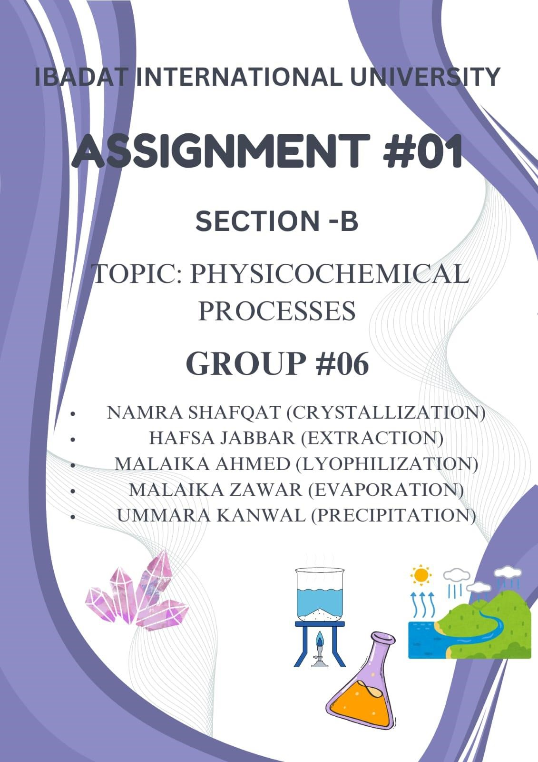

PHYSICO-CHEMICAL PROCESSES:
Physico-chemical processes involve the interplay of physical and chemical principles to modify, separate, or transform substances. These processes are essential in fields like environmental engineering, material science, and industrial applications. They are used for purification, waste treatment, resource recovery, and chemical synthesis, employing mechanisms such as adsorption, precipitation, oxidation-reduction, and membrane filtration.
❖ CRYSTALLIZATION:
Introduction:

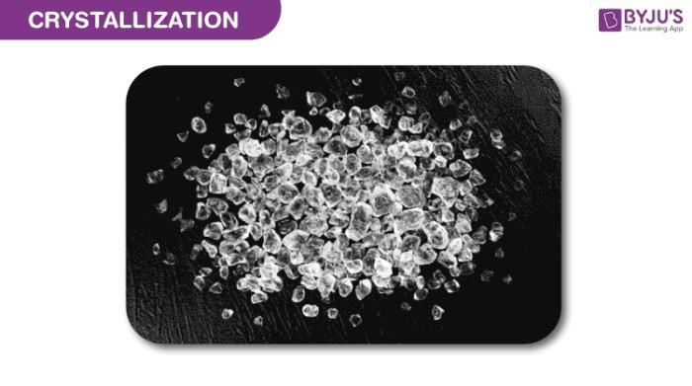
Crystallization can be defined as the process through which the atoms/molecules of a substance arrange themselves in a well-defined three-dimensional lattice and consequently, minimize the overall energy of the system. When a substance is subjected to crystallization, its atoms or molecules bind together through welldefined angles.
On adding a solid substance in a liquid and stirring it, the solid dissolves in the fluid. But when added more and more solid to the liquid, a point comes after which no more solid dissolves in the liquid. This point is called a saturation point and the fluid is called a saturation solution.
Crystal Lattice:
A crystal lattice is a 3D arrangement of atoms, ions, or molecules in a repeating pattern that forms the structure of a crystal. The basic repeating unit is called the unit cell, and its arrangement determines the crystal's shape and properties.
Crystal lattices are classified into seven types based on symmetry and unit cell dimensions.
- Cubic

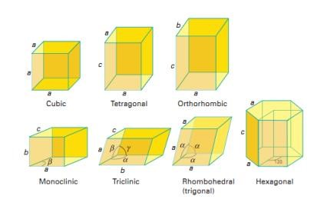
- Tetragonal
- Orthorhombic
- Rhombohedral (Trigonal)
- Hexagonal
- Monoclinic
- Triclinic
Explanation:
Crystallization occurs in two major steps. The first is nucleation, the appearance of a crystalline phase from either a supercooled liquid or a supersaturated solvent. The second step is known as crystal growth, which is the increase in the size of particles and leads to a crystal state. An important feature of this step is that loose particles form layers at the crystal's surface and lodge themselves into open inconsistencies such as pores, cracks, etc.
Crystallization is also a chemical solid–liquid separation technique, in which mass transfer of a solute from the liquid solution to a pure solid crystalline phase occurs. In chemical engineering, crystallization occurs in a crystallizer. Crystallization is therefore related to precipitation, although the result is not amorphous or disordered, but a crystal.
Crystallization Process:
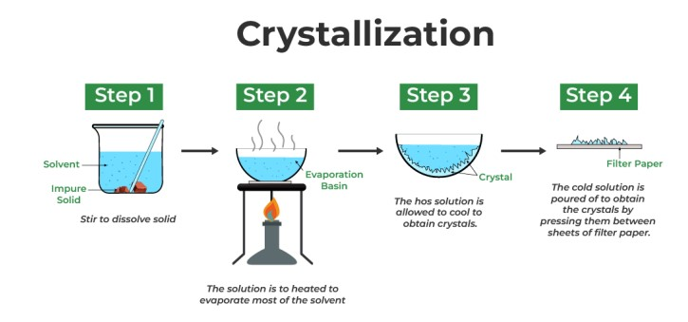
Examples of Crystallization:
Some common examples of where the crystallization process occurs are listed below:
- The crystallization of water forms ice cubes and snow.
- The crystallization of honey when it is placed in a jar and exposed to suitable conditions.
- The formation of stalagmites and stalactites (especially in caves).
- The deposition of gemstones is an example of crystal formation.
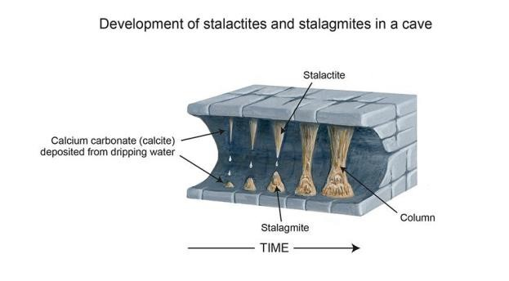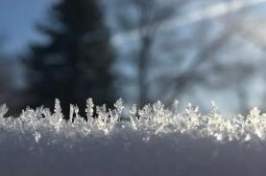

EXTRACTION:
Definition:

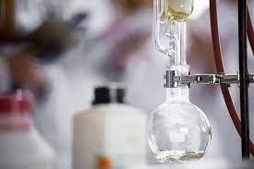
The process of separating a desired compound or group of compounds from a complex mixture or matrix, often using a solvent, mechanical forces, or other methods, to isolate and purify the desired substance.
Explanation:
Extraction is a process used to isolate and purify active pharmaceutical ingredients (APIs) from natural sources or chemical syntheses. The extraction process typically involves the use of a solvent, such as ethanol or methylene chloride, to dissolve and separate the desired compound from the matrix.
Principles of Extraction:
- Solubility:
The desired compound must be soluble in the solvent used for extraction.
- Partition Coefficient:
The desired compound must have a higher affinity for the solvent than for the matrix.
- Mass Transfer:
The desired compound must be transferred from the matrix to the solvent.
Methods of extraction:
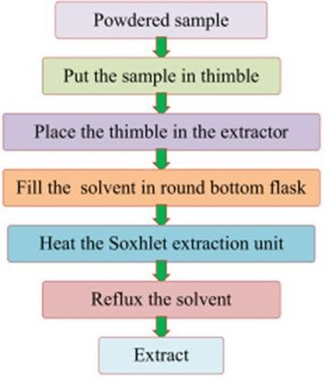

Types of Extraction:

1-Maceration:
This method involves steeping the matrix in a solvent, such as water or ethanol, for a prolonged period to extract the desired compound.
2-Percolation:
This method involves passing a solvent through a bed of matrix to extract the desired compound.
3-Infusion:
This method involves steeping the matrix in a solvent, such as water or ethanol, to extract the desired compound.
4-Decoction:
This method involves boiling the matrix in a solvent, such as water, to extract the desired compound.

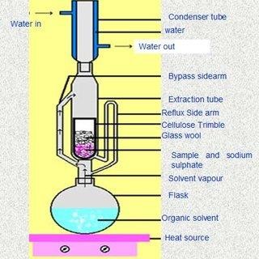
5- Digestion:
This method involves treating the matrix with a solvent, such as water or ethanol, and a digestive enzyme to extract the desired compound.
Pharmaceutical Applications:
- Extraction of Active Pharmaceutical
Ingredients (APIs): Extraction is used to isolate and purify APIs from natural sources, such as plants, animals, and microorganisms.
- Production of Herbal Medicines: Extraction is used to prepare herbal medicines, such as tinctures, extracts, and infusions, from plant materials.
- Isolation of Phytochemicals: Extraction is used to isolate and purify phytochemicals, such as alkaloids, glycosides, and terpenes, from plant materials.
- Preparation of Homeopathic Medicines: Extraction is used to prepare homeopathic medicines, such as mother tinctures and potencies, from plant and animal materials.
- Production of Vaccines: Extraction is used to isolate and purify antigens from microorganisms, which are then used to produce vaccines.
- Isolation of Enzymes: Extraction is used to isolate and purify enzymes from natural sources, such as plants, animals, and microorganisms, for use in pharmaceutical applications.
- Production of Hormones: Extraction is used to isolate and purify hormones from natural sources, such as animal tissues, for use in pharmaceutical applications.
- Preparation of Dietary Supplements: Extraction is used to prepare dietary supplements, such as vitamins, minerals, and herbal extracts, from natural sources.
LYOPHILIZATION
Definition
A stabilizing process where a substance is frozen, and then the solvent is reduced through:
Sublimation (primary drying stage)
Desorption (secondary drying stage)

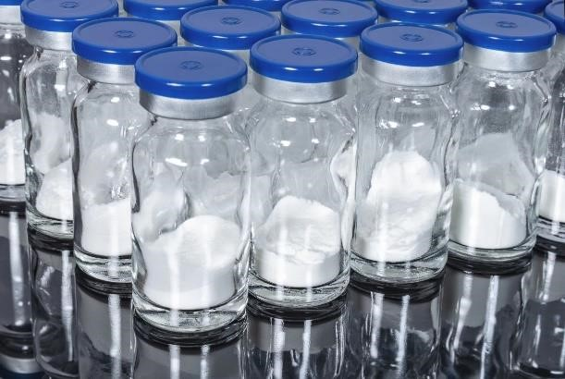
This process prevents biological activity or chemical reactions. In simpler terms, lyophilization removes water from a frozen product under vacuum, allowing ice to turn directly into vapor without becoming liquid.
Principle
Freeze drying relies on sublimation, where solid turns directly into vapor. Water is removed from the frozen state by sublimation. The process occurs at low temperature and pressure, below the triple point, making it suitable for thermolabile compounds.
Components of freeze dryer
- CHAMBER: Main compartment for freeze-drying the product.
- SHELVES: Heat transfer surfaces, usually stainless steel, where the product is placed.

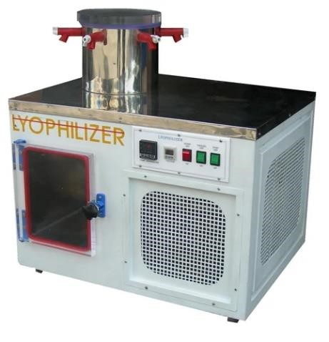
- CONDENSER: Collects and condenses water vapor removed from the product.
- VACUUM PUMP: Creates and maintains the vacuum environment in the chamber.
- REFRIGERATION SYSTEM: Cools the condenser and shelves for effective freezedrying.
- SILICONE OIL SYSTEM: Used for temperature control and heat transfer.
- TEMPERATURE SENSORS: Monitor the temperature of the product, shelves, and condenser.
Steps involved in lyophilization:
PRETREATMENT
Methods to treat the product before freezing, such as
Concentrating the product
Formulation revision
Decreasing high vapor pressure solvent
Increasing surface area
FREEZING
Liquid is frozen using methods like:

Shell Freezing: Liquid in a bottle rotates in a refrigerator bath, forming a thin shell of ice.
Vertical Freezing: Bottles are chilled and rotated in cold air, forming small ice crystals.
PRIMARY DRYING
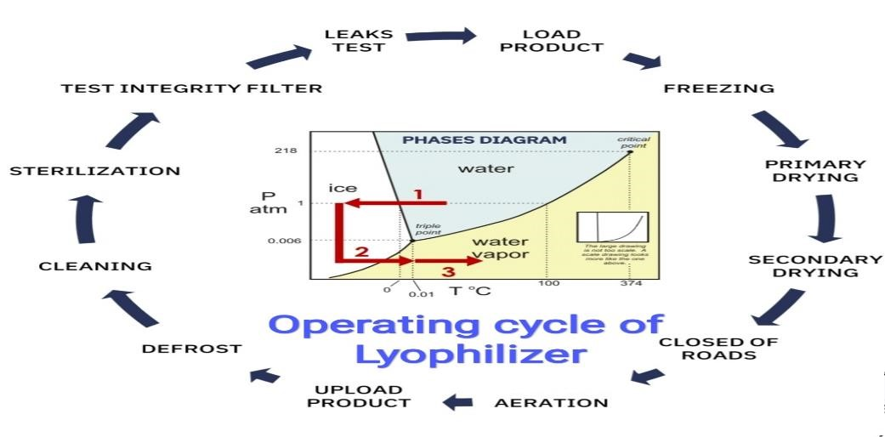

Pressure is lowered, and heat is supplied for sublimation.

About 95% of water sublimates

Controlled pressure through vacuum, with temperatures between

-
10

to
30

and pressure
at
50

mmHg
.

A
dvantages over conventional
drying:

- Low temperature minimizes decomposition.
- High vacuum prevents air contact, avoiding moisture and oxidation.
- Biological and pharmaceutical substances remain stable in dry state.
- Prevents salt concentration and protein denaturation Disadvantages:
- High equipment and running costs.
- Increased handling and processing time.
- Requires sterile diluents for reconstitution.
- Difficult for solutions with non-aqueous solvents. ▪ Prone to oxidation; should be packed in vacuum.

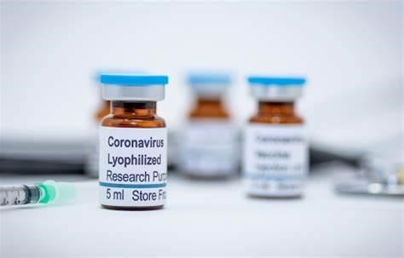
Some lyophilized formulations:
- Heat labile products.
- Moisture sensitive products.
- Antibiotics (to maintain potency).
- Enzymes (e.g., hyaluronidase).
- Hormones (e.g., insulin).
- Microbiological preparations (e.g., bacterial cultures).
- Food products (e.g., dry milk)
- Vaccines (e.g., yellow fever, smallpox).
EVAPORATION
Introduction
Evaporation is a fundamental process in the natural world, particularly within the water cycle. Evaporation is the process by which a liquid is changed into a gas or vapor. Specifically, it's the transition of a substance from its liquid state to its gaseous state.

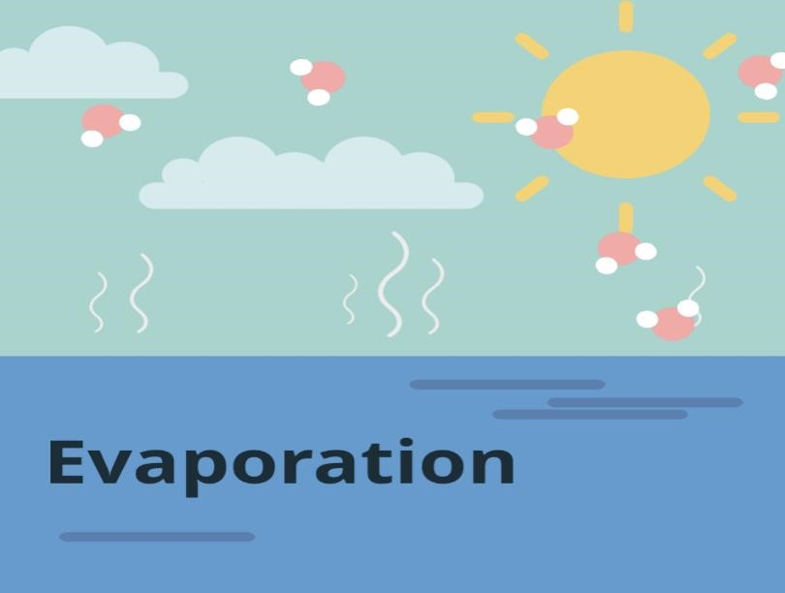
In the context of the water cycle, evaporation is the process that changes liquid water into water vapor. It occurs at the surface of a liquid. It can happen at any temperature below the liquid's boiling point. It's influenced by factors like temperature, humidity, wind speed, and surface area.
Explanation
The process of evaporation is a fascinating phenomenon that involves the transformation of a liquid into a
gas. Evaporation is a continuous process that plays a vital role in the water cycle ,climate , and many other natural and industrial processes .
Process:
Liquids are composed of molecules that are constantly in motion. This motion is related to their kinetic energy. Within a liquid, some molecules possess higher kinetic energy than others. Molecules at the liquid's surface with sufficient kinetic energy can overcome the attractive forces holding them in the liquid state. Evaporation primarily occurs at the surface of a liquid. This is a crucial distinction from boiling, which occurs throughout the entire volume of the liquid. When a molecule at the surface gains enough kinetic energy, it escapes from the liquid and enters the surrounding air as a gas, or vapor.
Examples
Evaporation is a common process that we observe in many everyday situations. Here are some examples:
Drying Clothes: When you hang wet clothes out to dry, the water in them evaporates into the air. The sun and wind speed up this process.
Puddles Disappearing: After a rainstorm, puddles of water on the ground gradually disappear as the water evaporates.
Sweating: When we exercise or get hot, our bodies produce sweat. The evaporation of this sweat helps to cool us down.
Drying of Water Bodies: Lakes, ponds, and rivers lose water through evaporation, especially during hot, dry weather.
Steam from Hot Drinks: The steam rising from a hot cup of tea or coffee is an example of evaporation.
Salt Production: In many places, seawater is evaporated in shallow ponds to produce salt.
Wet Floors Drying: When you mop a floor, the water left behind evaporates into the surrounding air.
Ironing Clothes: Using a hot iron on damp clothing causes the water within the fabric to evaporate.
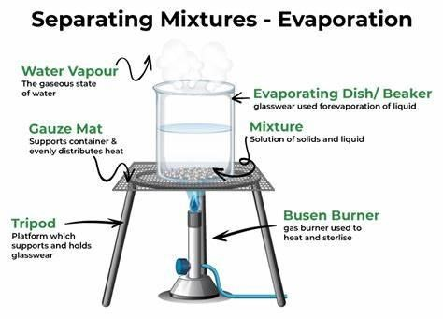
Methods

Natural Evaporation
Solar Evaporation
Wind - Driven Evaporation
Temperature - Driven Evaporation
Controlled Evaporation
Pan Evaporation
Rotary Evaporation
Flash Evaporation
Factors Influencing Evaporation

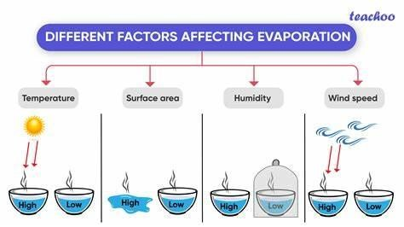

PRECIPITATION:
Definition:
Precipitation is the process of separating solid particles from a previously clear liquid by means of physical or chemical changes.

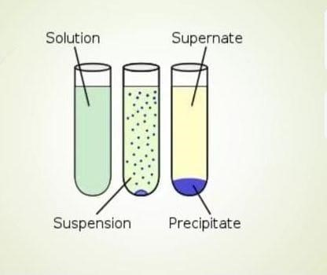
Precipitate:
The solid material that separates from a solution and settles at the bottom or floats on the surface during a reaction is called a precipitate.
Precipitant:
A precipitant is the substance or agent that causes a precipitation reaction to occur.
Supernate / Supernatant:
The supernate (or supernatant) is the clear liquid that remains above the solid precipitate after a precipitation reaction.
Steps Involved
Solution Preparation: A solution containing the desired solid is prepared.
Precipitating Agent: A precipitating agent (e.g., a chemical reagent) is added to the solution to induce precipitation.
Precipitation: The solution is mixed, and the precipitating agent reacts with the desired solid, causing it to precipitate out of the solution.
Filtration: The precipitated solid is separated from the solution using filtration.
Washing: The precipitated solid is washed with a suitable solvent to remove impurities. Drying: The precipitated solid is dried to remove excess solvent.
Types of Precipitation

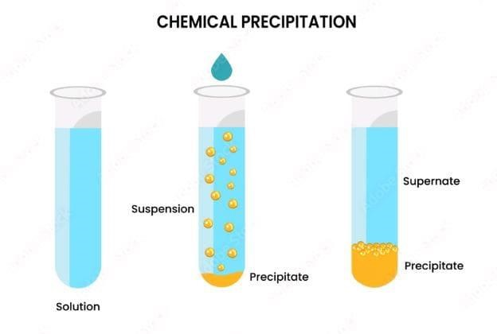
Chemical Precipitation: Involves the addition of a chemical reagent to induce precipitation.
Physical Precipitation: Involves changing the physical conditions of the solution, such as temperature or pressure, to induce precipitation.

Factors Affecting Precipitation
Concentration: The concentration of the solution affects the rate and extent of precipitation.
Temperature: Temperature can influence the solubility of the solid and the rate of precipitation. pH: The pH of the solution can affect the precipitation of certain solids.
Presence of Impurities: Impurities can affect the precipitation process and the purity of the final product.
Applications
Purification of Substances: Precipitation is used to purify substances, such as proteins, enzymes, and other biomolecules.
Separation of Mixtures: Precipitation is used to separate mixtures of solids, such as in the production of pharmaceuticals and other chemicals.
Wastewater Treatment: Precipitation is used to remove impurities and contaminants from wastewater.
Methods of precipitation:
- Organic Solvent Method:

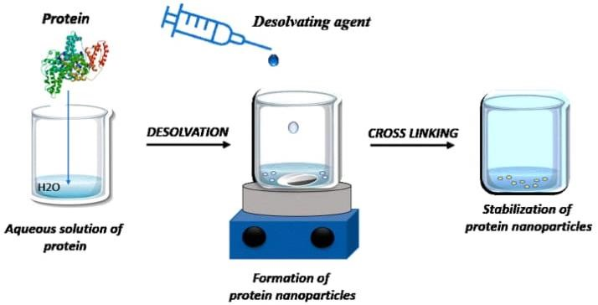
In this method, you add an organic solvent (like ethanol or acetone) to a solution where a substance (usually a polymer or protein) is dissolved in water. The organic solvent reduces the solubility of the substance in water because it changes the polarity of the solution. As a result, the dissolved substance can no longer stay in solution and precipitates out as a solid.
Example: Adding ethanol to a protein solution to make the protein precipitate.
- pH Change Method

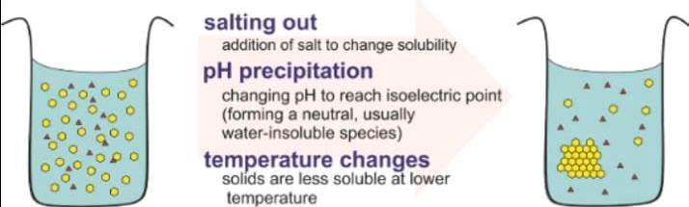
Many compounds (especially proteins or salts) are only soluble in water at certain pH levels. By changing the pH of the solution (either making it more acidic or more basic), you can alter the charge on the molecules, decreasing their solubility. Once the solubility drops, the substance precipitates out of solution.
Example: Adjusting the pH to the isoelectric point of a protein where it is least soluble, causing it to precipitate.
- Double Decomposition Method (Metathesis)

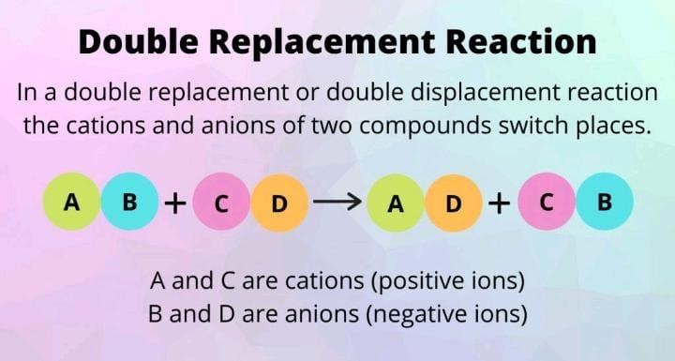
This involves mixing two solutions that each contain different soluble salts. When mixed, an insoluble compound (precipitate) forms from the exchange of ions between the two salts.The precipitate separates out because it's not soluble in water.
Example: Mixing solutions of barium chloride and sodium sulfate to form a white precipitate of barium sulfate.
REFERENCES:
  - Crystallization: Bentley Textbook of Pharmaceutics, Eighth edition, edited by E.A Rawlins, chapter 25 and 26, page 347-350, 351.
  - Extraction: Remington: The Science and Practice of Pharmacy, 22nd Edition, Editor
Allen LV, Chapter Extraction and Isolation of Natural Products, Page 725-730
  - Lyophilization: Lachman L, The Theory & Practice of Industrial Pharmacy, Varghese Publication, Bombay, Pg no: 762.
  - Evaporation: Pharmaceutical Engineering (Principles and Practice), Author: K. Sambamurthy, Edition: Latest available, Chapter Evaporation, Pages 235-240
  - Precipitation: Remington: The Science and Practice of Pharmacy, 22nd Edition, Editor Allen LV, Chapter Precipitation and Crystallization in Pharmacy, Page 745-750

