Tab 1
How Connect Speaker to Computer:
Simple Steps for Better Sound
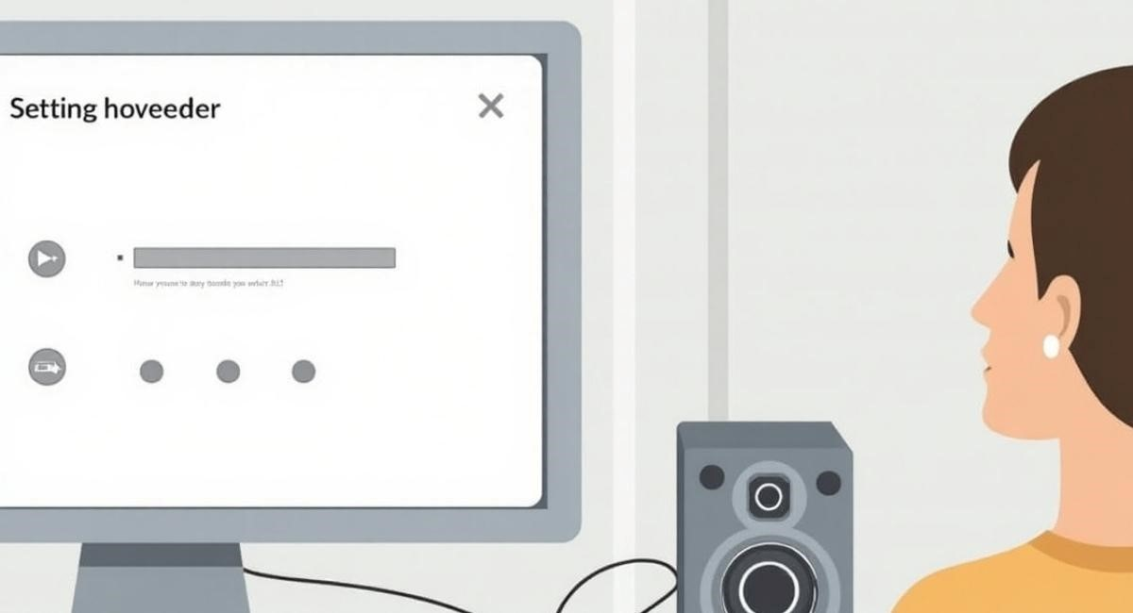

Getting sound from your computer through external speakers can truly upgrade your experience, whether you're gaming, watching movies, or working. Many users struggle with figuring out how to connect speakers to computers, especially when dealing with various types of connections and operating systems.

Fortunately, it's easier than it seems once you understand the basics of audio output, PC audio configuration, and the correct speaker connection method for your setup. Whether you're using a 3.5mm audio jack, Bluetooth connectivity, or a USB speaker connection, this guide will walk you through each option clearly. Let's make sure your speakers are set up right for the best sound possible.

Welcome to Dell
If you use a Dell computer, connecting computer speakers is easy. Dell machines have many types of audio output options. Most models come with built-in audio ports, and you can use
Bluetooth connectivity or USB speaker connection. Newer Dell laptops often need adapters because they have limited ports. Dell desktops usually have more choices like a 3.5mm speaker jack connection or HDMI. To get the best experience, always check your device’s manual. It shows where to find the correct ports. You can also visit Dell.com to get help or buy extra tools.

Your Dell.com Carts
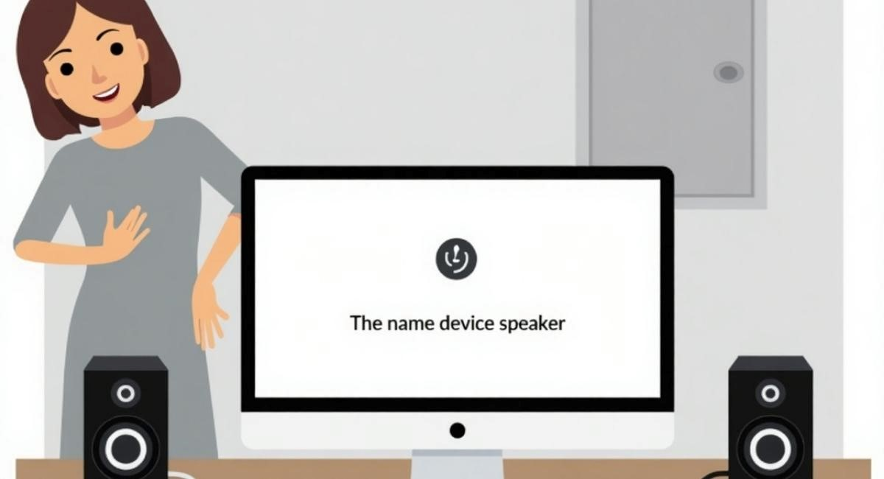
You can find all the items you need for a PC to speaker connection on Dell.com. Look for wired speaker connection sets or Bluetooth speaker pairing kits. Some even come with a full sound system optimization tool. Make sure the speaker system you choose supports your audio cable types and is made for your kind of Dell computer. You can compare prices, read reviews, and see which speaker setup works best. Dell.com also offers speaker stands, cables, and guides that help make your desktop sound enhancement much easier.

Types of Speakers
Speakers come in many types. Some are simple and plug into a 3.5mm audio jack. Others use USB ports or pair through Bluetooth connectivity. Many people prefer small portable speakers for travel. For a desktop speaker setup, larger speakers are better because they give richer sound. You can choose stereo speakers with left and right channel setup, or go for surround sound setup. There are also wireless speakers with voice control. Some advanced systems connect through HDMI. Picking the right kind depends on your space, your budget, and your computer type.

Connecting via 3.5mm Audio Jack
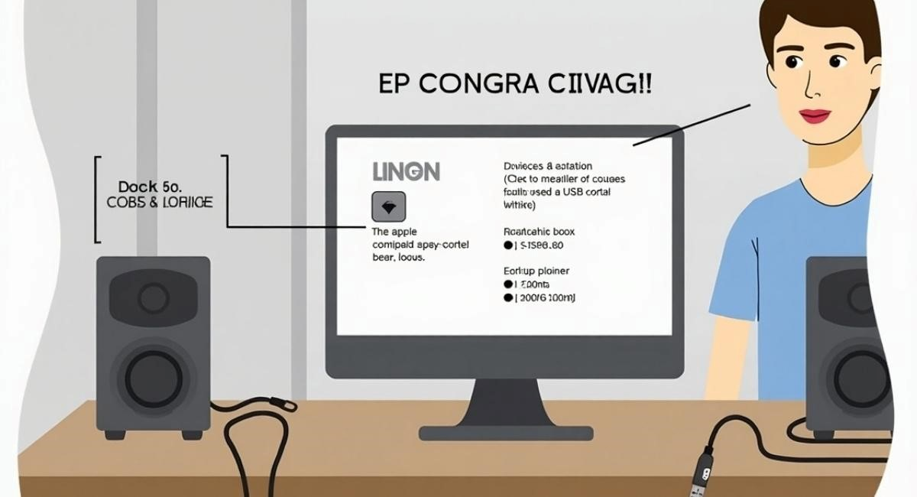
Most computers have a round green-colored port for a 3.5mm audio jack. This is where you plug in standard speakers or headphones. It gives basic audio output and is good for everyday use. Once connected, you can change the sound settings in your operating system sound settings. Make sure the cable is fully inserted. If your speaker has more than one cable, check which one goes into the aux input and which one goes into power.
If there is no sound, open the sound settings menu on your computer. Go to the volume settings and check if the correct output is selected. You can test the speakers by playing a video or song. If they still don’t work, try updating your sound drivers. These small programs help your PC talk to the speaker.

Troubleshooting Common Issues
Sometimes your speaker connection doesn’t work right away. This can happen for many reasons. Maybe the audio output is not selected. Go to your settings and choose the external speaker. Sometimes, cables are not pushed in all the way. You also might have a broken cable or loose wire. If you use Bluetooth connectivity, make sure the speaker is in pairing mode. Move it closer to your PC.
You can also check the sound card setup in your computer. In the control panel, click on sound settings. Pick the device you are using. Restart your PC if nothing else works. Updating your audio driver update can also solve most problems.

Connecting via Bluetooth
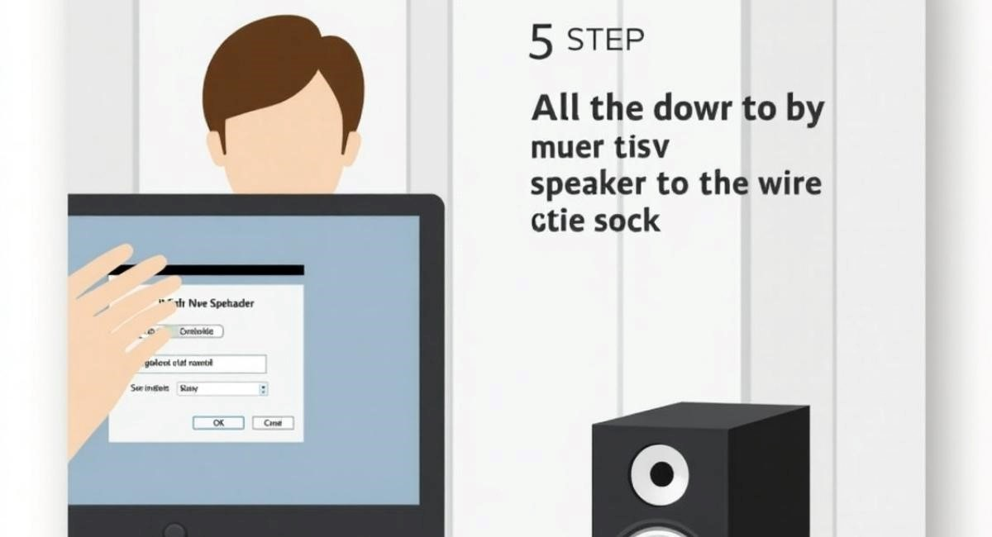
Modern laptops and desktops often support Bluetooth speaker pairing. First, turn on the speaker and press the Bluetooth button. On your PC, go to settings. Under Bluetooth, select "Add device" and wait for your speaker’s name to appear. Click to pair. Once connected, the sound will go to the speaker.
Make sure the audio output is set to Bluetooth in the settings. If the connection drops, move the speaker closer. Remove any other paired device that might interfere. Also, make sure your sound drivers are up to date for better results.

Connecting via USB
USB speaker connection is simple. Just plug the speaker’s USB cable into any USB ports on your computer. Your system will detect the device. It might install a driver. Wait a few seconds, then go to operating system sound settings and set the USB device as the default output.
Some USB speakers have built-in volume buttons. Use these to adjust the sound. If you don’t hear anything, open your volume settings and make sure the level is up. Also, test by playing a video or using a website with sound.

Frequently Asked Questions (FAQs)
You may wonder if you can connect more than one speaker at once. Yes, you can, but it depends on the speaker configuration. Some computers allow multiple outputs. Others do not. You might ask why the sound is low. That could be from poor desktop speaker stands or wrong speaker alignment. Another question is whether Bluetooth is as good as wired. Wired often has better quality, but Bluetooth gives more freedom.
Many users ask how to fix sound problems. The answer is to go to the sound settings menu, check your cables, and restart your computer. You should also update your sound drivers and check if your audio cable is working.

How To Connect Your Computer Speakers
To start, plug your audio cable into the correct port. This is usually green and labeled with a headphone symbol. Turn on the speaker and adjust the volume settings. On your computer, go to the PC audio settings and select your output. Click "Test" to make sure it’s working.
If you are using Bluetooth, press the Bluetooth button and pair it from your PC settings. For USB speaker connection, just insert the cable and wait for the PC to detect it. You may need to select it from the list of sound devices.

Step 1: Choose the output to use from your computer
Look at your computer’s sides or back. You’ll see USB ports, a round 3.5mm audio jack, or a Bluetooth symbol. Pick one depending on your speaker type. Each one has a different quality and setup time.
Make sure you use the correct cable. If you use the wrong port, the speaker will not work. If your computer has HDMI, you might also be able to use that for external sound system setups.

Step 2: Make the connection(s)
Now insert the cable or pair the Bluetooth speaker. Plug in the power cord if the speaker has one. Go to your computer’s sound settings menu and select the new speaker. You’ll hear a sound if it’s working.
Try a test video or song. Adjust the sound using both the speaker knob and your PC’s volume control settings. If nothing works, restart the computer and try again.

Speaker Setup
Once connected, you’ll need to set up your speaker configuration. Go to the settings and click on "Sound" or "Playback Devices." Choose your speaker and click "Set as default." You can test left and right channels to make sure they are working.
Use the balance setting if one speaker is louder. Also, check if your computer supports surround sound setup. This gives a better movie or gaming experience.

Tilted Desktop Speaker Stands
Many people place speakers flat on the desk. This is not ideal. Use tilted speaker alignment to point the sound toward your ears. This helps improve clarity. You can buy desktop speaker stands or use books to raise the speaker.
If the speaker is too low or facing away, the sound becomes dull. A simple tilt makes a big difference in your daily use. Your ears should be at the same level as the speaker’s output.

Stay in the Loop
For the latest updates on PC audio configuration and speaker tech, follow your favorite tech blogs or YouTube channels. New models and tips come out all the time. Keeping your setup current helps with desktop sound enhancement.
Sign up for email alerts or product releases from Dell, Logitech, or Bose. These brands lead in speaker setup tools and accessories.

Get in Touch
If you’re still having problems, contact customer support from your speaker or computer brand. They can walk you through audio troubleshooting steps. Many companies also have online user guide PDFs.
You can also post your question in online forums. Tech communities often answer faster than official channels. Just explain your setup clearly and list what you’ve already tried.

Gather Your Materials And Make Space
Before you start, find the right audio cable, your speaker’s power cord, and a clean desk space. Remove any clutter that might block the sound. Also, make sure you have access to your audio ports.
Place the speaker in a clear spot where the sound will travel freely. Avoid corners or tight spaces. These can block or reflect the sound.

Connecting Your Speakers to a PC: Step-by-Step
Start with finding the right port. Plug in your speaker using the proper cable. Power it on. Go to your PC and open the sound settings menu. Pick your speaker as the default device. Adjust the volume settings.
Then test the sound. If it works, you’re done. If not, update your sound drivers, check the cable, or restart your computer. Don’t forget to enjoy your new setup once everything works.

How To Connect Bluetooth Speakers
Turn on your speaker and press the Bluetooth button. On your PC, open settings. Click "Bluetooth & Devices" and choose your speaker. Click pair. It may take a few seconds.
Once done, go to your PC audio settings and make the speaker the default device. Play a song or video to check if the sound works.

Test The Speakers On Your PC
Go to your volume settings. Click on "Test" next to the speaker’s name. You should hear a sound. If not, check the audio output. You might need to switch from internal to external.
If the speaker still doesn’t work, try another cable or port. Try a different song or app. Make sure the sound drivers are up to date.

Speaker Setup Tips
Keep your desktop speaker setup clean and simple. Use good-quality audio cables. Keep wires short. Don’t twist or bend them too much. Use a stable table or stand.
Always restart your system after changing your setup. This refreshes the sound card setup and helps with bugs.
Why Use Speakers?
Computer speakers give better sound than built-in ones. They’re louder and clearer. They help you enjoy music, movies, and games. They also improve calls and online meetings.
You can pick from many types—small, big, wired, or wireless. The right speaker makes your computer feel more complete.

FAQ
Can I use a TV speaker? Sometimes, yes. Use HDMI or audio out. Why is my sound crackling? That could be a bad cable or poor speaker alignment. Try replacing the wire.
Can I fix a speaker that only plays one side? Go to your sound settings menu and adjust the balance. That often solves the issue. Or check the left and right channel setup in your PC settings.

