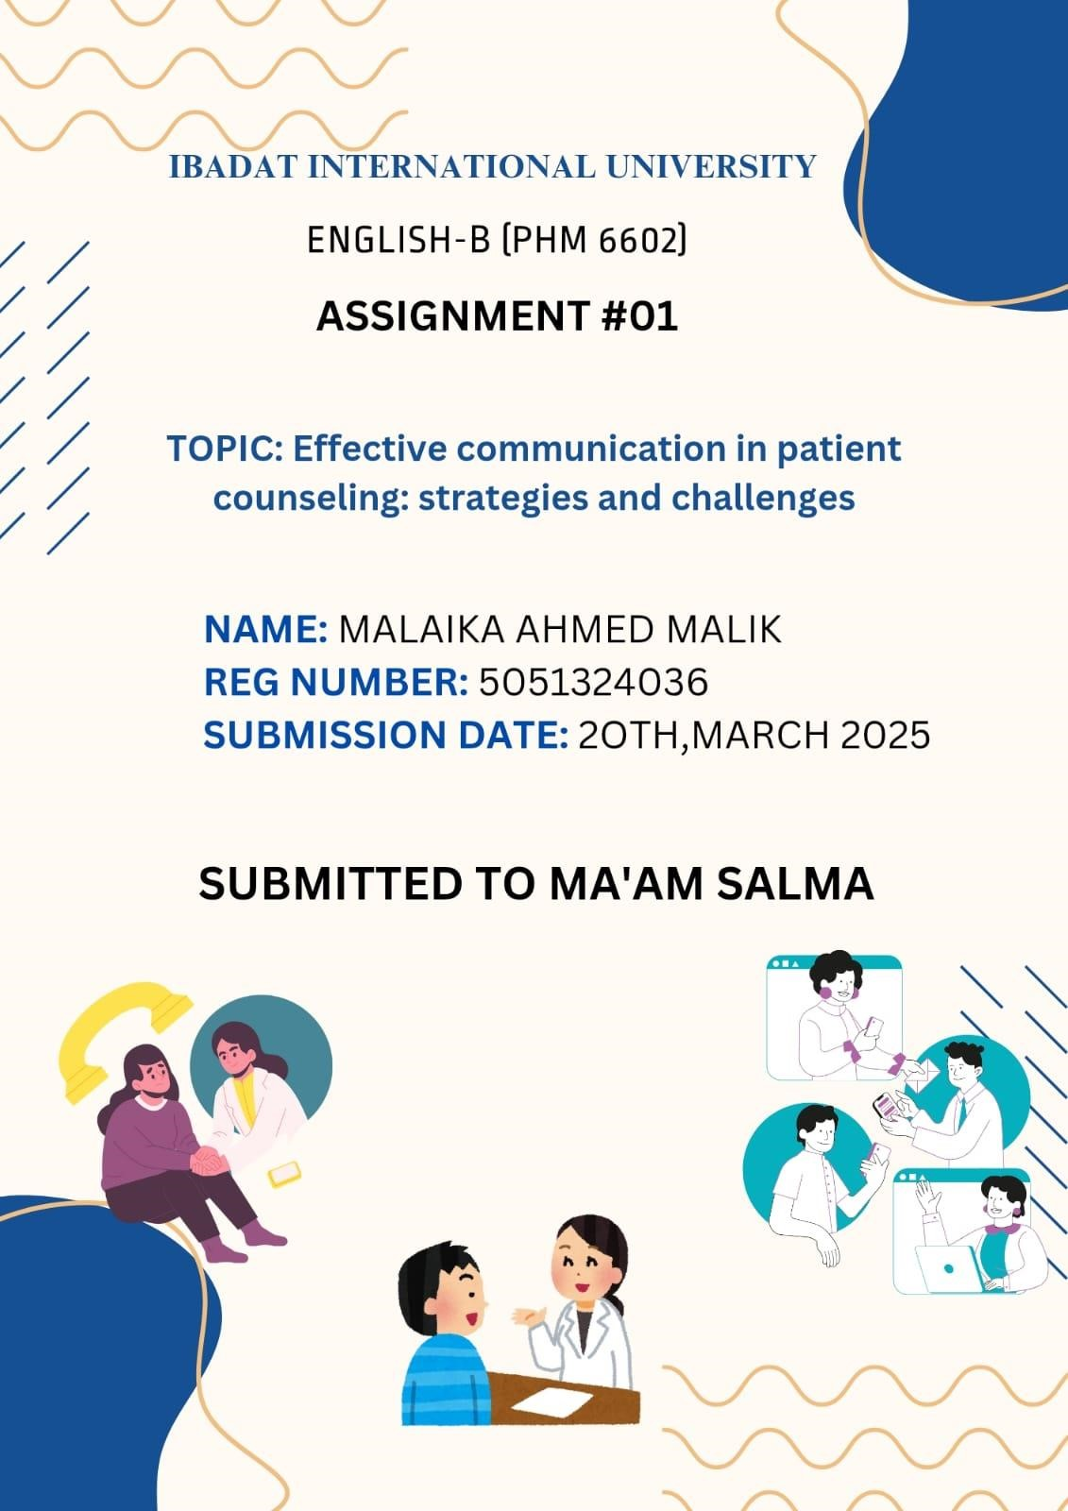

EFFECTIVE COMMUNICATION IN PATIENT COUNSELING:
STRATEGIES AND CHALLENGES

INTRODUCTION

Communication is human interaction and is particularly significant in pharmacy practice. Pharmacy communication not only involves the transfer of information from the pharmacist to the patient, but also between other healthcare services. This process is actively inherent. It not only involves the communication of facts, but also the creation of understanding, empathy and trust. Functions of communication are especially crucial regarding patient counseling. This is how pharmacists can transmit critical information regarding drug therapy, health and lifestyle change. The sheer criticality of effective communication in pharmacy practices cannot be excessively blended. This impact bears direct consequences on patient safety, medication regimen adherence, and overall health outcomes. Through effective communication, pharmacists empower patients to enable them to actively participate in managing their health, and finally enhance treatment of disease and quality of life. [Cite: 1, 2]
The aim of the report is to identify the position of communication skills in patient advising, define effective communication techniques, and verify general communication issues faced by patients while the pharmacist is busy. Depending on the investigation of the above factors, making reports on the ways pharmacists can enhance their communication strategy in a bid to achieve improved patient outcomes.

IMPORTANCE OF COMMUNICATION IN PATIENT COUNSELING

First, we need good communication so that we can be certain about patients being safe. You are the last contact of a patient with medication and the initial contact with them. You provide appropriate and honest information regarding your responsibility, medication usage, drug reactions, precautions, and side effects, and thus you are needed for this job. Effective communication prevents drug errors and drug interactions and thereby guarantees patient safety.
Secondly, there should be enhancement of communication for enhancing compliance in drug treatment protocols. The proportion of patients is quite high to ignore the drug treatment plan and thereby lead to loss in efficacy of the treatment as well as to additional expenses. Communication intervention is capable of encouraging the participation of patients in the drug treatment programs, can erase wrong information and fear, and adhere to the treatment plan. This is possible through numerous strategies like motivational interviews, information resources and family supply within the counseling process. [Cite: 4, 6]
Moreover, great communication fosters a strong relationship among pharmacists and patients grounded in trust and respect. They report health issues voluntarily since they believe that caring and valueless communication is achievable. It may result in an aggressive style of care where patients and pharmacists collaborate to enhance health outcomes. [Quote: 7, 8]

CRITICAL COMMUNCATIONS STRATEGIES FOR PHARMACISTS

In order to communicate with patients effectively, pharmacists have a number of key strategies that can be utilized. It involves staying focused, listening to the patient fully, and offering verbal information via nonverbal cues like nodding or paraphrasing. Empathy is a term used to describe the capacity to identify and share other individuals' feelings. When counseling patients, empathy involves the capacity to recognize patient concerns, recognize patients' emotions, and empathize. Through the application of proactive listening skills and empathetic demonstrations, pharmacists can establish an environment that facilitates openness of communication. [Quote: 4, 9]
- Simple and easy-to-understand language: Pharmacists may face difficult medical information that is difficult to present to their patients. The utilization of easy-to-use words and plain terms in reporting such information is of great significance. This entails maintaining small segment information, use of visual aids, and comprehension through repetition of patient fundamentals. Such aspects are capable of conveying information like spoken words.
- Non-verbal communication: Pharmacists need to be aware of non-verbal communication in order to balance the message conveyed verbally. Eye contact, a smile and a comfortable and helpful introduction to posture are an excellent method to establish reporting and trust with patients. [Quote: 4, 10]
- Treatment of patient issues and building up of trust: The patients should be concerned about their sickness and the medication. The pharmacists need to allow the patients to present their concerns and query their therapy. Pharmacists have a moral responsibility to explain these issues, give correct and true information, and to remove misconceptions. The framework of trust is a continuous process that demands consistency, reliability and genuine commitment to the patient. Pharmacists require the skill to communicate with patients of various cultures and varying health literacy. This communication includes the use of an interpreter, providing written material in various languages, or using strategies for plain languages. [Quote: 4, 11]

CHALLENGES IN PHARMACIST-PATIENT COMMUNICATION

- Treating with difficult patients: There may be patients who are not tactic, frightening or angry, and communication is difficult. Pharmacists need to learn new ways to treat difficult interactions. B. Keep calm, listen sensitively and pay attention to solutions.
- Drug Time Limits: Pharmacists typically work in hectic surroundings where patients do not provide sufficient time to counsel. This restricts the collection of enough information as well as response to all patient questions. Pharmacists must preferably provide significant information, practice effective communication based on time, and make optimal use of available time.
- Cultural and ethical issues: Cultural beliefs and values can shape patients' definition of illness and health as well as their communication style preference. Pharmacists are culturally aware and need to accommodate their style of communication depending on the patient's requirements.

CASE STUDY ANALYSIS

Referring to the following hypothetical case studies to describe the foregoing challenges and strategies:

Case study: Rodriguez
Rodriguez, a 65-year-old Hispanic woman with limited English proficiency, presents to the pharmacy to record a new recipe for diabetes medication. Lee, a pharmacist, finds Rodriguez to be confused and uncertain. Rodriguez's limited English proficiency creates challenges for her to follow the pharmacist's instructions. [Quote: 4, 11].
Health Competence: Rodriguez has only basic awareness of diabetes and his care. [Quote: 4, 11]
Cultural Influences: The culture of Rodriguez may shape her attitudes towards medication and health services. Rodriguez in her own words.
Simplified Language: Lee needs to speak in simple terms and not in terms of medical jargon while explaining drugs and their application.
Visual aid: Mr. Lee can apply the following visual aids: For your medicine.
Teaching Back Method: Lee must employ teaching strategies to ascertain that Rodriguez grasps the information. Rodriguez requests this to be explained in his own words.
Using these techniques will assist Mr. Lee overcome communication issues and Mrs. Rodriguez possesses the information and assistance you need to be able to effectively manage your diabetes. Case Study: Davis and her Inhaler
Mr. Davis, a 55-year-old female patient with asthma, visits the pharmacy and documents inhaled corticosteroids. When the pharmacist starts to counsel herself, Mrs. Davis indicates she is not frequently prescribing an inhaler because she thinks she will cough "not work." She also says she does not know if she will use it appropriately.
Active Listening and Empathy: The pharmacist hears Davis without judgment, identifies her feelings and validates her experiences. The pharmacist found that Davis was not inhaled deeply enough and did not breathe after inhalation. The pharmacist describes that inhaled corticosteroids are prophylactic medications and might not act immediately like rescue inhalers. The pharmacist also discusses Davis' issues with cough, describing that it can be a frequent side effect, but is usually minimized by ongoing use, and recommends ways to reduce this (e.g., spacers). By describing the distinction between relievers and controller drug therapy
in asthma, Davis' objections to drugs "do not work." It is vital for maintaining patient safety and enhancing pharmacotherapy compliance in ensuring patient safety and in fostering good pharmacist-patient relationships. This report describes how crucial communication in patient counseling explains major strategies for successful communication and explores some of the frequent challenges for pharmacists.
CONCLUSIONS AND RECOMMENDATIONS

To enhance communication in pharmacy practice, here are a few recommendations to consider:
- Offer communication skills training: Pharmacy schools and ongoing education programs should focus on providing thorough training in communication skills, which should include active listening, empathy, and cultural sensitivity.
- Encourage the use of technology: Leveraging technology can significantly improve communication. This includes using translation apps, patient portals, and telehealth services to bridge gaps.
- Foster a supportive environment: Pharmacies should cultivate an atmosphere that promotes open dialogue and gives pharmacists enough time to engage in meaningful patient counseling.
- Encourage interprofessional collaboration: Strong communication between pharmacists and other healthcare professionals is vital for delivering coordinated and comprehensive care to patients.
- Invest in ongoing research: More research is needed to pinpoint best practices in pharmacist-patient communication and to assess how effective various communication strategies are.
By making effective communication a priority, pharmacists can boost their ability to deliver patient-centered care, which ultimately leads to better health outcomes and greater job satisfaction.
REFERENCES

- Communication Skills. (n.d.). Course: Communication Skills [cite: 1, 2, 3, 4, 5, 6, 7, 8, 9, 10, 11, 12, 13]
- American Pharmacists Association. (n.d.). Medication Adherence. https\://[www.pharmacist.com/term/medication-
adherence](https://www.google.com/search?q=https://www.pharmacist.com/term/medicationadherence)
- National Academies of Sciences, Engineering, and Medicine. (2006). The Health Literacy Implications of the e-Prescribing National Initiative. National Academies Press.
- Agency for Healthcare Research and Quality. (n.d.). Health Literacy: AHRQ.
https\://www.ahrq.gov/health-literacy/index.html
- World Health Organization. (2023, July 31). Medication errors. World Health Organization.
https\://www.who.int/news-room/fact-sheets/detail/medication-error
- Centers for Disease Control and Prevention. (2022, February 15). Medication Adherence.
Centers for Disease Control and Prevention.
https\://www.cdc.gov/chronicdisease/management/adherence.htm
- The Joint Commission. (n.d.). Standards. https\://www.jointcommission.org/standards
- American Society of Health-System Pharmacists. (2023). ASHP Guidelines on Pharmacist Involvement in Patient-Centered Care. https\://www.ashp.org/-/media/assets/policypositioning/guidelines/gdl-patient-centered-care.ashx
- National Institute for Health Care Management (NIHCM) Foundation. (2018, October 23).
Improving Patient Communication: How Pharmacists Can Help. NIHCM.
https\://www.nihcm.org/publications/improving-patient-communication-how-pharmacists-canhelp
- Purdue University Global. (n.d.). The Importance of Nonverbal Communication in Pharmacy.
https\://www.purdueglobal.edu/blog/healthcare/importance-nonverbal-communicationpharmacy/
- U.S. Department of Health and Human Services. (n.d.). National Standards for Culturally and
Linguistically Appropriate Services in Health and Health Care (The National CLAS Standards).
HHS.gov. https\://www.thinkculturalhealth.hhs.gov/clas
- American Psychological Association. (n.d.). Dealing with Difficult People.
https\://www.apa.org/topics/interpersonal-relationships/difficult-people
- Pharmacy Times. (n.d.). Overcoming Time Constraints in Pharmacy Practice. https\://[www.pharmacytimes.com/view/overcoming-time-constraints-in-pharmacypractice](https://www.google.com/search?q=https://www.pharmacytimes.com/view/overcomingtime-constraints-in-pharmacy-practice)
- American Pharmacists Association. (n.d.). Code of Ethics for Pharmacists.
https\://[www.pharmacist.com/Practice-
Policy/Ethics](https://www.google.com/search?q=https://www.pharmacist.com/PracticePolicy/Ethics)

