
Student Name:
Date Submitted:
Wordcount:
Module Name:
Assignment Name:
Tutor’s Name:
Declaration:
I certify that I have read and understood the University Regulations relating to Plagiarism. All the material in this assignment is my work, except where I have indicated with appropriate references.
Comments on my usual/mitigation circumstances:

Table of Contents
1 Task 1: Digital Transformation Strategic Framework 3
1.1 Introduction 3
1.2 Digital Capabilities Analysis 3
2 Digital Transformation Framework Recommendation 4
2.1 Discover Phase Implementation 4
2.2 Design Phase Strategy 5
2.3 Deliver Phase Execution 5
2.4 De-risk Phase Management 6
3 Implementation Action Plan 6
3.1 Impact Assessment and Success Metrics 7
4 Task 2: Two disruptive technologies and techniques 8
5 Task 3: Digital Leadership Styles Analysis 8
5.1 Introduction 8
6 Recommended Leadership Style 1: Hyperaware Agile Leadership 9
6.1 Justification and Organisational Alignment 9
6.2 Impact on Digital Transformation 9
7 Recommended Leadership Style 2: Ethical-Tech Leadership 10
7.1 Rationale for Selection 10
7.2 Digital Transformation Impact Analysis 10
8 Integration of Leadership Theories and Frameworks 11
8.1 Theoretical Foundation 11
9 Framework Application 11
9.1 Practical Implementation Considerations 11
10 References 12

List of Figures
Figure 1: Overview of Kingston Hospital NHS Foundation Trust Source (Kingston Hospital, 2024) 3
Figure 2:McKinsey 4Ds Framework Source (Self-made) 5
Figure 3: Emotional intelligence framework Source (Goleman,2024) 11

Task 1: Digital Transformation Strategic Framework

Introduction
Kingston Hospital NHS Foundation Trust is a critical case study of the issues surrounding healthcare digital transformation (Kingston Hospital, 2024). The organisation is a large NHS trust that covers South West London, employs more than 3,500 staff members, and has 500 beds, which means it needs to modernise its clinical systems without compromising the high level of patient care (Kingston Hospital, 2024). The current difficulty in achieving the longer deadline of March 2026 to implement Electronic Health Records within the framework of the £2 billion Frontline Digitisation programme highlights the immediate necessity of an overall digital transformation strategy that addresses the technological and organisational obstacles (Kingston Hospital, 2024).

Figure 1: Overview of Kingston Hospital NHS Foundation Trust Source (Kingston Hospital, 2024)

Digital Capabilities Analysis
The Kingston Hospital exhibits critical digital deficiencies, with fragmented legacy systems, resulting in misalignment between organisational objectives and technological capabilities. Infrastructure limitations include outdated hardware and insufficient cloud capacity, while digital literacy among the workforce varies significantly across departments (Brunner, Schuster, and Lehmann, 2023). Patient-centered services remain underdeveloped with limited online functionality, minimal telemedicine capabilities, and restricted patient portals. Weak data analytics capabilities hinder comprehensive patient insights and the implementation of predictive analytics, leading to a reactive approach that scores approximately 40% on digital maturity frameworks (Christy Harris Lemak et al., 2024).

Digital Transformation Framework Recommendation
The McKinsey 4Ds framework is the most suitable strategy for the transformation journey at Kingston Hospital, addressing the complex healthcare environment and regulatory needs that an organisation faces.

Discover Phase Implementation
The discovery phase should engage all clinical units, administrative roles, and patients as stakeholders. Digital maturity must be assessed using healthcare models, such as the HIMSS Analytics EMRAM and the NHS Digital Maturity Assessment (Demir & Kocaoglu, 2021). To identify automation and integration opportunities, patient flows, clinical activities, and administration must be process-mapped (Brunner, Schuster, and Lehmann, 2023). The ability to benchmark competitive performance against other NHS EHR implementations, such as Guy's and St Thomas' NHS Foundation Trust and University College London Hospitals, can inform best practices and address implementation issues (Wang, Kung, and Byrd, 2023).
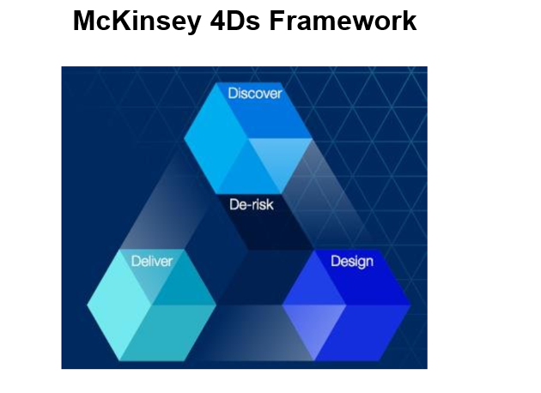
Figure 2:McKinsey 4Ds Framework Source (Self-made)

Design Phase Strategy
The design phase will use several technological architectures based on NHS Digital standards and interoperability needs. Solution architecture should prioritise cloud-first strategies and NHS-approved vendors and frameworks (Sriharan et al., 2023). To ensure that technology provides value and does not disrupt patient care, clinical workflow redesign requires collaboration among medical staff (Sultan, Nor, and Abdullah, 2024). The change management strategy adapts Kotter's eight phases to healthcare settings, focusing on clinical champion networks and peer-to-peer learning models.

Deliver Phase Execution
The implementation approach will start with simpler outpatient departments and move to critical care units. Pilot initiatives in selected departments enable early improvement and risk reduction before large-scale deployment (Santarsieri et al., 2022). Technical skills and clinical workflow integration are taught through rigorous training courses that utilize simulation and practice. To prioritise patient safety during transition, continuous monitoring systems track implementation, user uptake, and clinical outcomes (Rivera, 2022).

De-risk Phase Management
Risk management encompasses clinical safety management, led by qualified clinical informatics nurses and patient safety committees. Technical risk mitigation involves sound backup systems, disaster recovery plans, and 24/7 support services during implementation stages (Malik et al., 2024). Change resistance management applies individualized coaching, peer mentoring, and recognition programs to motivate the adoption process. The performance monitoring systems also track key indicators, including system availability, user satisfaction, clinical outcomes, and financial performance, to ensure that transformation objectives are met (Nandy, 2025).

Implementation Action Plan
The CEO of Leadership Organisation leads a Digital Transformation Board including clinical directors, IT executives, patient advocates, and external advisors. Project governance follows the PRINCE2 approach, which specifies decision-making and escalation authority (Kokol et al., 2022). Resources must be allocated strategically in many industries. Equipment improvements, network upgrades, and cloud platform adoption cost 2.8 million. Software licensing and installation expenditures for EHR systems, integration platforms, and clinical decision support tools total £ 2.2 million. Human resources investments of £ 1.5 million support project-specific teams, external advice, and rigorous training (Kingston Hospital, 2024).
Resource Allocation and Timeline Overview
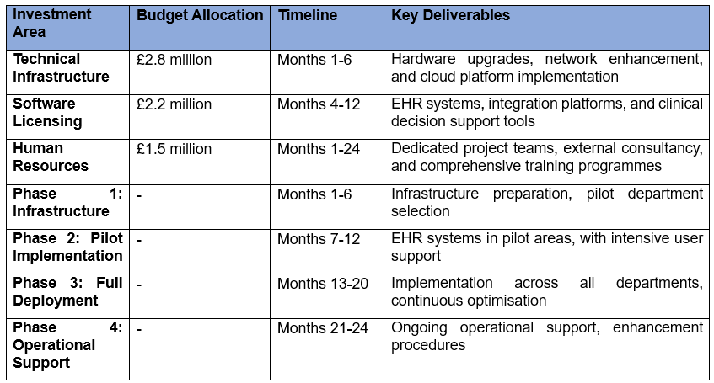
The 24-month implementation timetable includes quarterly milestones and delivery checkpoints. Phase One prepares infrastructure and selects the pilot department. Phase two involves the rollout of EHRs in pilot locations, accompanied by intensive user training and support. Optimisation and department-wide adoption occur in the third phase. In phase four, operational support and improvement are established.

Impact Assessment and Success Metrics
Among the benefits expected are fewer medication errors and improved clinical decision support systems, which will ultimately lead to safer patient care (Hauck, Rice, and Smith, 2022). Efficiency streamlines administrative operations, improves information availability, and improves departmental care coordination. From decreased administrative overhead, increased resource utilisation, and revenue cycle management, $3.2 million in annual savings are predicted (Khaw et al., 2022). The success assessment includes a system availability rate of 99.9%, user adoption exceeding 95% within six months, and a patient safety rate of at least 25% reduction in adverse events. Quality indicators help monitor better healthcare outcomes, patient satisfaction, and staff engagement (Kernick, 2022). Budget compliance, ROI calculation, and operational cost reduction are key financial performance criteria used to justify the value of transformation (Harris, Cortvriend, and Hyde, 2021).

Task 2: Two disruptive technologies and techniques
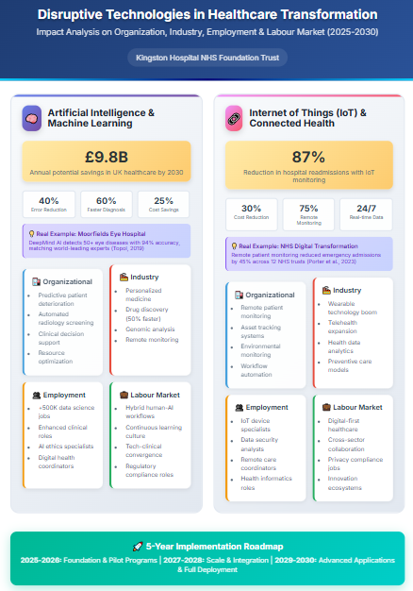

Task 3: Digital Leadership Styles Analysis

Introduction
The optimal way to achieve effective digital transformation within healthcare organisations is through leadership strategies that consider complex technological, cultural, and operational challenges simultaneously. The change process at Kingston Hospital needs leaders to overcome conventional healthcare hierarchies and promote the implementation of creative technologies. This analysis suggests two digital leadership styles that complement each other and align with the cultural context of the organisation, its level of digital maturity, and the goals of transformation.

Recommended Leadership Style 1: Hyperaware Agile Leadership

Justification and Organisational Alignment
If Kingston Hospital had to undergo a transition, hyper-aware agile leadership would be the most suitable fundamental leadership style to employ. This leadership style combines environmental scanning with dynamic management to handle the rapidly changing digital environment in healthcare effectively. The organisation's digital maturity requires leadership that can anticipate technological change and preserve clinical excellence (Haggerty, 2022a). Kingston Hospital requires hyper-aware executives who understand developments in healthcare technology, regulatory changes, and patient expectations (Gopal et al., 2023). This environmental knowledge promotes proactive decision-making over reactive approaches, which helps reduce delays in EHR adoption. In complex healthcare system deployments where requirements change over the project lifetime, agile leadership provides flexibility and experimentation (Group, 2022).

Impact on Digital Transformation
Hyper-aware agile leadership manages change with continual input and adaptive planning (Demir & Kocaoglu, 2021). These leaders employ the Kotter change management framework with agile adjustments to build urgency by communicating a clear purpose and being flexible in implementation. Agile leadership iteratively solves technical issues, solicits user feedback, and minimises resistance through inclusive problem-solving (Flanding, Grabman, and Cox, 2022). Within the bounds of clinical safety, innovation facilitation takes place in the context of calibrated risk-taking and experimental attitudes. Hyper-aware, agile hospital leaders create innovation labs where staff can test new technologies and operations without compromising patient care. This method fosters bottom-up innovation and top-down strategic alignment. Collective leadership methods empower clinical staff to become change partners, not change receivers, which underpins employee engagement initiatives (Cognativ.com, 2025). Hyperaware agile leaders accelerate change with clinical champion networks, cross-functional teams, and peer learning. Recognition systems reinforce desired organisational behaviours by rewarding innovation in technology and healthcare practice (C. Vincent, 2025).

Recommended Leadership Style 2: Ethical-Tech Leadership

Rationale for Selection
In addition to digital transformation in healthcare, ethical tech leadership may address unique ethical issues related to the use of medical technology. This leadership strategy prioritizes patient privacy, data security, and equitable access to technology to promote innovation and efficiency (Brunner, Schuster, and Lehmann, 2023). Healthcare businesses face complex ethical challenges related to patient data, AI, and technology in care delivery. Kingston Hospital requires leaders who can balance ethics with driving change and improving clinical outcomes (Harris, Cortvriend, and Hyde, 2021). Ethical tech executives blend innovation and accountability to ensure that technology benefits patients, not just operational efficiency.

Digital Transformation Impact Analysis
Ethical frameworks inspect all technology for patient privacy, care equity, and clinical autonomy before implementation. Ethical tech leaders establish digital health ethics committees to oversee and advise on digital health activities (Malik et al., 2024). Overcoming healthcare workers' skepticism of new technologies requires building trust. Ethical tech leaders communicate openly and make ethical judgements to promote technology confidence and prioritise clinical values and patient health (Rivera, 2022). This method reduces opposition by aligning technology with the values and patient care priorities of healthcare personnel. Ethics-tech leadership simplifies and actively addresses data security, clinical governance, and professional regulatory obligations (Christy Harris Lemak et al., 2024). The proactive strategy removes regulatory hurdles that may delay deployment and assures technology use for years.

Integration of Leadership Theories and Frameworks

Theoretical Foundation
The proposed leadership mix incorporates various proven leadership theories, modified to apply to the healthcare digital transformation environment. The principles of situational leadership enable adjusting the style to meet departmental preparedness and clinical situation requirements (Kingston Hospital, 2024). The transformational aspects of leadership encourage the development of a shared vision and encourage participation in the change. The qualities of servant leadership make sure that employee development and empowerment are at the center of transformation strategies. This combination supports both the autonomy and professional growth requirements of healthcare professionals and advances organisational change goals.

Framework Application
The emotional intelligence framework created by Goleman offers the basis of the capabilities of both recommended leadership styles. Self-understanding helps leaders identify their technology biases and constraints. Social awareness facilitates the understanding of diverse stakeholder attitudes and interests (Santarsieri et al., 2022). The relationship management skills will facilitate efficient coalition building and conflict resolution during the challenges of transformation. The integration of complexity leadership theory recognises the complex adaptive system nature of healthcare organisations. The leaders who employ this framework realise that change thrives through the interaction of networks, rather than top-down requirements, resulting in more efficient influence tactics and lasting change enactment (Sultan, Nor, and Abdullah, 2024).
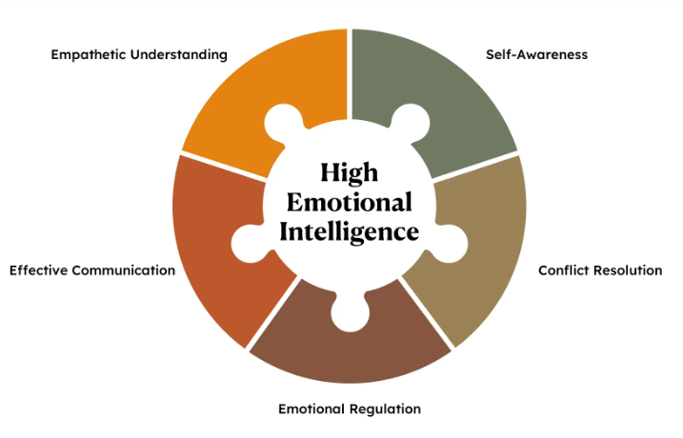
Figure 3: Emotional intelligence framework Source (Goleman,2024)

Practical Implementation Considerations
The leadership development programmes should include not only leadership capability building but also technical competency building. To effectively develop these advanced leadership strategies, Kingston Hospital will need to invest in leadership coaching processes, mentoring programs, and peer learning networks (Christy Harris Lemak et al., 2024). Succession planning provides the sustainability of leadership ability beyond ongoing transformation efforts, developing the organisational capacity to continuously undergo transformation in digital form and become a leader in healthcare innovation (C. Vincent, 2025).

References
Brunner, T.J.J., Schuster, T. & Lehmann, C. (2023). Leadership’s long arm: The positive influence of digital leadership on managing technology-driven change over a strengthened service innovation capacity. Frontiers in Psychology, 14. doi: https://doi.org/10.3389/fpsyg.2023.988808.
C Vincent (2025). Institutional Change and Healthcare Organizations. [online] Google Books. Available at: https://books.google.com/books?hl=en&lr=&id=vomaHpFVcOAC&oi=fnd&pg=PR12&dq=dhealthcare+organisations&ots=GrhKx1EFtG&sig=s7QQMyN-DtYd4MeMRlrq8m3QNyI [Accessed 25 Sep. 2025].
Christy Harris Lemak, Pena, D., Jones, D.A., Dae Hyun Kim & Guptill, J. (2024). Leadership to Accelerate Healthcare’s Digital Transformation: Evidence From 33 Health Systems. Journal of Healthcare Management, 69(4), pp.267–279. doi: https://doi.org/10.1097/jhm-d-23-00210.
Cognativ.com. (2025). Top Digital Transformation Frameworks for Successful Implementation. [online] Available at: https://www.cognativ.com/blogs/post/top-digital-transformation-frameworks-for-successful-implementation/234.
Demir, E. & Kocaoglu, B. (2021). The Use of McKinsey's 7S Framework as a Strategic Planning and Economic Assessment Tool in the Process of Digital Transformation. Pressacademia, 9(9), pp.114–119.
Flanding, J.P., Grabman, G.M., & Cox, S.Q. (2022). Leading Change in the Digital Era. The Technology Takers, pp.161–175. doi: https://doi.org/10.1108/978-1-78769-463-720181005.
Gopal, G., Crazzolara, C., Toldo, L. & Eberhardt, W. (2023). Digital transformation in healthcare – architectures of present and future information technologies. Clinical Chemistry and Laboratory Medicine (CCLM), 57(3), pp.328–335. doi: https://doi.org/10.1515/cclm-2018-0658.
Group, P.I. (2022). Leadership in the Digital Age: A Study on the Role of Leaders in this Era of Digital Transformation. [online] International Journal on Leadership. Available at: https://www.academia.edu/download/60686981/120190924-7274-n4072j.pdf.
Haggerty, E. (2022). Healthcare and digital transformation. Network Security, 2017(8), pp.7–11. doi: https://doi.org/10.1016/s1353-4858(17)30081-8.
Harris, C., Cortvriend, P. and Hyde, P. (2021). Human Resource Management and Performance in Healthcare Organisations. Journal of Health Organization and Management, 21(4/5), pp.448–459. doi: https://doi.org/10.1108/14777260710778961.
Hauck, K., Rice, N. & Smith, P. (2022). The influence of health care organisations on health system performance. Journal of Health Services Research & Policy, 8(2), pp.68–74. doi: https://doi.org/10.1258/135581903321466021.
Kernick, D. (2022). Complexity and Healthcare Organization. CRC Press. Doi: https://doi.org/10.1201/9781315376318.
Khaw, T.Y., Teoh, A.P., Abdul Khalid, S.N. & Letchmunan, S. (2022). The impact of digital leadership on sustainable performance: a systematic literature review. Journal of Management Development, 41(9/10). Doi: https://doi.org/10.1108/jmd-03-2022-0070.
Kingston Hospital (2024). Home Kingston and Richmond NHS Foundation Trust. [online] Kingston and Richmond NHS Foundation Trust. Available at: https://www.kingstonandrichmond.nhs.uk/.
Kokol, P., Blažun Vošner, H., Kokol, M. and Završnik, J. (2022). Role of Agile in Digital Public Health Transformation. Frontiers in Public Health, 10. doi: https://doi.org/10.3389/fpubh.2022.899874.
Malik, M., Raziq, M.M., Sarwar, N. & Tariq, A. (2024). Digital leadership, business model innovation, and organizational change: role of the leader in steering digital transformation. Benchmarking. Doi: https://doi.org/10.1108/bij-04-2023-0283.
Nandy, B. (2025). Hospital Investment Decisions and Prioritization of Clinical Programs. Cureus, 17(3). doi: https://doi.org/10.7759/cureus.79998.
Puckett, S. & Neubauer, R.M. (2020). AGILE LEADERSHIP. Doi: https://doi.org/10.5771/9783869805559.
Rivera, M. (2022). Leading Growth through the Digital Leader. Journal of Leadership Studies, 12(3), pp.53–56. doi: https://doi.org/10.1002/jls.21595.
Santarsiero, F., Schiuma, G., Carlucci, D. & Helander, N. (2022). Digital transformation in healthcare organisations: The role of innovation labs. Technovation, 122, p.102640. doi: https://doi.org/10.1016/j.technovation.2022.102640.
Sriharan, A., Sekercioglu, N., Mitchell, C., Senkaiahliyan, S., Hertelendy, A., Porter, T., & Banaszak-Holl, J. (2023). Leadership Dynamics in Driving AI Transformation in Healthcare: Insights from a Scoping Review (Preprint). Journal of Medical Internet Research, 26. doi: https://doi.org/10.2196/54556.
Sultan, H., Nor, and Abdullah, B. (2024). The Effect of Digital Leadership Styles on Sustainable Performance: A Systematic Literature Review. Engineering, Technology & Applied Science Research, [online] 14(6), pp.17781–17785. doi: https://doi.org/10.48084/etasr.8761.
Wang, Y., Kung, L. & Byrd, T.A. (2016). Big Data analytics: Understanding Its Capabilities and Potential Benefits for Healthcare Organizations. Technological Forecasting and Social Change, 126(1), pp.3–13. doi: https://doi.org/10.1016/j.techfore.2015.12.019.

