 | 
  CANDIDATE NUMBER (C-NUMBER) | C2104332
  MODULE NAME | Innovation Management In A Digital Age
  WORD COUNT | 2,737
  SUBMISSION DATE | 10th June 2024
  DECLARATION
  I certify that this assessment submission is entirely my work and I have fully referenced and correctly cited the work of others, where required. I also confirm the contents of my submission have not been generated by a third party, or through an Artificial Intelligence generative system*.
  I have read the Student Discipline Regulations (Student Discipline Regulations) and understand any Assessment Related Offence/ Academic Misconduct may result penalties being applied.
  By submitting this assessment submission, I am confirming that I am fit to sit according to the Assessment Regulations.
  I declare that:
  - This is my own unaided work.
  Yes ☒
  No ☐
  - The word count stated by me is correct.
  Yes ☒ No ☐
  - I’m happy for my work to be retained on the Elite repository and made available to staff and future students.
  Yes ☒
  No ☐
  Please note that all the assignments are submitted to Turnitin.
  Please note personal information (such as names) will be deleted.
Instructions to candidates:
- Please complete this cover sheet by entering your Candidate Number, Module Name, Word Count, and S Date.
- You must NOT use your NAME on this cover sheet or on any part of your coursework.

Innovation Management In A Digital Age
A Digital Approach To Innovation Management in Unilever's Personal Care Products
Division


Table Of Content
Introduction 4
1. Identification of Jobs To Be Done (JTBD) and Customer Needs 4
1.1. Customer Persona (Jobs To Be Done (JTBD): 4
1.2. Market Trends and Customer Feedback: 5
2. PESTLE Analysis 7
3. leveraging AI Initiatives for Innovation - Implementation Plan 9
4. Evaluation of Personal Digital Capabilities 14
4.1. SWOT Analysis of Personal Digital Capabilities 15
4.2. Personal Digital Skills Goals Utilizing S.M.A.R.T. Action Plan 16
Conclusion 17
References 19
Appendix 1 – Beginning Assessment Jisc | Building Digital Capability 23
Appendix 2 – End Assessment Jisc | Building Digital Capability 40
Appendix 3 – BCG Digital Transformation Job Simulation – Foraj Certificate 59

Introduction
In the rapidly evolving digital landscape, companies like Unilever face significant challenges in meeting the shifting expectations of consumers and adapting to technological advancements. As a €13.8 billion business renowned for its commitment to caring for both people and the planet, Unilever's Personal Care Products division, with beloved brands like Dove, Rexona, and Lifebuoy, plays a crucial role in driving positive change (Unilever, 2023). This report addresses the need for innovation management in Unilever's Personal Care division. Recognizing the urgency for improved innovation processes, it offers strategic recommendations for product innovations. By analyzing market trends, consumer feedback, and leveraging digital capabilities, the report outlines actionable strategies to drive the division forward. Additionally, it emphasizes stakeholder alignment to ensure success. Ultimately, the report aims to equip Unilever with insights to navigate the digital landscape, drive innovation, and meet consumer and stakeholder needs effectively.

1. Identification of Jobs To Be Done (JTBD) and Customer Needs
Unilever's Personal Care division boasts a vast array of successful products (Luigi, Candidate and Shiqian, 2021). To pinpoint innovation opportunities, here is the elaboration on the needs and Jobs To Be Done (JTBD) of a key customer segment (Barden, 2022), like the environmentally conscious professionals prefer the best self-care products.

1.1. Customer Persona (Jobs To Be Done (JTBD):
Unilever's strategy in the personal care domain is deeply rooted in innovation and addressing emerging consumer needs. Considering personas like Emily Green, Alex Rivera, and Lily Chang, who prioritize sustainability and efficacy in their self-care products, Unilever must leverage cutting-edge technology to develop solutions that meet their evolving demands. For Emily, Unilever could focus on creating self-care products with natural ingredients and sustainable packaging, utilizing advanced manufacturing processes to minimize environmental impact. Alex, with his emphasis on performance and sustainability, would benefit from products that merge eco-consciousness with high efficacy, perhaps incorporating innovative formulations or packaging designs.
Additionally, by targeting professionals like Lily, who advocate for ethical and cruelty-free products, Unilever can utilize technology to ensure transparency in sourcing and production processes. By aligning its innovation efforts with the functional, social, and emotional needs of these personas, Unilever can position itself as a leader in sustainable personal care solutions, driving positive change in the industry while meeting consumer expectations.
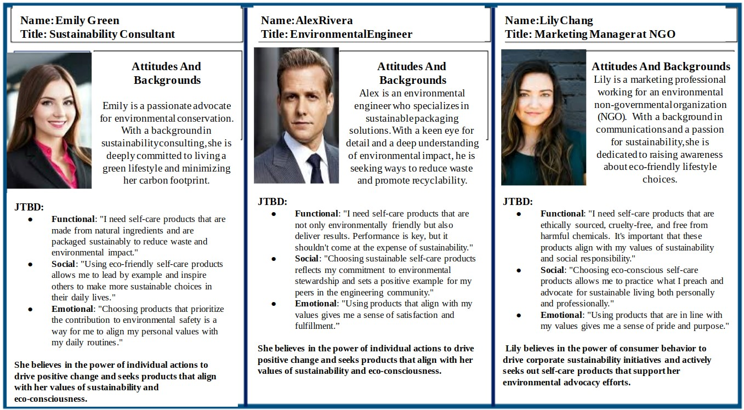
Figure 1 - Unilever Customer’s Persona (Jobs To Be Done (JTBD) - Self Made

1.2. Market Trends and Customer Feedback:
The personal care market, exemplified by Unilever's flagship brands Dove and Tresemme, is undergoing a transformative shift driven by evolving consumer preferences and market dynamics. In 2023, Dove's brand value soared to approximately 6.5 billion U.S. dollars, marking a significant uptick compared to previous years as shown in Figure 2 below. In Europe, Dove emerged as a frontrunner, particularly in Italy where it garnered 49 million Consumer Reach Points (CRP) and secured the third spot in Germany, with nearly 29% of households purchasing its products (Statista, 2023b). Additionally, Tresemme, Unilever's shampoo brand, witnessed remarkable success, surpassing Procter & Gamble's Pantene in market share within just three years of its launch (Malviya, 2015). These achievements underscore the immense potential within the global beauty and personal care market, which amassed a revenue of around 528.6 billion U.S. dollars in 2022, with the United States, China, and Japan leading the charge (Statista, 2023a). However, amidst this growth, there arises a pressing need for innovation to address emerging trends and consumer demands.
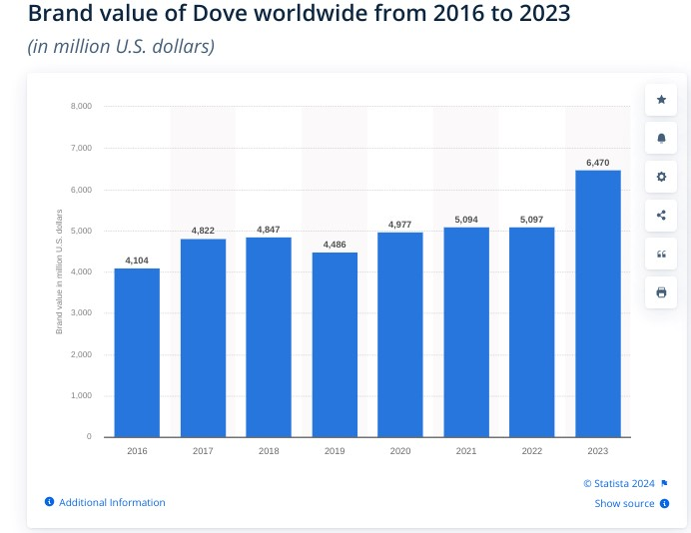
Figure 2 - Global brand value of Dove from 2016 to 2023 Source - (Statista, 2023)
Specific opportunities for innovation in Unilever's Personal Care products include sustainable packaging, personalized product lines, transparency, and traceability, as well as enhanced digital experiences. Market trends and customer feedback indicate a growing concern for sustainability, with 83% of global consumers willing to pay more for eco-friendly products (Babar, 2024). Moreover, there's a rising demand for personalized cosmetics and greater transparency regarding product ingredients and sourcing origins. Unilever has already taken strides towards sustainability, pledging to halve its virgin plastic use by 2025 and exploring refillable packaging solutions (Unilever, 2022). However, further innovation is needed to capitalize on the demand for personalization and digital experiences. That is why, by embracing these recommendations, Unilever can not only meet the functional needs of consumers but also align its products with their social and emotional values, securing a competitive advantage in the dynamic personal care market.

2. PESTLE Analysis
Unilever as a global player in the fast-moving consumer goods works within an industry that is characterized by changes and numerous drivers. Legal issues, for example, trade rules and government policies, determine its distribution network and determine what proprietary products are allowed on shelves as the last link in the supply chain. Other factors which also affect the company’s procedure include economic fluctuations, socio-cultural shifts towards sustainability, development of technology, environmental problems, and legal compliance (Cheng, 2021). It is obvious that these factors are a voice against Unilever's strategic considerations in managing global markets.
Table 1 - Unilever PESTLE Analysis
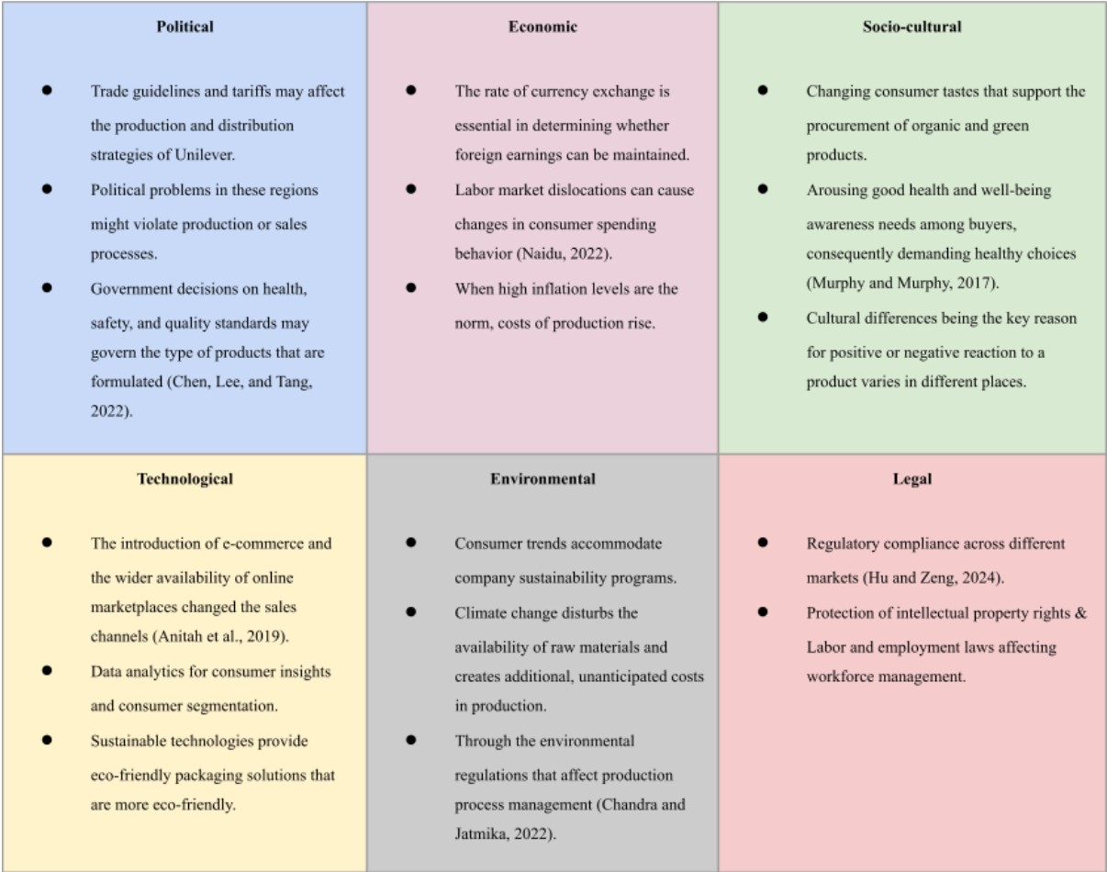
Among others, the dynamics of markets characterize the context within which Unilever's Personal Care Products Division has to make changes towards innovation (Patel, 2023). In order to meet the demand from consumers for greener alternatives, innovation in packaging and formulations is required to cover up the issue of sustainability, which is mostly driven by them. Additionally, evolving consumer sentiment toward natural products will result in recurring changes in product portfolio offerings. Through technological accelerators like data analytics, it is possible to create custom solutions, which ultimately lead to exceptional customer experience. Hence, Unilever could focus on the development of customized products based on data insights (Langhe & Puntoni, 2024). Additionally, investing in sustainable packaging corresponds with customer desire for responsible buying. The global eco-friendly packaging market is expected to develop at a 7.6% CAGR from 2023 to 2032, reaching an estimated USD 430.38 billion as shown in figure 3 below (Swapna, 2022). Implementing transparency measures like blockchain technology ensures compliance with evolving regulatory standards while fostering consumer trust. This innovation approach combines sustaining and disruptive strategies, addressing market demands for eco-friendly products and setting new standards for transparency and sustainability. Aligned with Unilever's commitment to sustainability and innovation, it ensures competitiveness in the personal care market (Shaoping, 2023). That is why, by meeting consumer preferences, complying with regulations, and embracing technology, Unilever solidifies its position while delivering on environmental responsibility and customer satisfaction, ensuring long-term relevance and resilience.
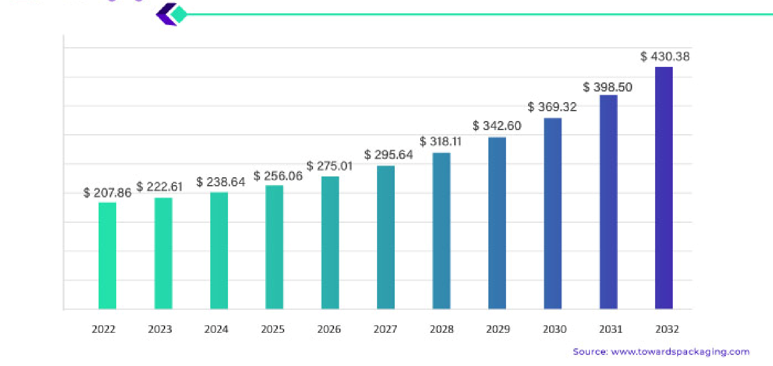
Figure 3 - Eco-friendly Packaging Market Size Anticipated to Attain USD 430.38 Billion by 2032
Source - (Swapna, 2022)

3. leveraging AI Initiatives for Innovation - Implementation Plan
For Unilever's AI-driven personal care product line implementation strategy, sustaining innovation involves enhancing current offerings with AI-driven personalization features, eco-friendly packaging, and natural ingredients. By leveraging technology and consumer insights, Unilever can refine its product formulations, optimize production processes, and improve overall customer experience. Sustaining innovation as guided by (Cote, 2022) allows Unilever to stay ahead of market trends, retain customer loyalty, and strengthen its position as a leader in the personal care industry. Moreover, this approach aligns with Unilever's commitment to sustainability and responsible business practices, ensuring that its products meet both consumer expectations and environmental standards for long-term viability and success.
The implementation plan aims to introduce personalized product lines in Unilever's Personal
Care Products Division to meet evolving consumer demands and enhance customer satisfaction. Leveraging artificial intelligence (AI) initiatives will play a crucial role in enhancing innovation and improving the overall customer experience (Cooper, 2023). Here is the implication plan for it:
Table 2 - Implication Plan
Implementation  Plan Components |  | Stakeholders  Involved | Strategies for Acceleration | Strategies for  Overcoming Blockers
Development  Personalized  Product Lines | of | Marketing,  Product  Development,  AI Experts | Conduct comprehensive market research and data analysis; Collaborate with  AI experts; Utilize  AI-driven technology for customized formulations | Address concerns about data privacy and security; Provide ongoing support and resources for employees; Collaborate  with regulatory authorities
Integration of  Initiatives | AI | IT Department,  Marketing,  Customer  Service | Implement AI-powered recommendation systems; Utilize AI chatbots for customer service; Employ machine learning  algorithms | Ensure seamless integration of AI systems; Pilot test in  select markets for feedback; Obtain necessary permissions for data usage
Stakeholder  Identification  Involvement | and | Marketing,  Product  Development,  IT, Customer  Service | Establish cross-functional teams; Conduct training programs and workshops | Educate employees about AI technology; Streamline communication and  collaboration
The risk management plan, elaborated for AI-based personal care products manufactured through Unilever, forms the reason why risks can be identified and counter-measures are undertaken in order to eliminate them. In today’s digital environment where data privacy dilemmas, regulatory compliance barriers, and technology integration difficulties are all more thought-provoking issues, Unilever should be vigilant to ensure that it continues to meet the trust of consumers and protect its reputation. Furthermore, lean risk management measures including data security, data breaches, and AI algorithm biases are indicators of Unilever’s ethical values and its priority for the consumer.
Here's a risk management plan matrix for Unilever's AI-driven personal care product line implementation strategy:
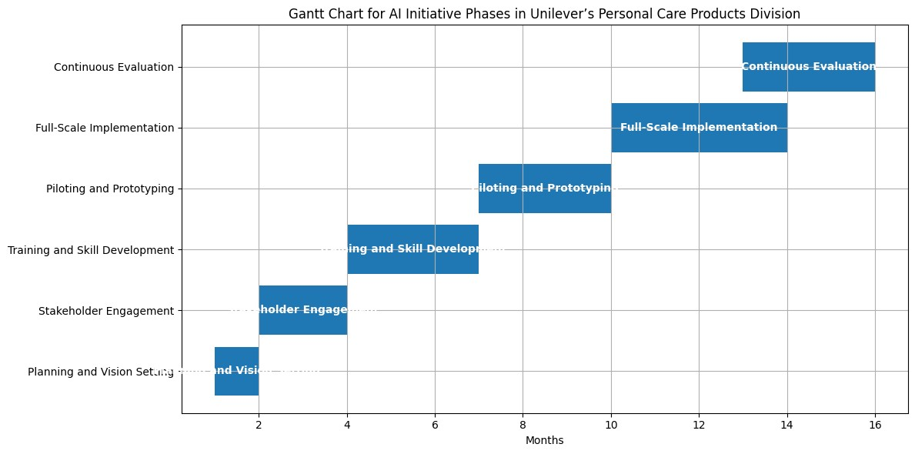
Figure

4:

Gannt

chart;

Source

(
Author,

2024)
Table 3 - The Project Risk Management Plan Matrix
Risk Event | Likelihood | Impact | Risk  Level | Mitigation Strategy

Data Privacy  Concerns | High | High | High | Implement robust data encryption protocols; Obtain explicit consent from customers for data usage; Regular audits and compliance checks
Regulatory  Compliance Issues | Medium | High | High | Collaborate closely with legal and regulatory teams; Stay updated with evolving regulations; Conduct thorough compliance assessments
Technology  Integration  Challenges | High | Medium | High | Conduct extensive testing and quality assurance before full implementation; Provide comprehensive training and support for employees; Have backup systems in place
Customer  Resistance to AI  Technology | Medium | Medium | Medium | Educate customers about the benefits of AI-driven personalization; Offer transparent communication about data usage; Provide exceptional customer support
Data Security  Breaches | Medium | High | High | Implement multi-layered cybersecurity measures; Regularly update security protocols; Develop incident response plans for quick and effective resolution
Lack of  Cross-Functional  Collaboration | Medium | Medium | Medium | Establish clear communication channels between departments; Encourage teamwork and collaboration through incentivization and recognition programs
AI Algorithm Bias | Medium | High | High | Implement bias detection and mitigation techniques in AI algorithms; Regularly audit algorithms for fairness and accuracy; Ensure diverse representation
 |  |  |  | in AI development teams
Resistance from  Traditional Product  Lines | Low | High | Medium | Provide incentives for transitioning to AI-driven products; Communicate the benefits of innovation and market competitiveness; Offer training and support for product teams
Overall, the risk management plan functions as a proactive defence against complications that may arise during the launch of Unilever's Artificial Intelligence (AI) inspired personal care products. Significantly, the process of uncovering potential risks, mitigating them proactively, and promoting collaborations across functions will make Unilever well-suited for managing challenges flexibly, which, in turn, will help to maintain the company as an innovation and sustainability leader in the personal care sector. The following plan for Unilever's personal care product division's AI-driven successful product strategy implementation is an ongoing mission to deliver that potential. (Hu, 2023). Thus, through full-scope market research and data analysis, Unilever can obtain useful information on consumer preferences to make properly targeted product formulas. Cooperation with AI experts is possible for algorithms designed to read consumer data to afford more customized suggestions, cooperation with AI experts is possible, and that effectively leads to better customer journeys. AI-supported recommendation systems located in both e-commerce sites and mobile apps are combined with chatbots for customer service so that Unilever can deliver personalized encounters and product suggestions to its customers (Candelon & Reeve, 2022). Furthermore, using machine learning methods gives us a robust and dynamic way of changing products based on consumers’ feedback and provides a basis for ultimate product improvement and relevancy. The involvement of major hubs, for instance, marketing, product development, IT, and customer service teams, streamlines cross-functional collaboration and makes AI-driven processes well-integrated (Aldoseri, Al-Khalifa, and Hamouda, 2023). Strategies like training programs and pilot testing of the new protocols help to have a smooth shift and mitigate the obstacles to fast change.
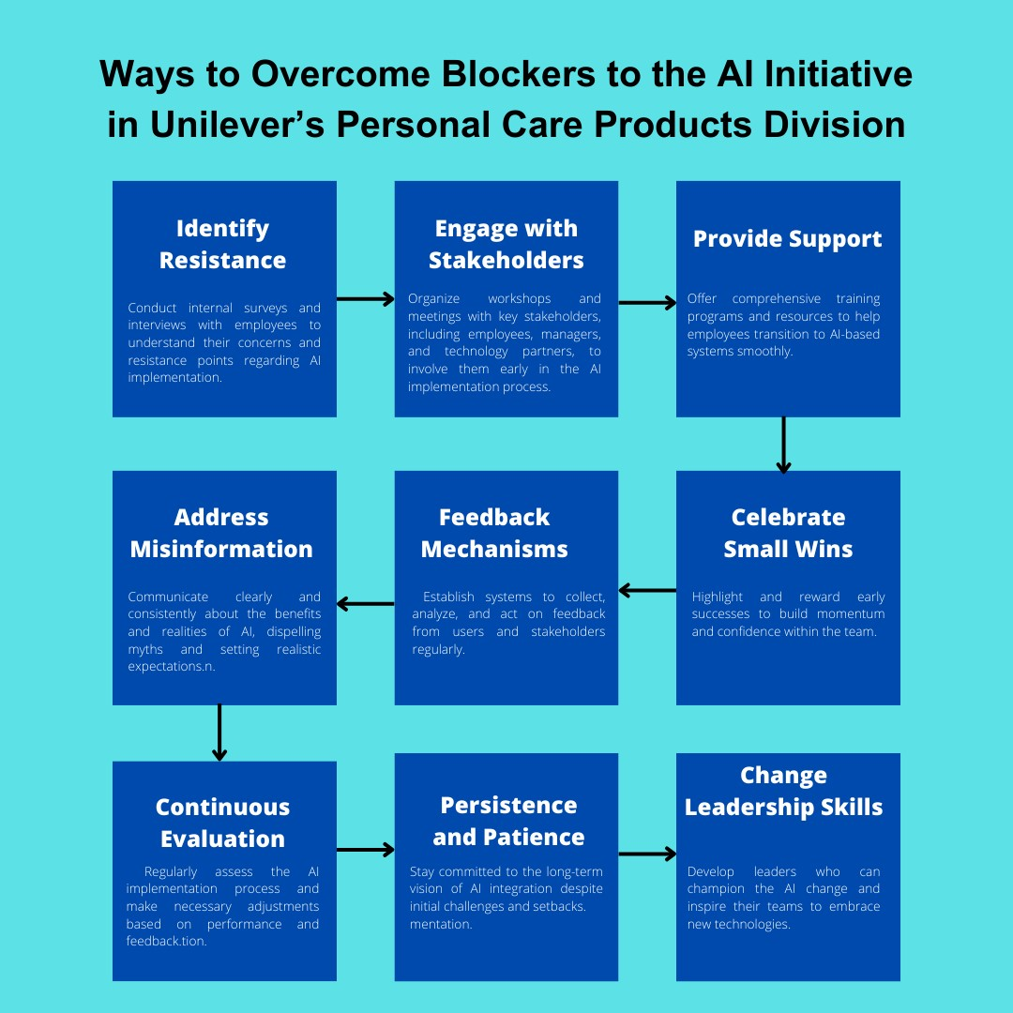
Figure 5: Ways to overcome blockers to the A.I. initiative; Source: (Author, 2024)
Addressing obstacles in AI implementation at Unilever is crucial for innovation strategy. This involves creating a supportive environment, addressing misinformation, utilizing feedback mechanisms, achieving small victories, fostering morale, and enhancing change leadership capabilities. These strategies improve AI applications in organizations and boost relevancy in the job market.
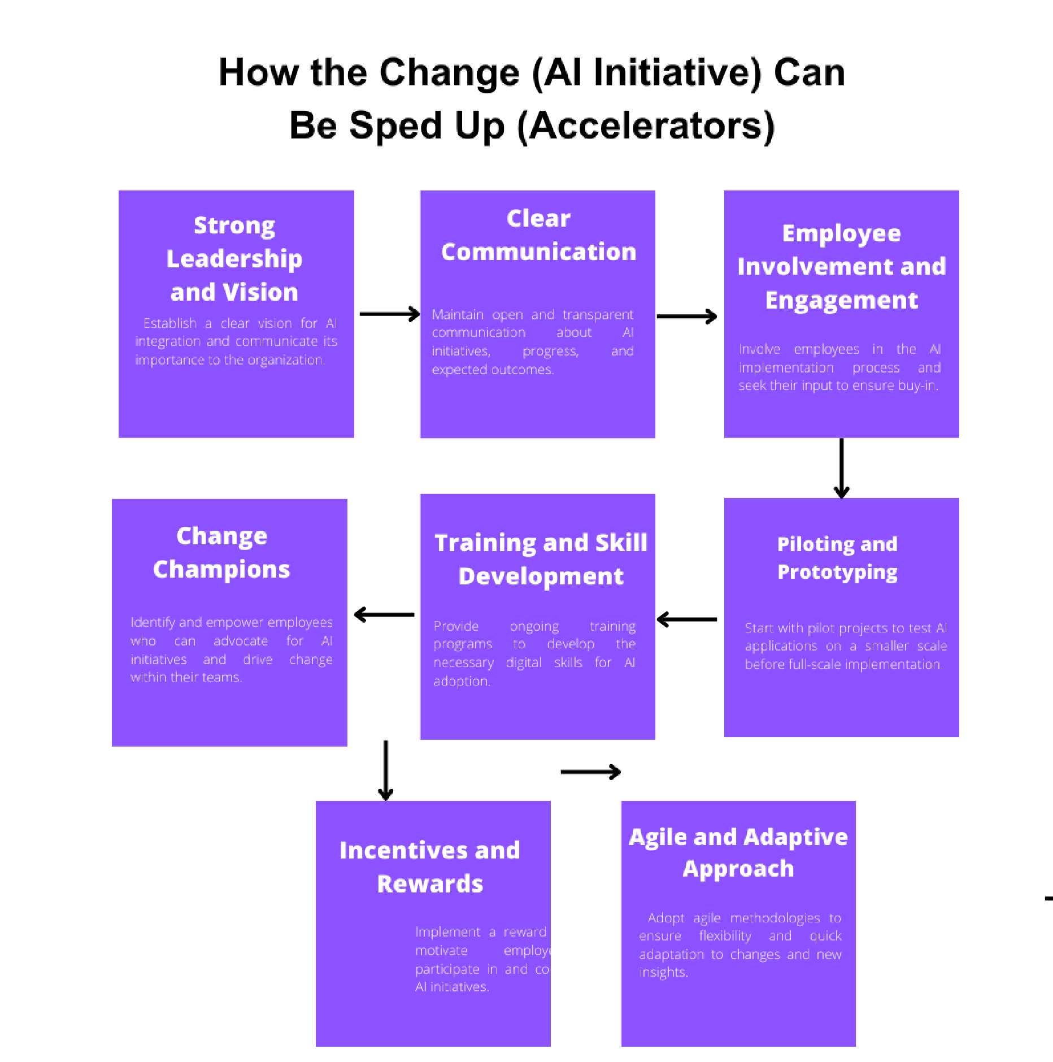
Figure 6: How the change (AI Initiative) can be sped up (Accelerators); Source: (Author, 2024)
Accelerating AI initiatives is crucial for Unilever to stay competitive in the rapidly evolving digital landscape (Figure 5). Political support guides leadership, while training and rewards motivate employees. Engaging staff in agile processes promotes flexibility. Piloting projects improve AI efficiency and boost employability.

4. Evaluation of Personal Digital Capabilities
In today's digital age, personal digital capabilities are crucial for individuals involved in innovation management. Using the JISC tool (Kiflei, 2020), I conducted a self-assessment of my digital capabilities across different areas such as digital communication, information and media literacy, digital creation, problem-solving, digital collaboration, and digital learning (detailed assessment is attached in Appendix 1). This assessment provided a comprehensive overview of my strengths and areas needing development in the context of digital innovation management.

4.1. SWOT Analysis of Personal Digital Capabilities
Table 4 - SWOT Analysis of Personal Digital Capabilities
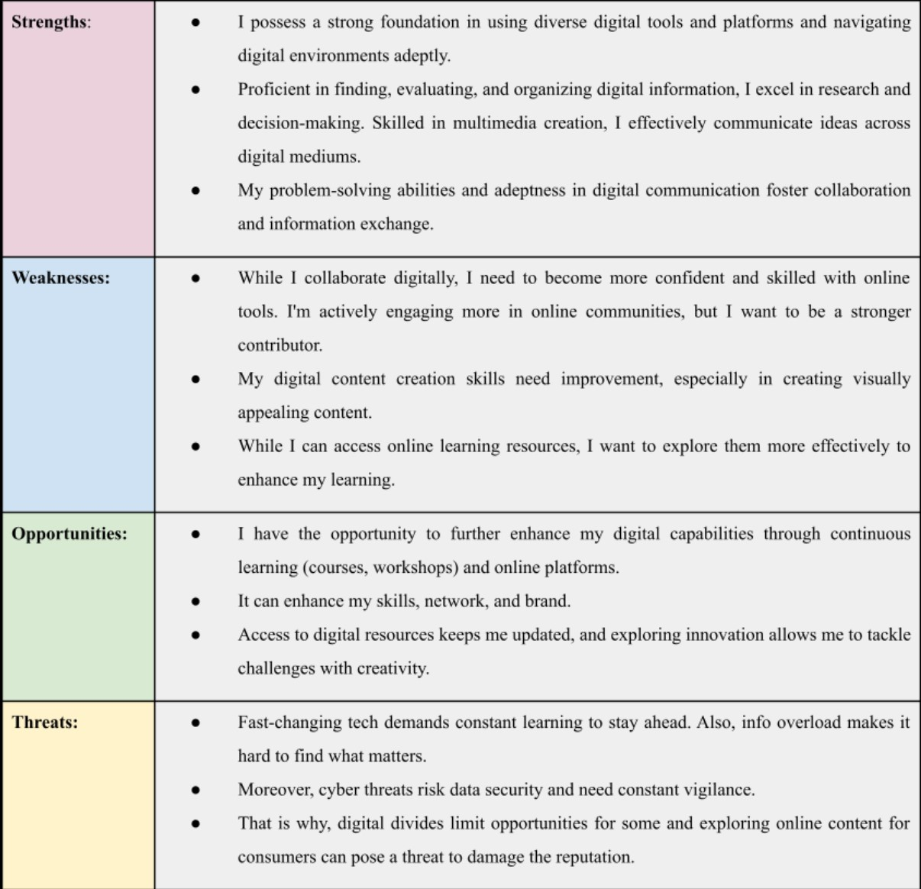

4.2. Personal Digital Skills Goals Utilizing S.M.A.R.T. action plan
At Unilever, robust digital skills are crucial for competitiveness and innovation. Employees with strong digital capabilities navigate market changes, utilize technology for product enhancement, and engage consumers effectively. These skills drive Unilever's digital transformation, fueling business growth. Enhancing digital abilities is key to employability and personal success within Unilever. Thus, I've developed S.M.A.R.T. goals (Syahid, Hernawan, and Dewi, 2023) & action plans to enhance my digital skills and ensure relevance in the company.

Objective | Specific  Actions | Measurable  Goals | Achievable  Steps | Relevant Resources | Time frame
Enhance  Digital  Proficiency | Enroll in  online  courses on  relevant digital tools. | Achieve a  score of 90% on proficiency tests. | Complete at least 3 courses within the next 6 months. | Online learning platforms (e.g., Coursera, Udemy) Digital devices and applications | 6 months
Develop  Digital  Productivity  Skills | Research and adopt time-saving productivity apps. | Increase efficiency by 15%. | Implement 3 new apps within the next 3 months. | Online productivity tools and tutorials Digital organization tools (e.g., Trello,  Evernote) | 3 month
Improve  Information  Literacy | Explore information literacy frameworks. | Familiarize  with key concepts. | Complete reading of 2 frameworks  within 2 weeks. | Online resources and academic journals Collaborative  platforms (e.g.,  Wikipedia) | 3 month
Improve  Digital  Communicat ion | Engage in  online discussions with industry experts. | Contribute to  5 discussions. | Participate in 1 discussion per week. | Professional networking platforms (e.g., LinkedIn)  Also, presentation software and public speaking resources | Ongoing
Foster  Digital Collaboratio n | Join digital workgroups or projects. | Participate in  2  collaborative projects. | Join 1 session per month. | Collaboration  platforms (e.g.,  Microsoft Teams) Video conferencing tools (e.g., Zoom) | Ongoing
Enhance | Diversify | Try 3 new | Experiment | Digital content | 3 Month
Digital  Creation  Skills | digital content creation methods. | content creation techniques. | with 1 new  technique every month. | creation tools and  tutorials  Coding platforms and programming resources
Enhancing digital skills through BCG training and other activities supports innovation at Unilever (Appendix 2). SMART goals focus on improving digital literacy, collaboration, information literacy, and media creation. To develop further, I will take advanced courses, attend webinars, and explore various digital tools. These improvements are crucial for enhancing innovation at Unilever and my career prospects.

Conclusion
In a nutshell, all this suggests that Innovation management in Unilever’s Personal Care division in the digital world is a source of continuous product creation and capturing the markets. Through examining market trends, consumer reviews, and optimizing digital capabilities, Unilever can tactfully occupy a position to deal with today's aggressive industry transformations alongside social support to the industry (Zhan et al., 2024). The introduction of Jobs To Be Done (JTBD) and customer personas - for instance Emily Green, Alex Rivera, and Lily Chang - highlight the need to engage in innovation processes that do not only consider customer preferences but also take into account the value system of the consumers. Also, surveys and customers suggest a rising trend of preference for green, natural, and personalized products, hence, this presents a good opportunity for innovation in the company's Personal Care division. Sustainable packaging, individualized design store lines, and digital presence upgrades stand out as vital aspects for maximizing performance.
Moreover, the PESTLE analysis highlights the external factors of Unilever's market like political and economic processes as well as social trends and technological progress that impact the environment.

References
Aldoseri, A., Al-Khalifa, K. and Hamouda, A. (2023) A Roadmap for Integrating Automation with Process Optimization for AI-powered Digital Transformation, Preprints.org. Available at: https://doi.org/10.20944/preprints202310.1055.v1.
Anitah, J. et al. (2019) ‘Industry 4.0 Technologies And Operational Performance Of Unilever
Kenya And L’oreal East Africa’, Noble International Journal of Business and Management Research ISSN, 03(10), pp. 125–134. Available at: https://napublisher.org/pdf-files/NIJBMR-3(10)-125-134.pdf.
Babar, I.N. (2024) The Great Green shift: The world moves towards a sustainable future, The Business Standard. Available at:
https://www.tbsnews.net/economy/industry/great-green-shift-world-moves-towards-sustainable-f uture-767670#:~:text=Key%20Statistics&text=78%25%20of%20consumers%20feel%20that%2
0sustainability%20is%20important.&text=55%25%20of%20consumers%20are%20willing (Accessed: 30 March 2024).
Barden, P. (2022) Decoded: The Science Behind Why We Buy, Google Books. John Wiley & Sons.
Candelon, F. and Reeves, M. (2022) The Rise of AI-Powered Companies, Google Books. Walter de Gruyter GmbH & Co KG..
Chandra, R. and Jatmika, S. (2022) Unilever Unilever Surabaya Corporate Social Responsibility
(Csr) Policy in Maintaining Environmental Sustainability in Surabaya in 2014-2020, www.atlantis-press.com. Atlantis Press. Available at: https://doi.org/10.2991/aebmr.k.220209.057.
Chen, L., Lee, H.L. and Tang, C.S. (2022) ‘Supply chain fairness’, Production and Operations Management, 31(12). Available at: https://doi.org/10.1111/poms.13849.
Cheng, Y. (2021) Analysis on the Opportunities and Challenges of Unilever’s Differentiated Competition by Using SWOT and PEST, www.atlantis-press.com. Atlantis Press. Available at: https://doi.org/10.2991/aebmr.k.210210.044.
Cooper, R. (2023) The Artificial Intelligence Revolution in New-Product Development | IEEE Journals & Magazine | IEEE Xplore, ieeexplore.ieee.org. Available at: https://ieeexplore.ieee.org/abstract/document/10330569/.
Cote, C. (2022) Sustaining vs. Disruptive Innovation: What’s the Difference?, Harvard Business
School Online. Available at: https://online.hbs.edu/blog/post/sustaining-vs-disruptive-innovation.
Hu, Q. (2023) ‘Unilever‘s Practice on AI-based Recruitment’, Highlights in Business, Economics and Management, 16(2), pp. 256–263. Available at: https://doi.org/10.54097/hbem.v16i.10565.
Hu, Y. and Zeng, Y. (2024) ‘Achieving Sustainable Operations: Challenges, Countermeasures, and the Case of Unilever’, SHS Web of Conferences, 181, p. 01036. Available at: https://doi.org/10.1051/shsconf/202418101036.
Kiflei, S. (2020) Digital skills in university students : a self-guided online tool on improving students’ digital skills : an exploratory feasibility study, essay.utwente.nl. Available at: http://essay.utwente.nl/82523/ (Accessed: 30 March 2024).
Langhe, B.D. and Puntoni, S. (2024) Decision-Driven Analytics: Leveraging Human Intelligence to Unlock the Power of Data, Google Books. University of Pennsylvania Press.
Luigi, B., Candidate, Y. and Shiqian (2021) Economic Analysis of the FMCG Industry In China (Fast Moving Consumer Goods). Available at: https://webthesis.biblio.polito.it/secure/17759/1/tesi.pdf.
Malviya, S. (2015) ‘Unilever’s shampoo brand Tresemme overtakes P&G’s Pantene in market share in modern trade’, The Economic Times, 18 March. Available at:
https://m.economictimes.com/industry/cons-products/fmcg/unilevers-shampoo-brand-tresemmeovertakes-pgs-pantene-in-market-share-in-modern-trade/articleshow/46602979.cms (Accessed:
30 March 2024).
Murphy, P.E. and Murphy, C.E. (2017) ‘Sustainable Living: Unilever’, Progressive Business Models, pp. 263–286. Available at: https://doi.org/10.1007/978-3-319-58804-9_12.
Naidu, R. (2022) ‘Analysis: Unilever leads pack on price rises as consumer goods industry squeezed’, Reuters, 14 November. Available at:
https://www.reuters.com/business/retail-consumer/unilever-leads-pack-price-rises-consumer-goo ds-industry-squeezed-2022-11-14/.
Patel, K.R. (2023) ‘Harmonizing Sustainability, Functionality, and Cost: Navigating Responsible
Packaging Innovations in Modern Supply Chains’, American Journal of Economic and Management Business (AJEMB), 2(8), pp. 287–300. Available at: https://doi.org/10.58631/ajemb.v2i8.51.
Shaoping, L. (2023) ‘Unilever Global Sourcing and Purchasing Strategies: A Case Study of
Trade and Logistics between the EU and UK Post-Brexit’, Industrial Engineering and Innovation Management, 6(10), pp. 124–131. Available at: https://doi.org/10.23977/ieim.2023.061016.
Statista (2023a) Beauty & Personal Care - Worldwide | Statista Market Forecast, Statista.
Available at: https://www.statista.com/outlook/cmo/beauty-personal-care/worldwide.
Statista (2023b) Dove: brand value worldwide 2016-2019, Statista. Available at: https://www.statista.com/statistics/1010915/dove-brand-value-worldwide/.
Swapna (2022) Eco-friendly Packaging Market Size Anticipated to Attain USD 430.38 Billion by 2032, www.towardspackaging.com. Available at:
https://www.towardspackaging.com/insights/creating-good-packaging-for-eco-friendly-packagin g.
Syahid, A.A., Hernawan, A.H. and Dewi, L. (2023) ‘SMART for the Improvement of Primary
School Teachers’ Digital Competence in the 21st Century: An Action Research Study’, International Journal of Learning, Teaching and Educational Research, 22(3), pp. 448–469.
Available at: http://ijlter.net/index.php/ijlter/article/view/1568 (Accessed: 30 March 2024).
Unilever (2022) Reuse. Refill. Rethink. Our progress towards a packaging revolution, Unilever. Available at: https://www.unilever.com/reuse-refill-rethink-plastic/.
Unilever (2023a) Beauty & Personal Care Brands, Unilever global company website. Available at: https://www.unilever.com/brands/personal-care/.
Unilever (2023b) Innovation, Unilever Global Company Website. www.unilever.com. Available at: https://www.unilever.com/brands/innovation/.
Unilever (2023c) Unilever at a Glance, Unilever. www.unilever.com. Available at: https://www.unilever.com/our-company/at-a-glance/.
Unilever (2024) Unilever Annual Report and Accounts 2023, www.unilever.com. Available at: https://www.unilever.com/files/92ui5egz/production/b09c3510ee7cec58440d5f044f02bdefe85aa 186.pdf.
Zhan, Y. et al. (2024) ‘The impact of artificial intelligence adoption for business-to-business marketing on shareholder reaction: A social actor perspective’, International Journal of Information Management, p. 102768. Available at: https://doi.org/10.1016/j.ijinfomgt.2024.102768.

Appendix 1 – Beginning Assesssment Jisc | Building digital capability
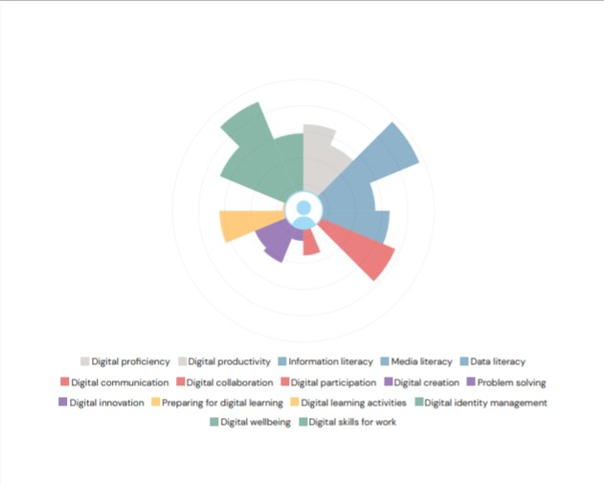

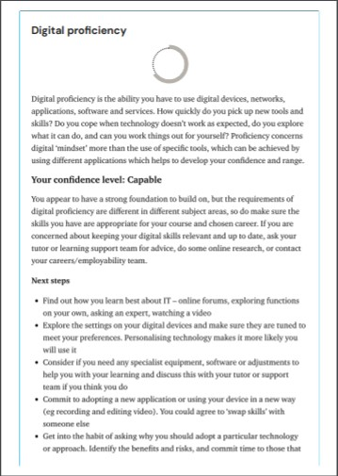
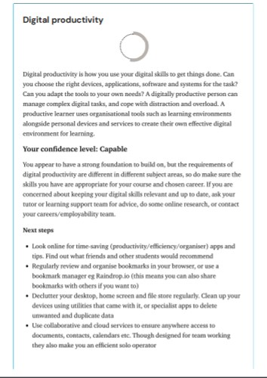
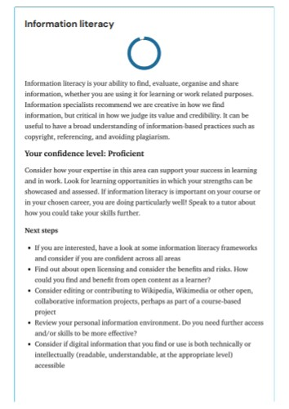
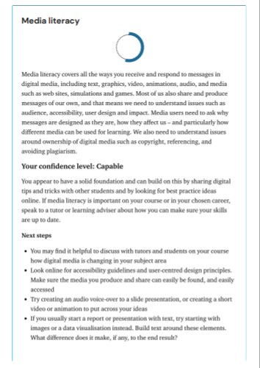
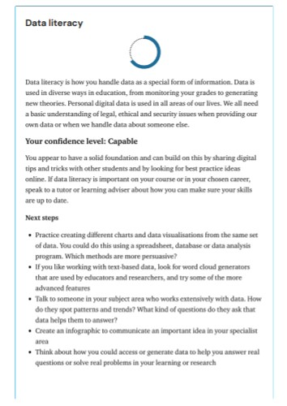
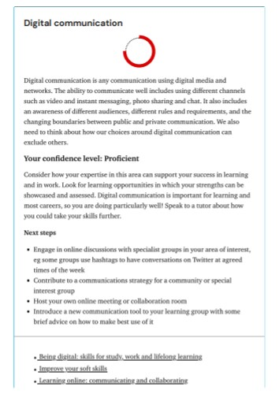
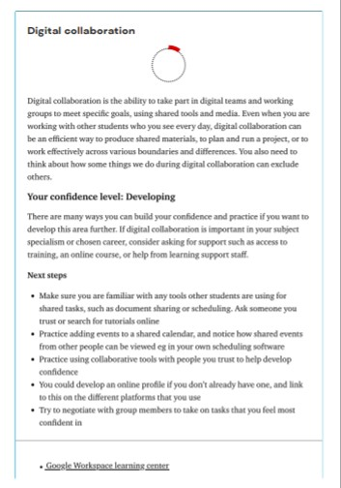
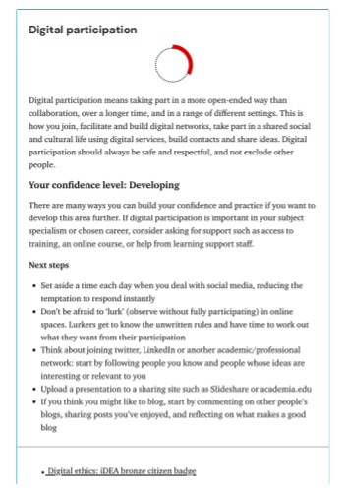
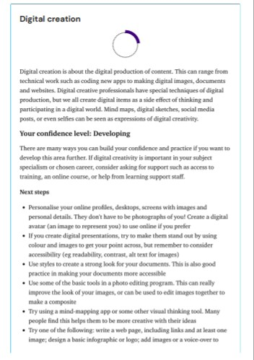
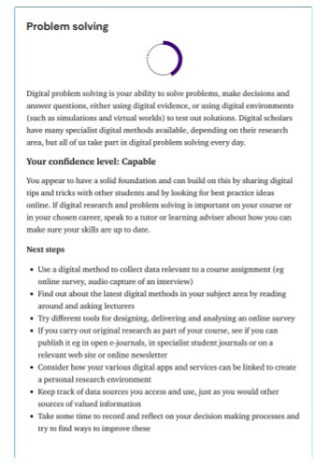
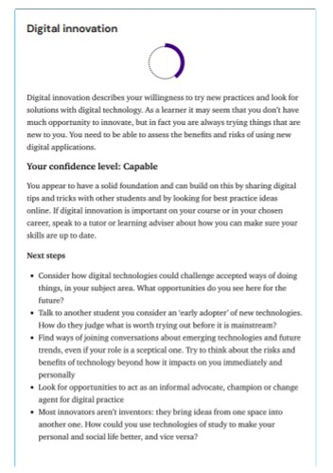
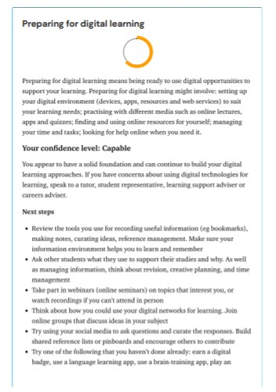
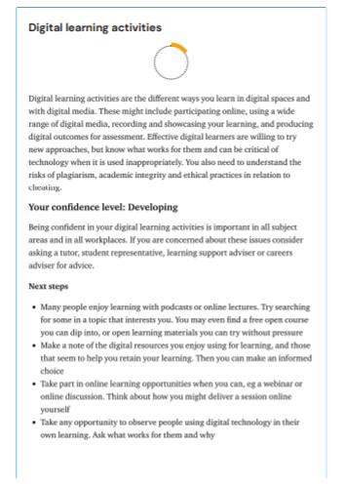
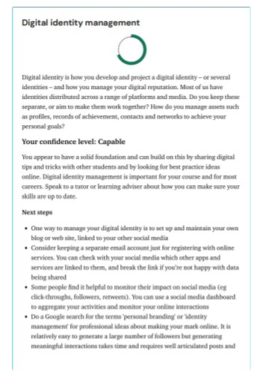
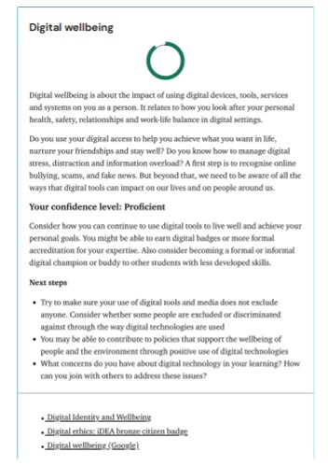
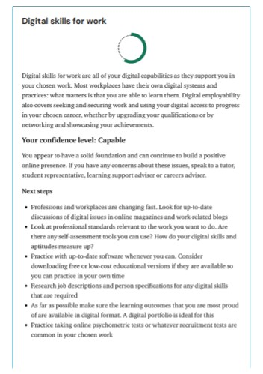

Appendix 2 – End Assessment Jisc | Building digital capability
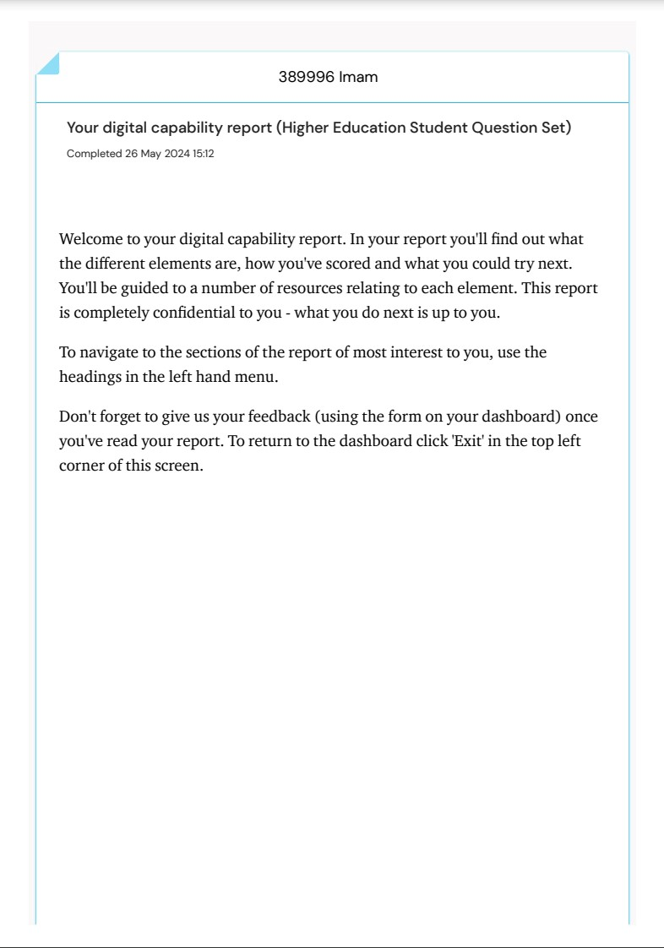

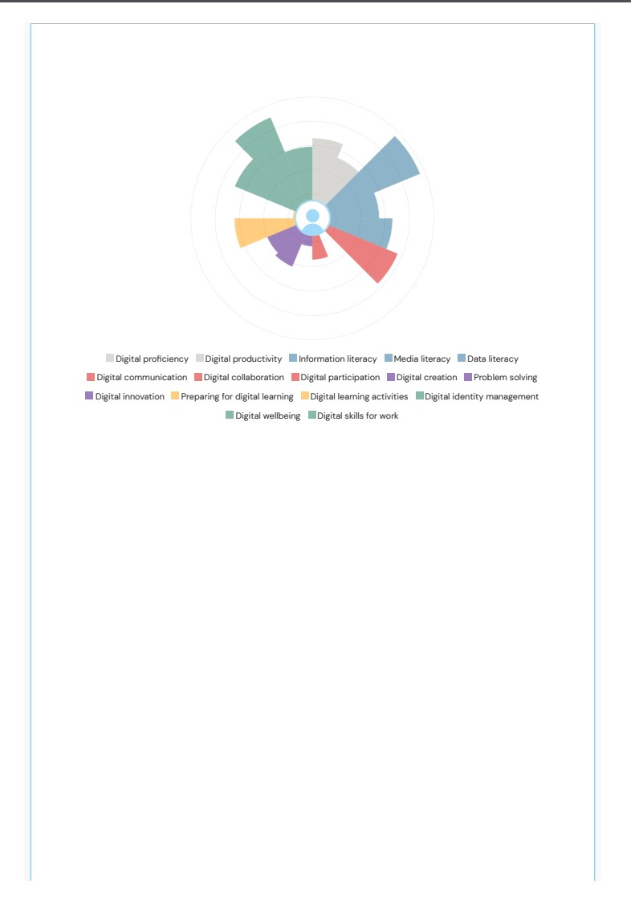
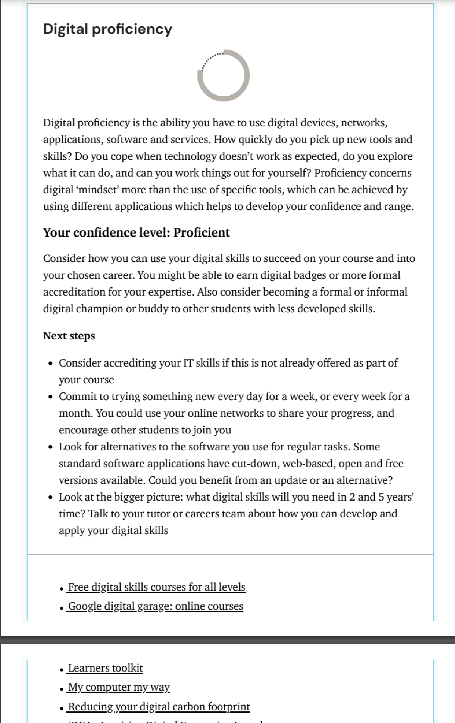
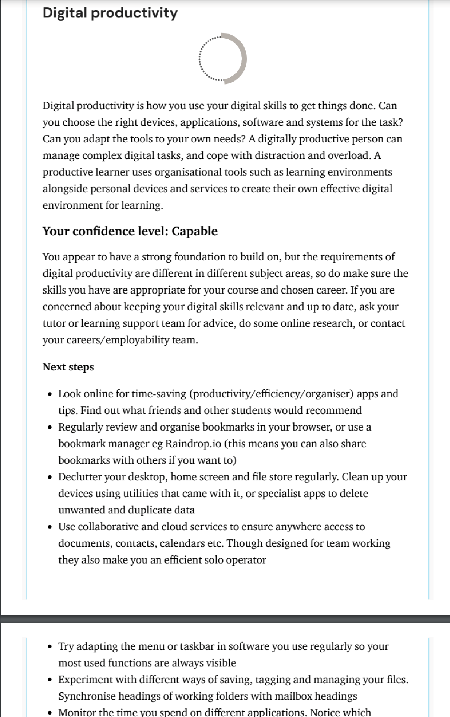
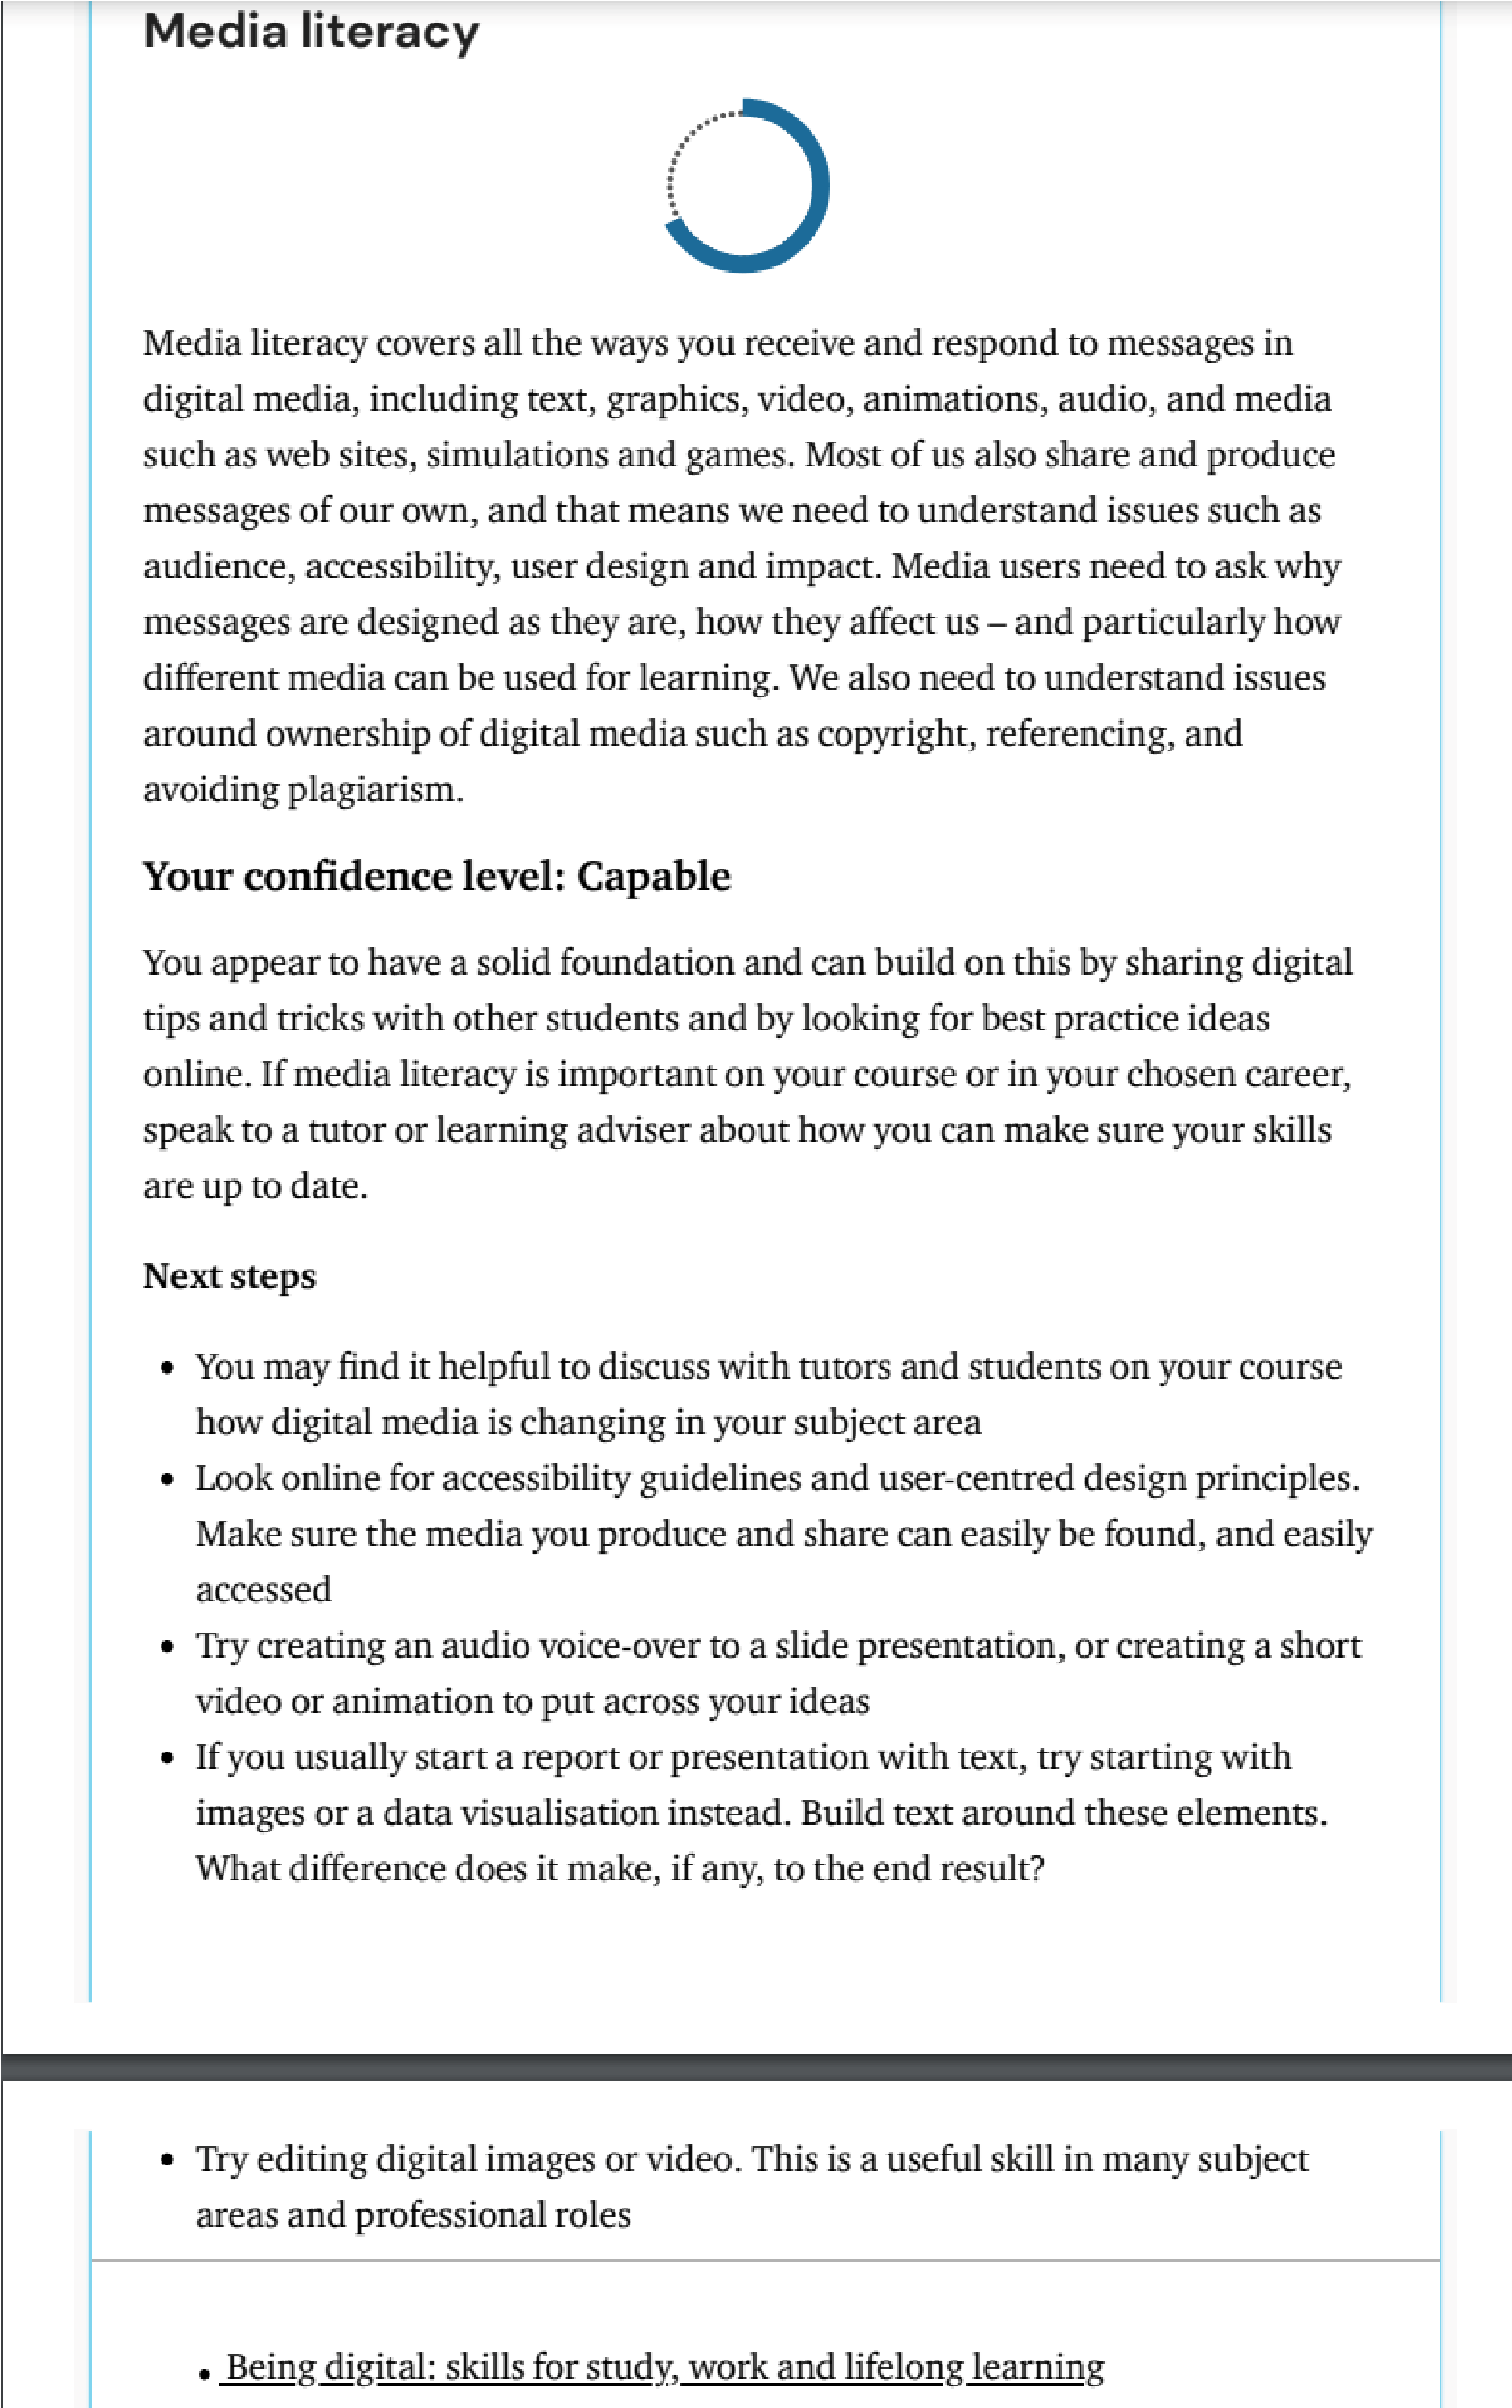
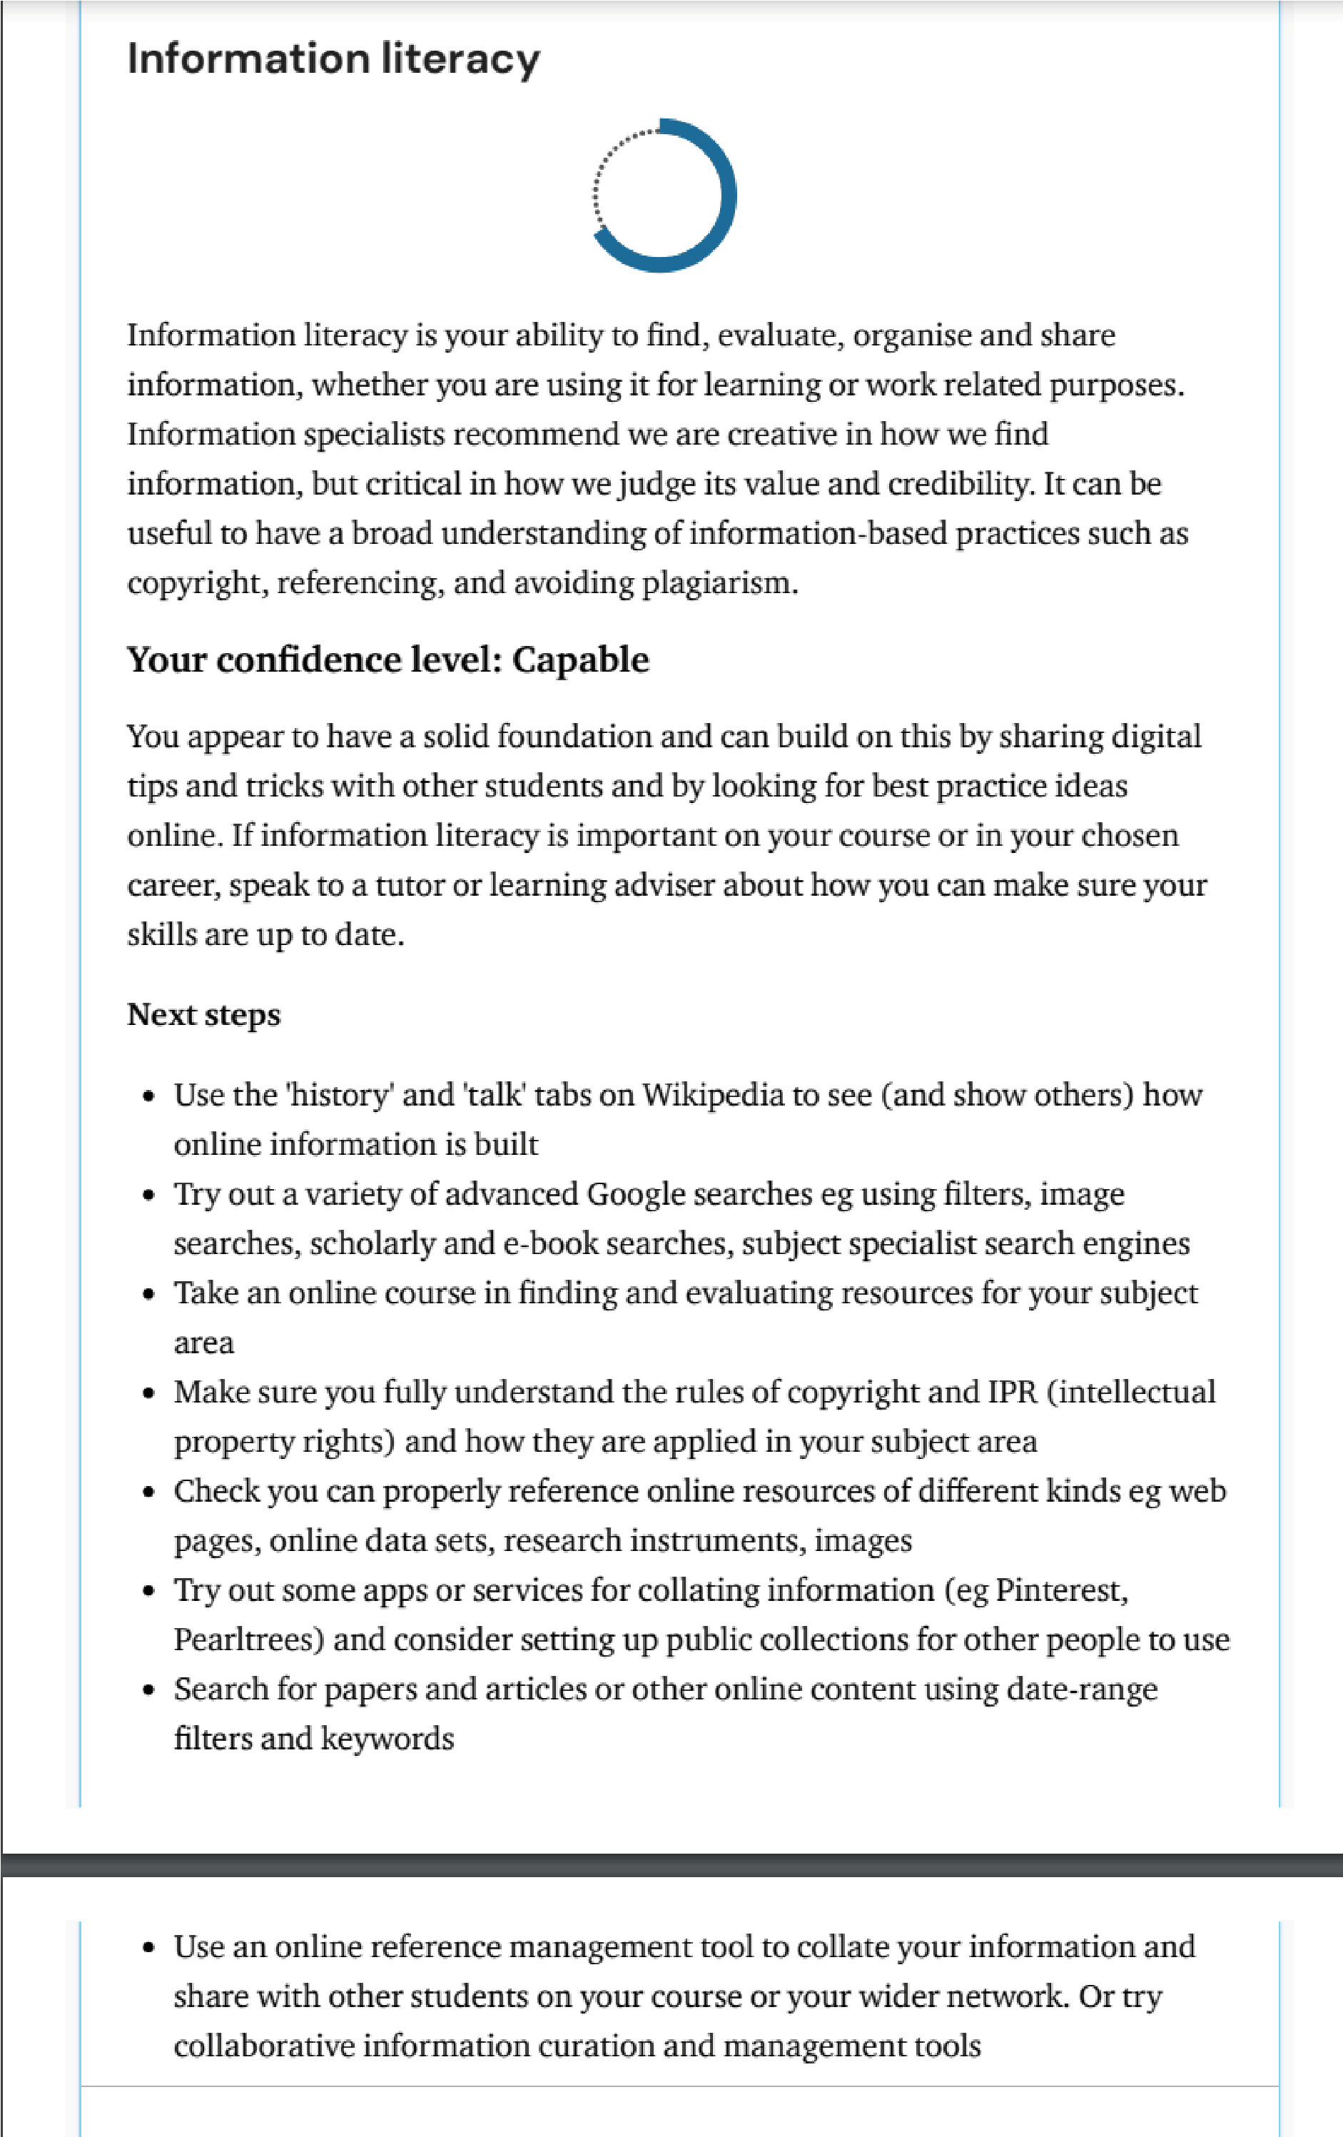
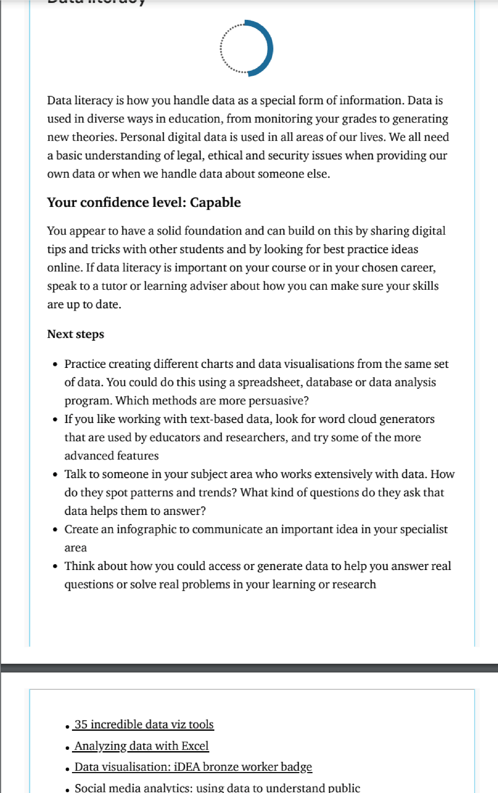
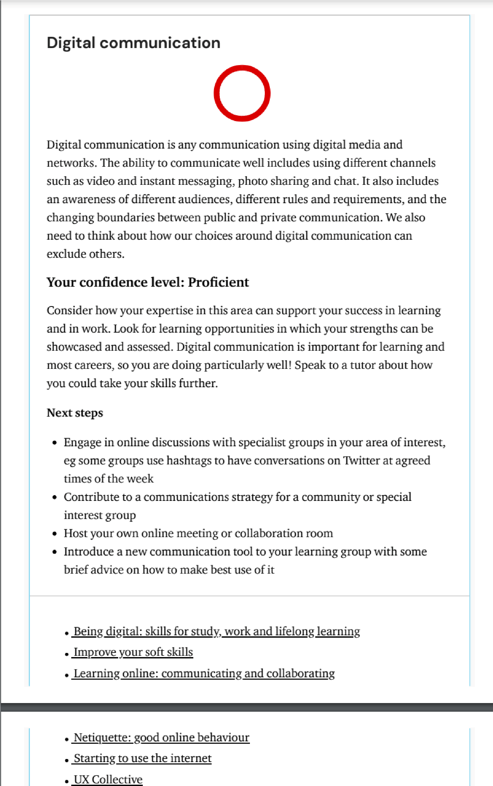
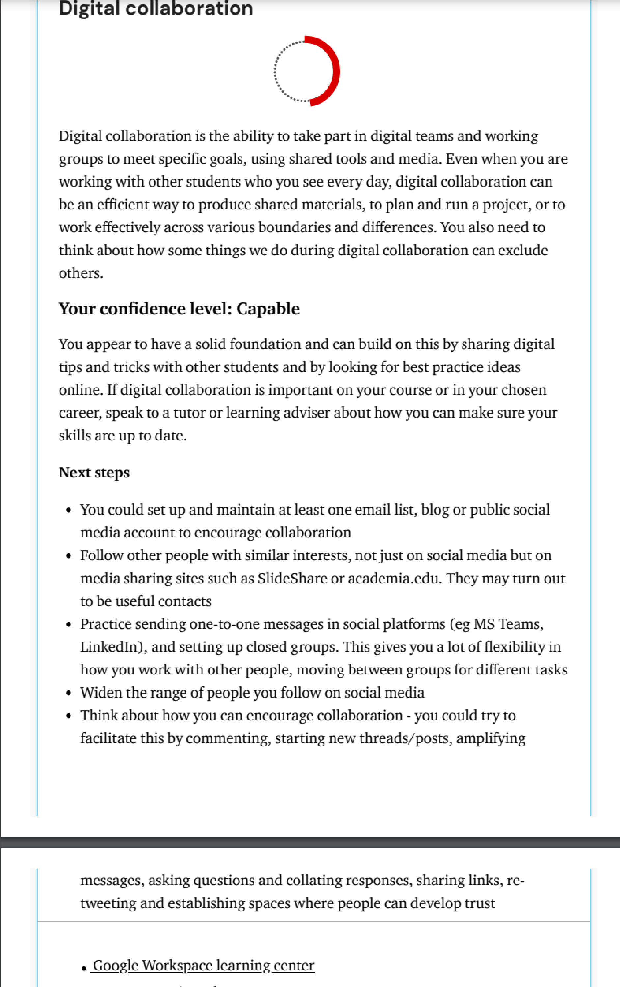
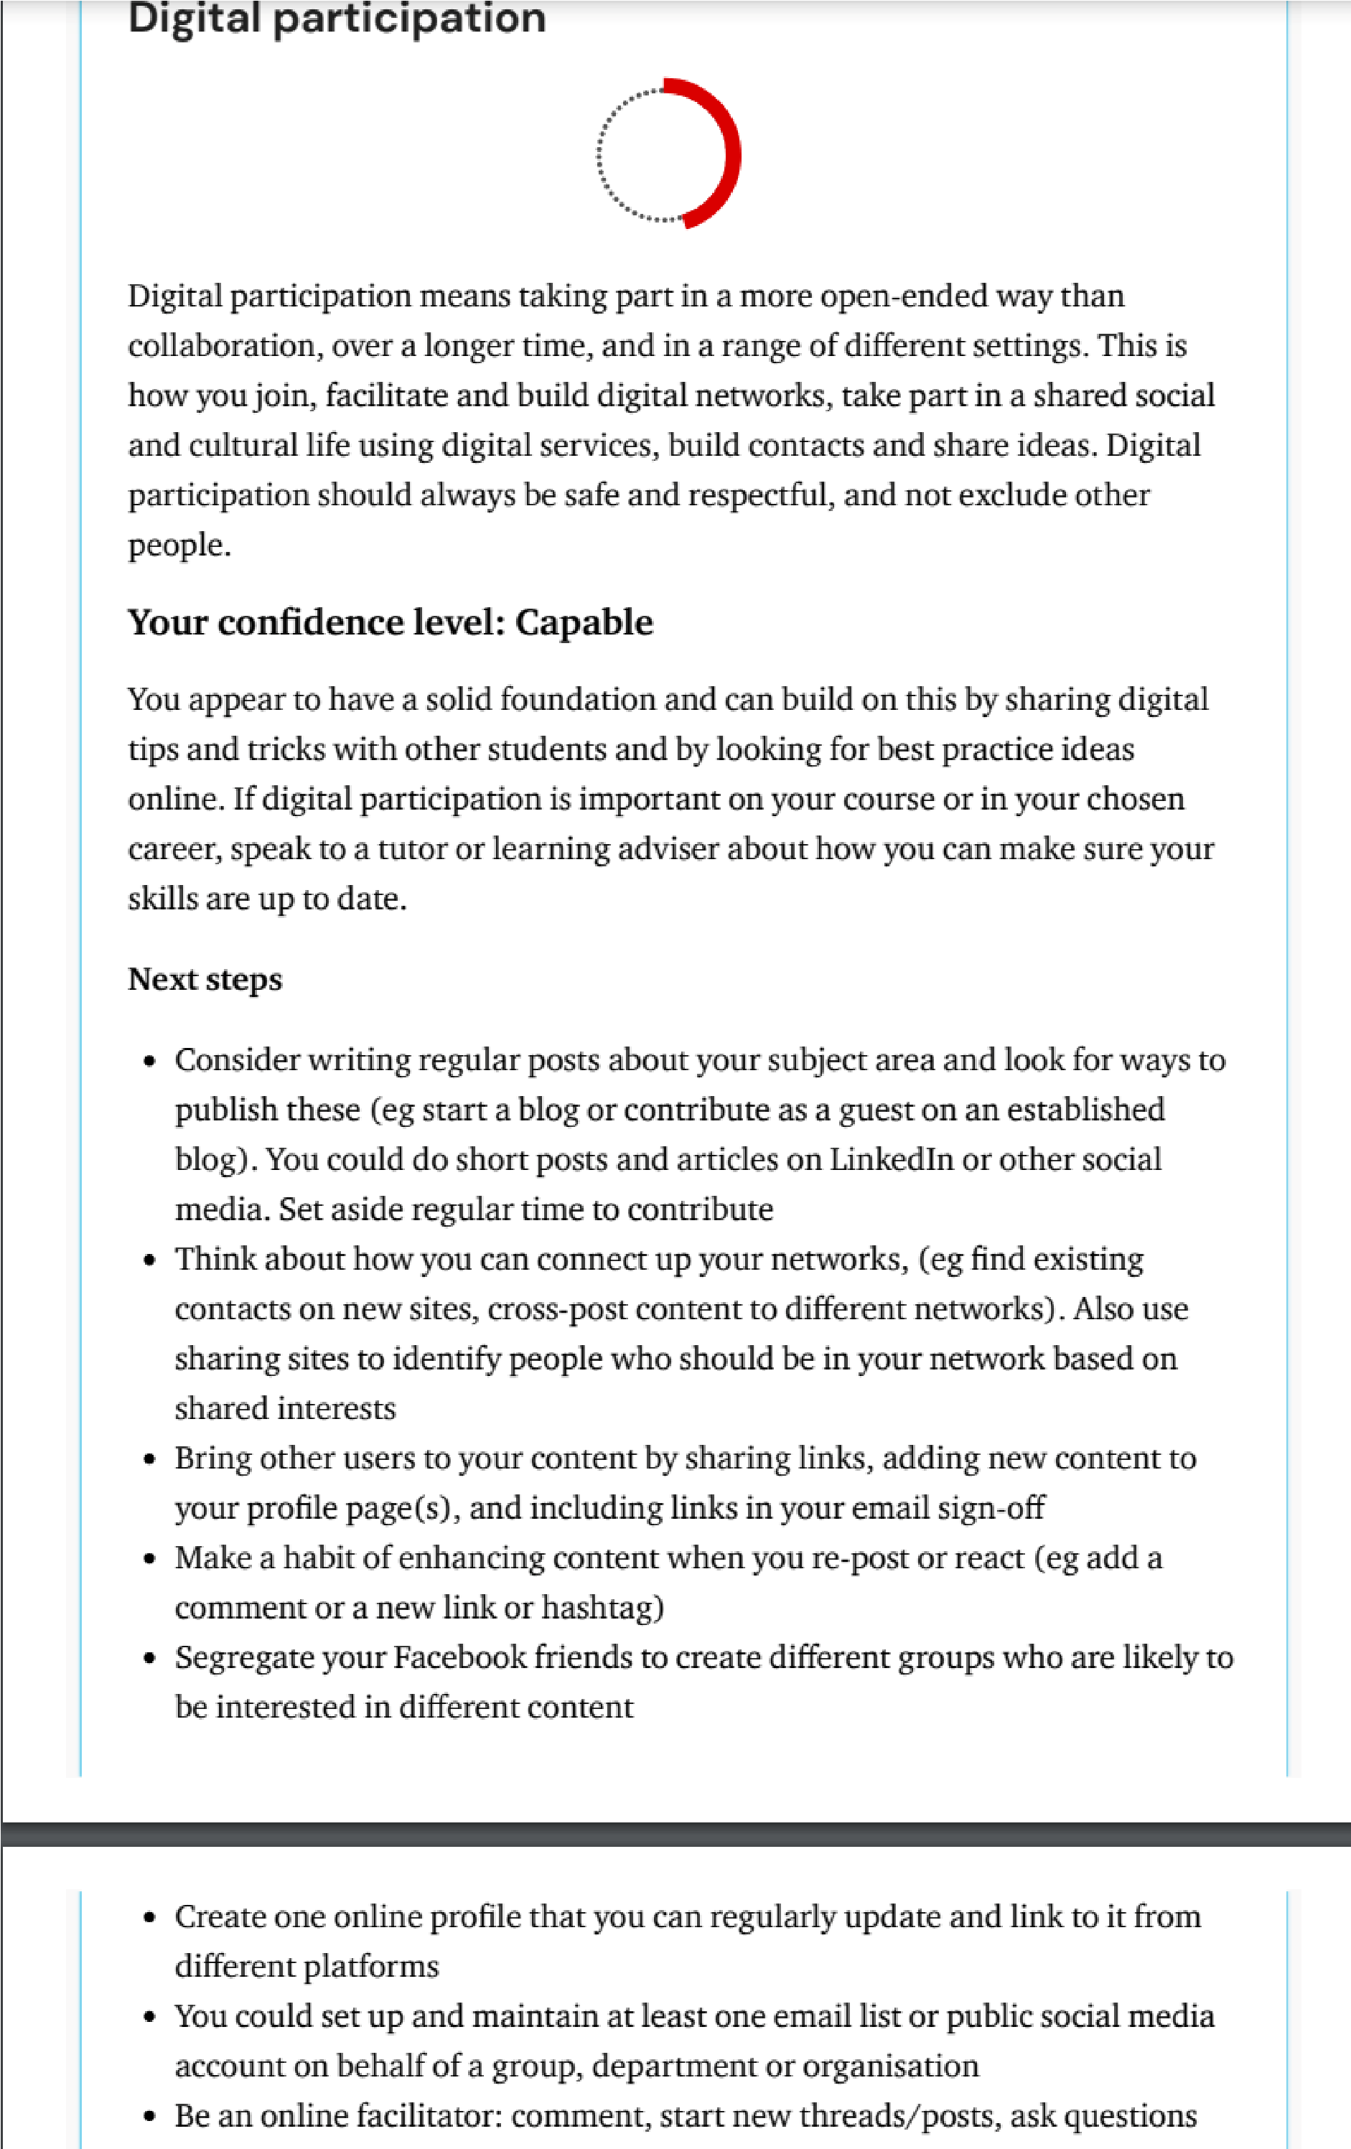
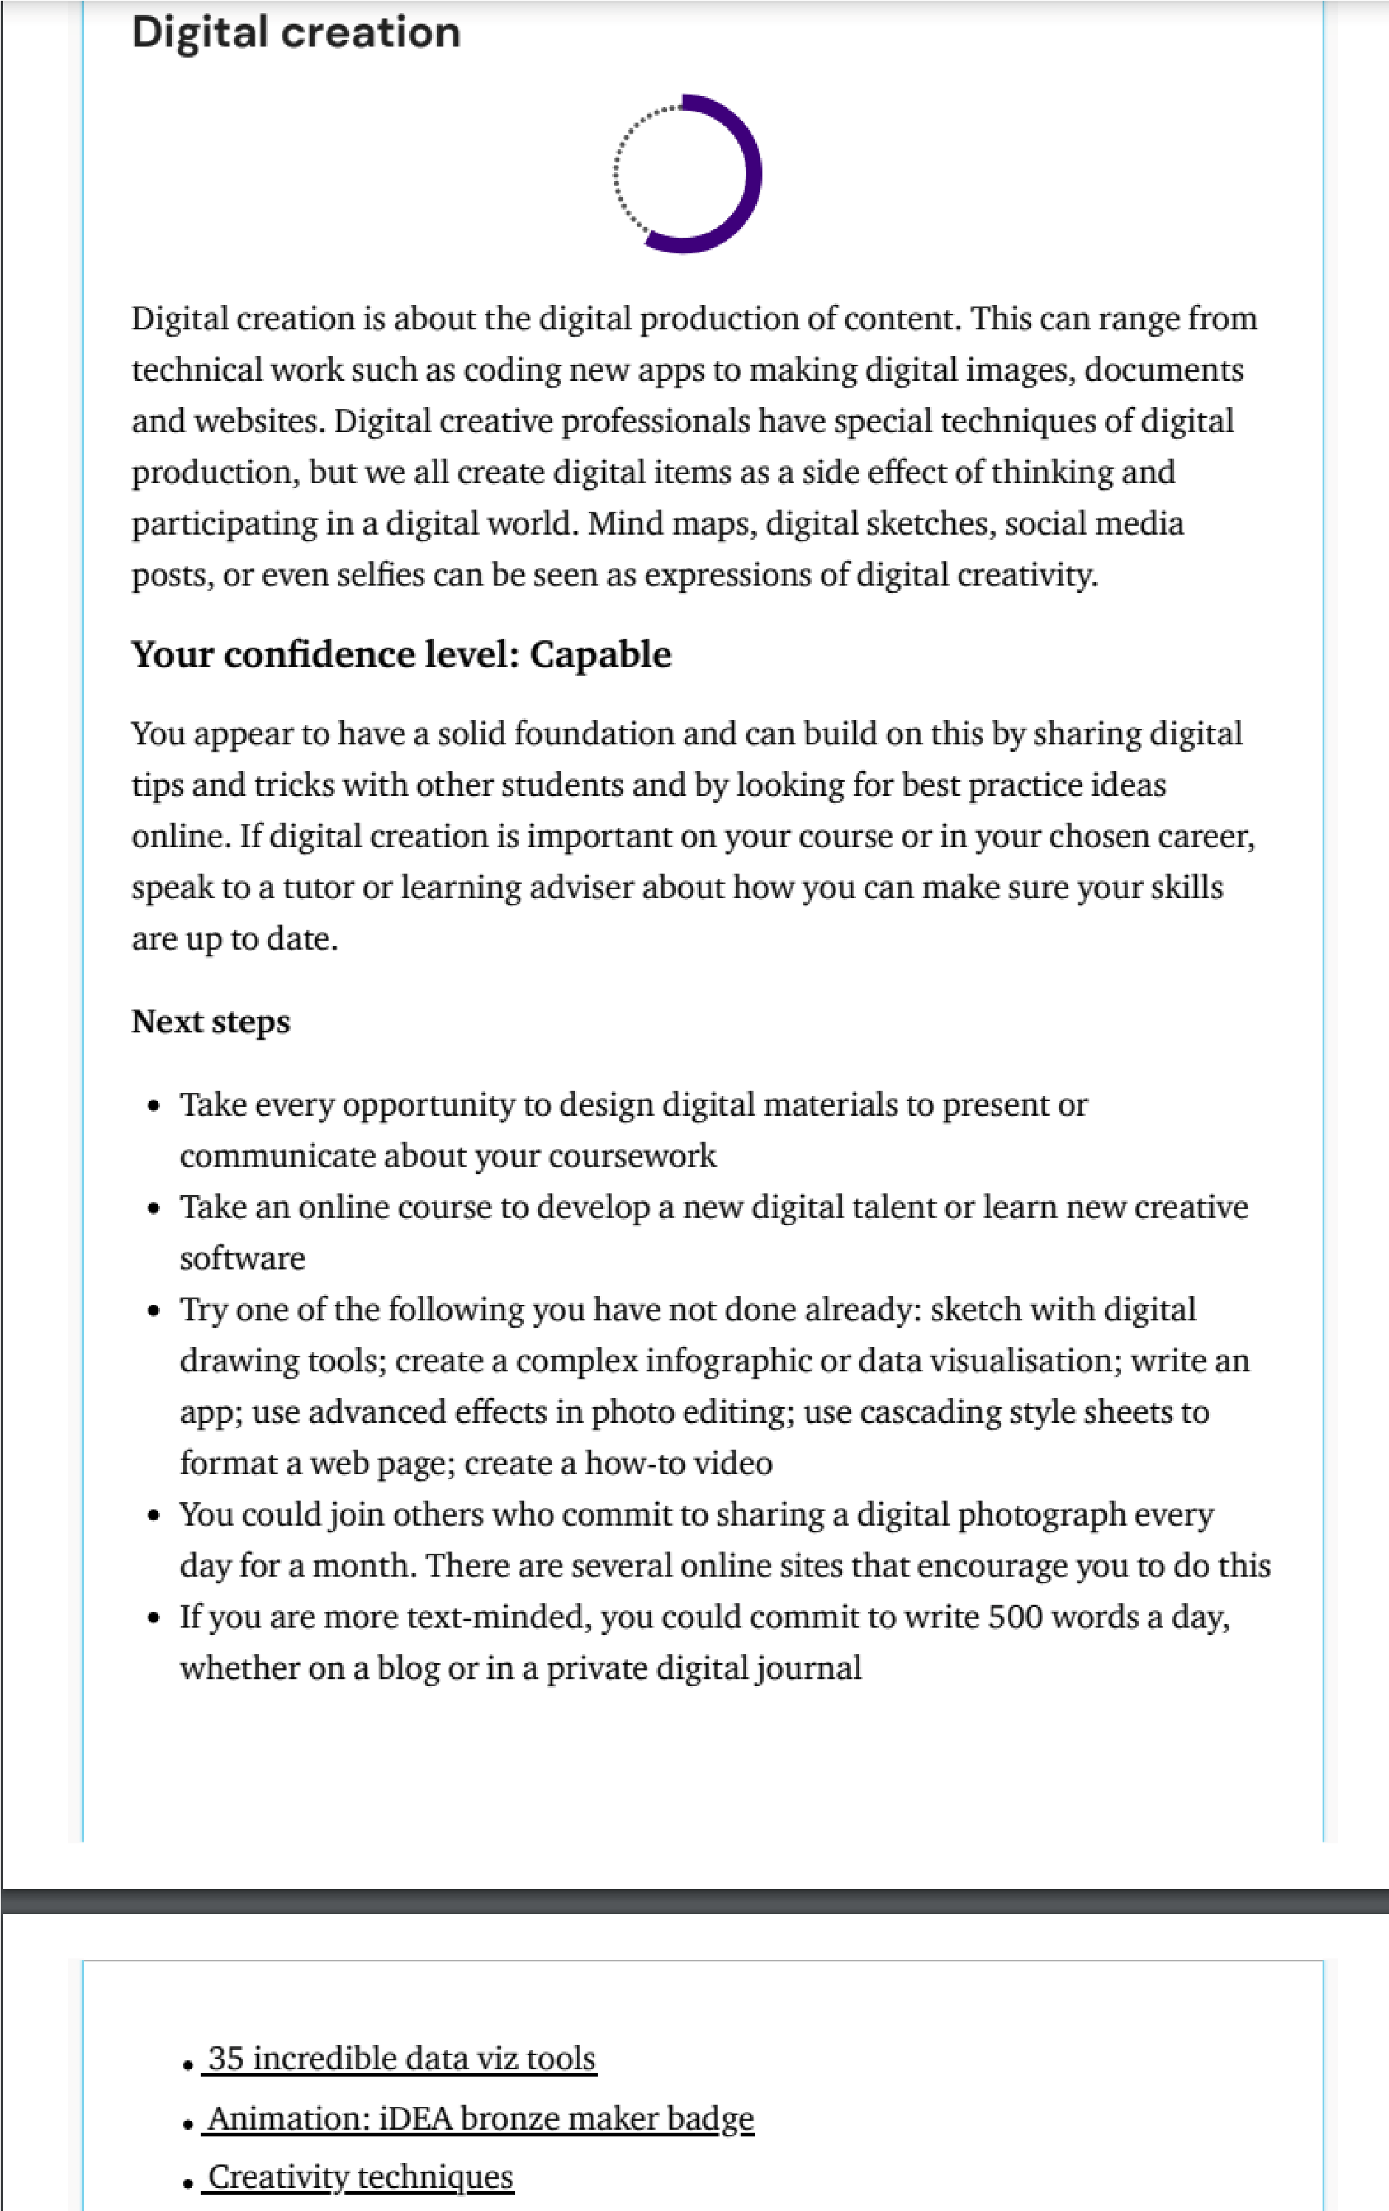
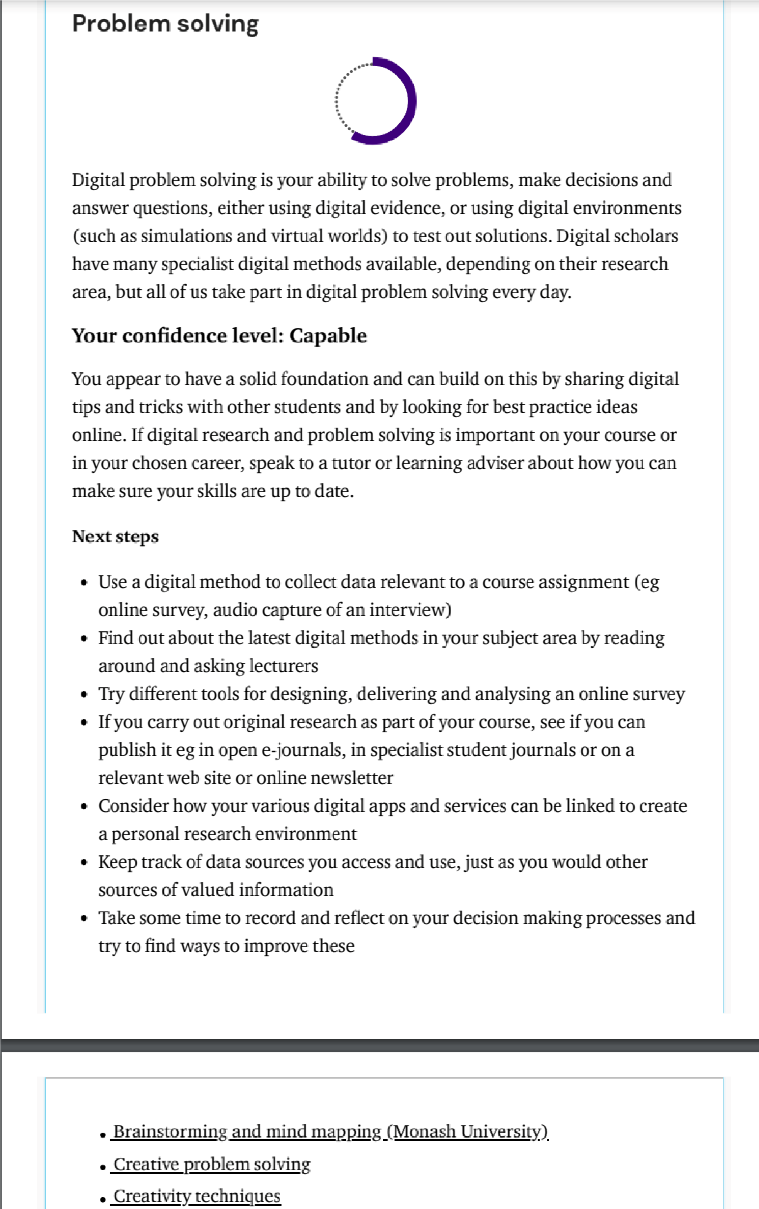
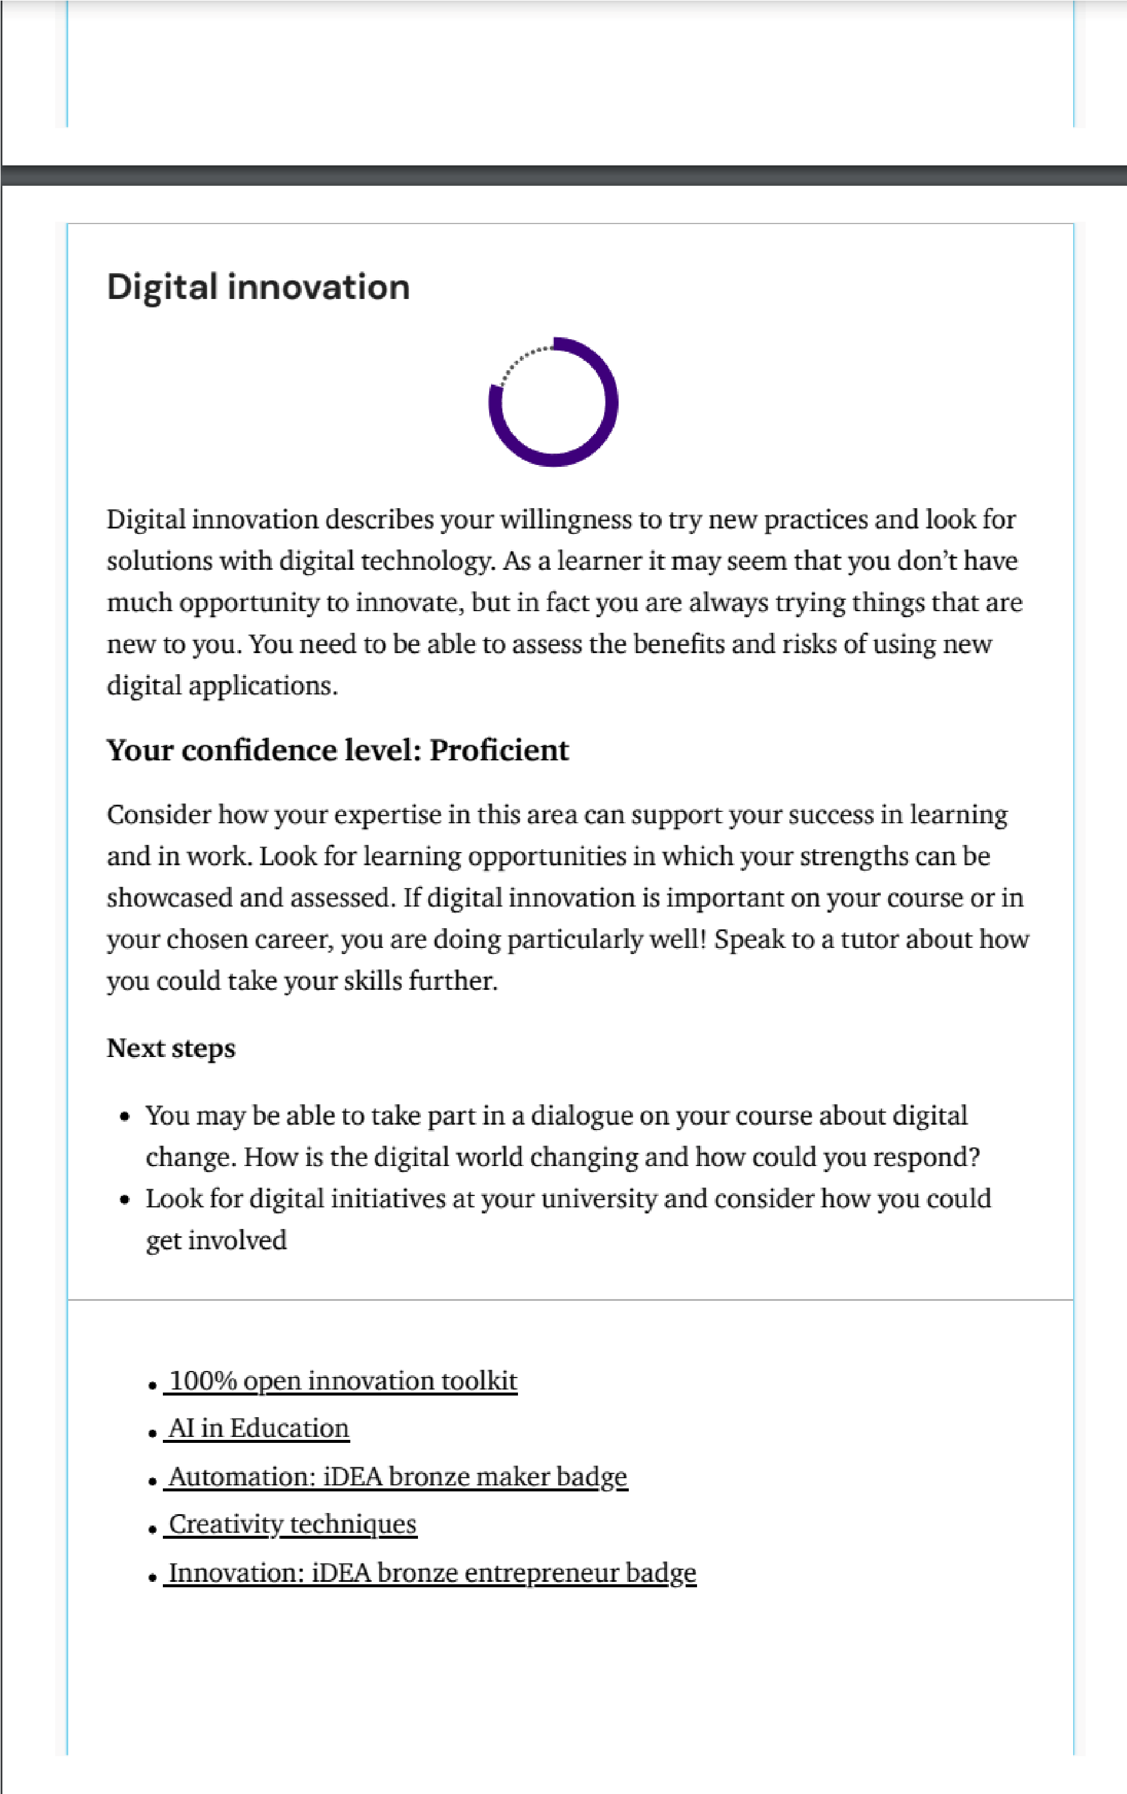
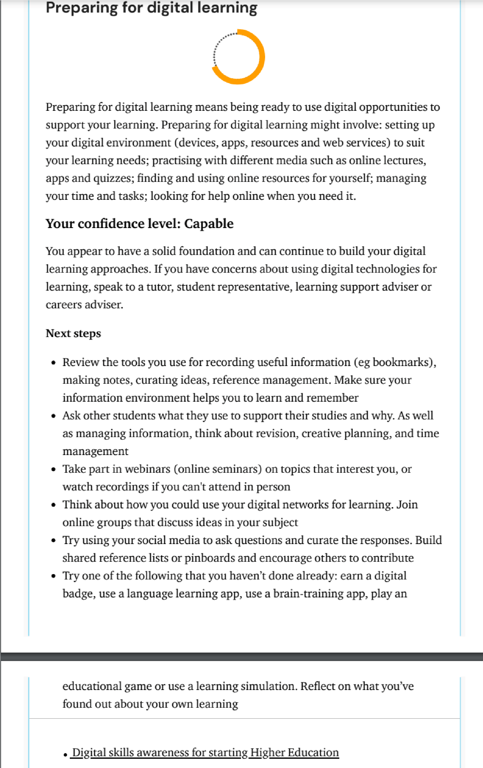
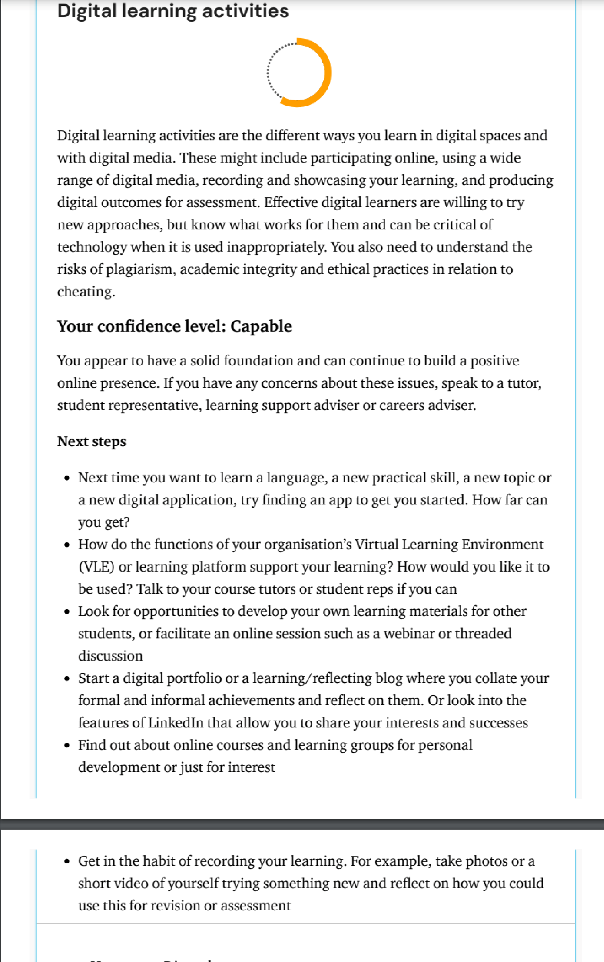
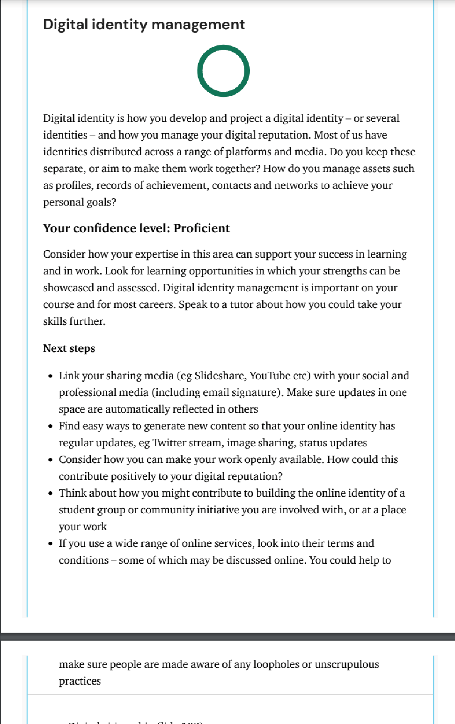
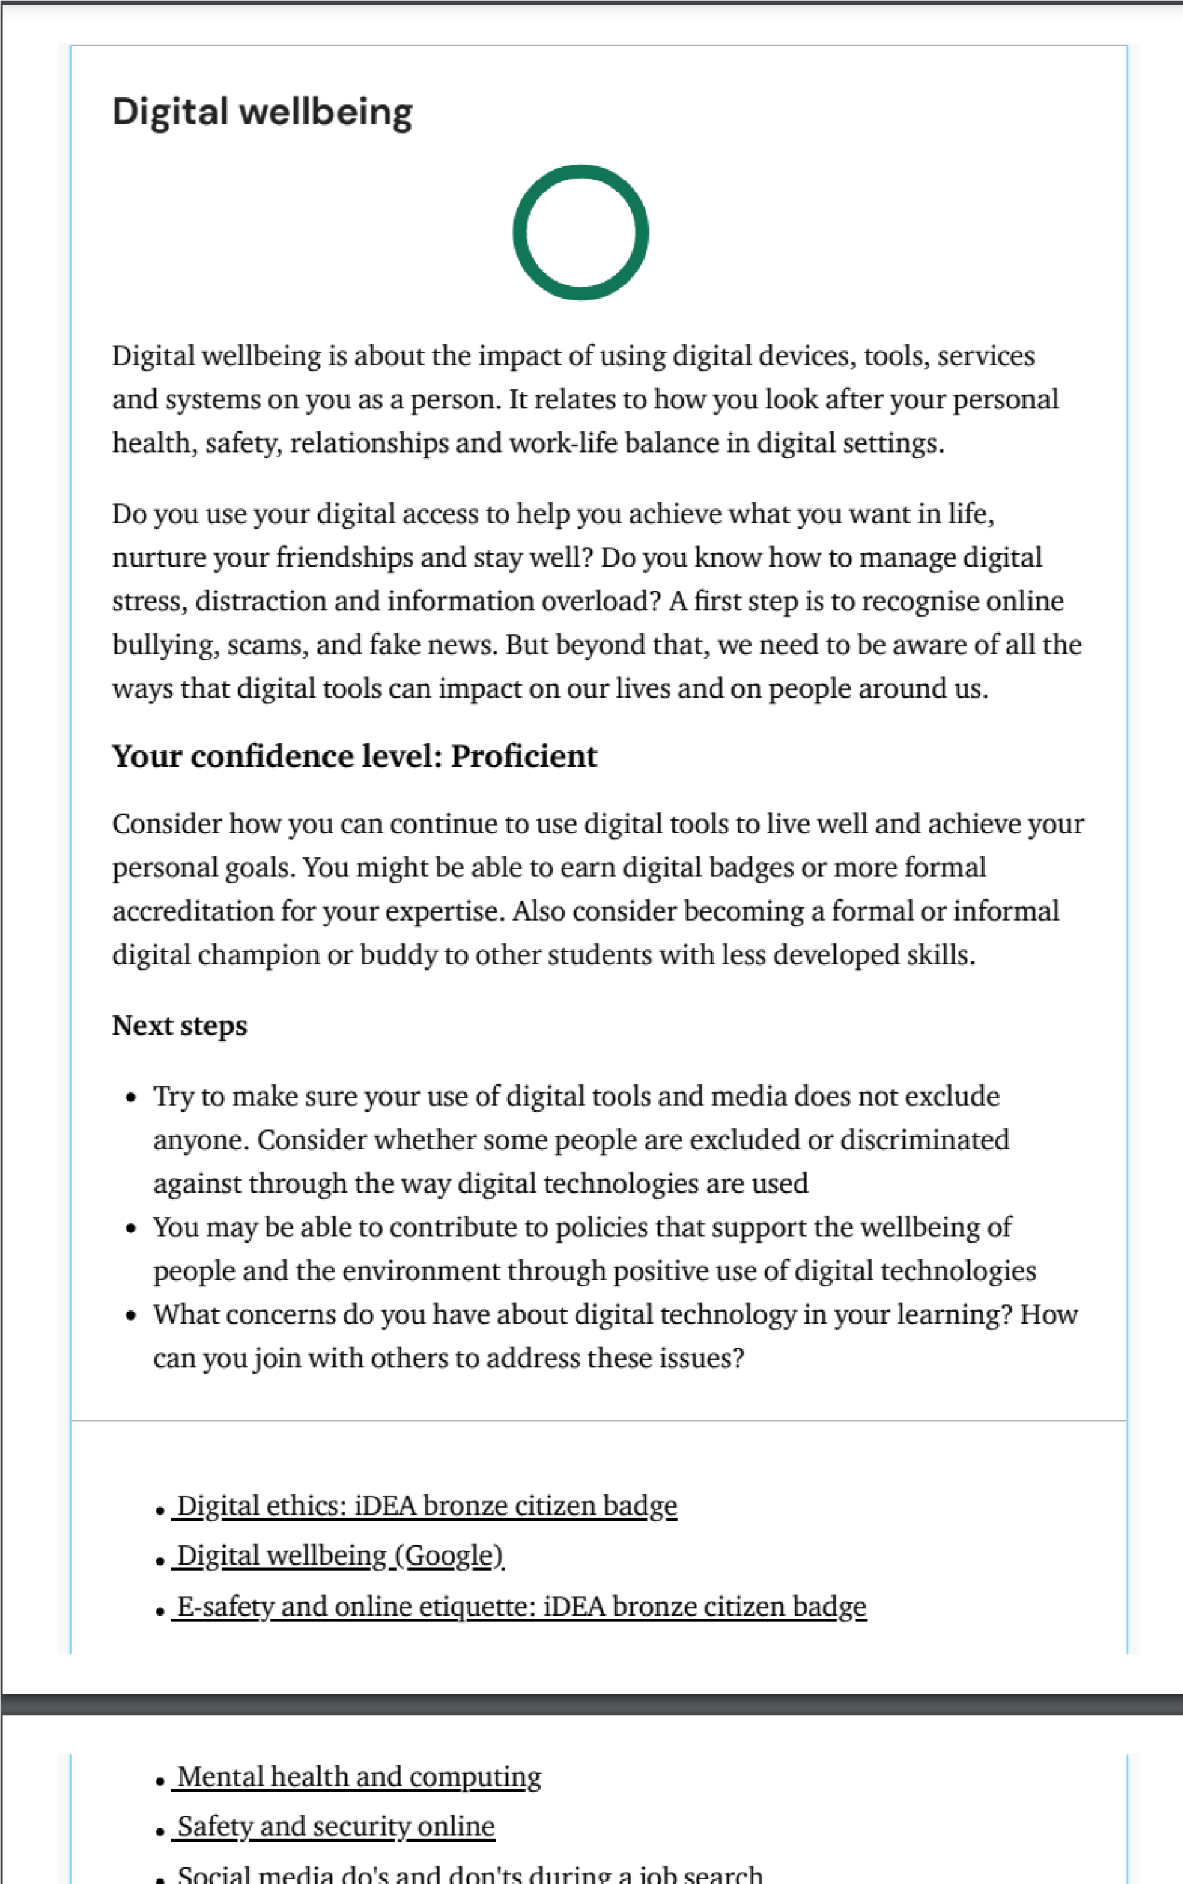
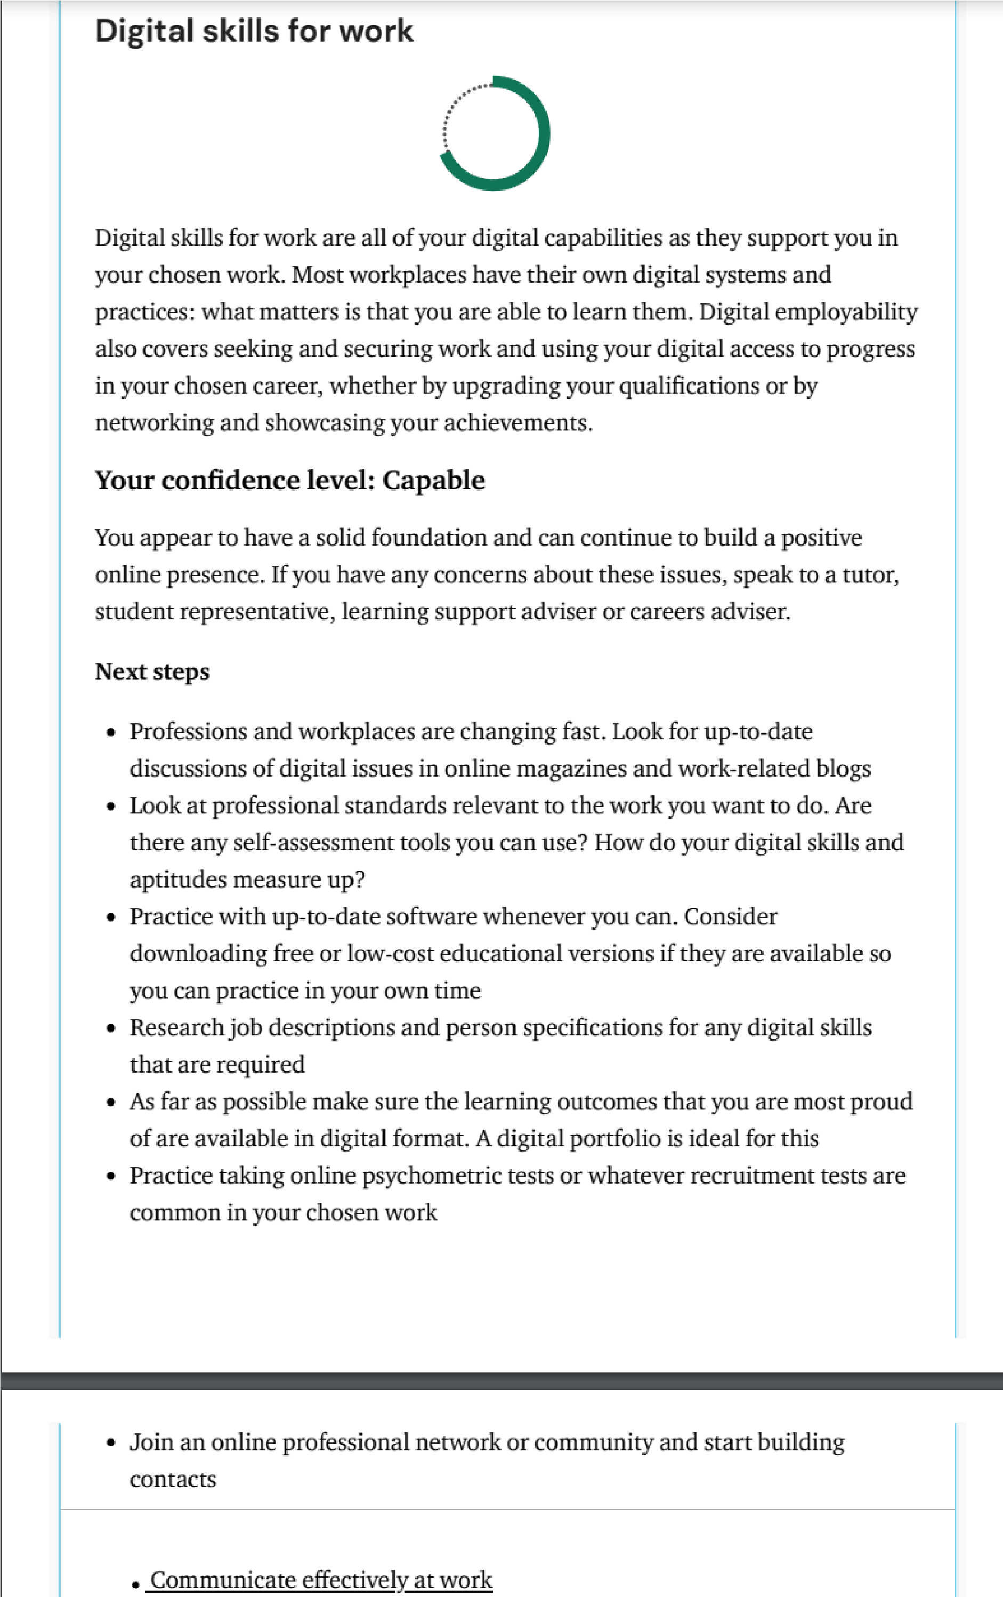
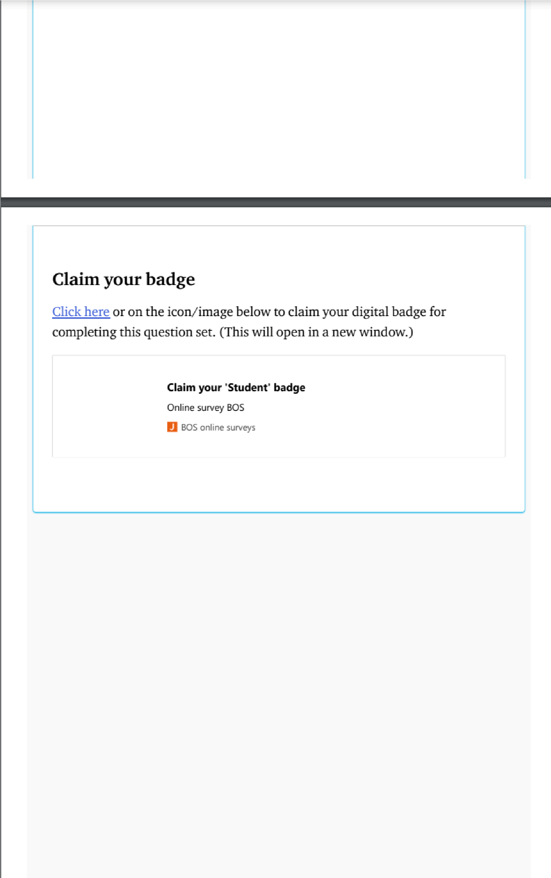

Appendix 3 – BCG Digital Transformation Job Simulation – Foraj Certificate

