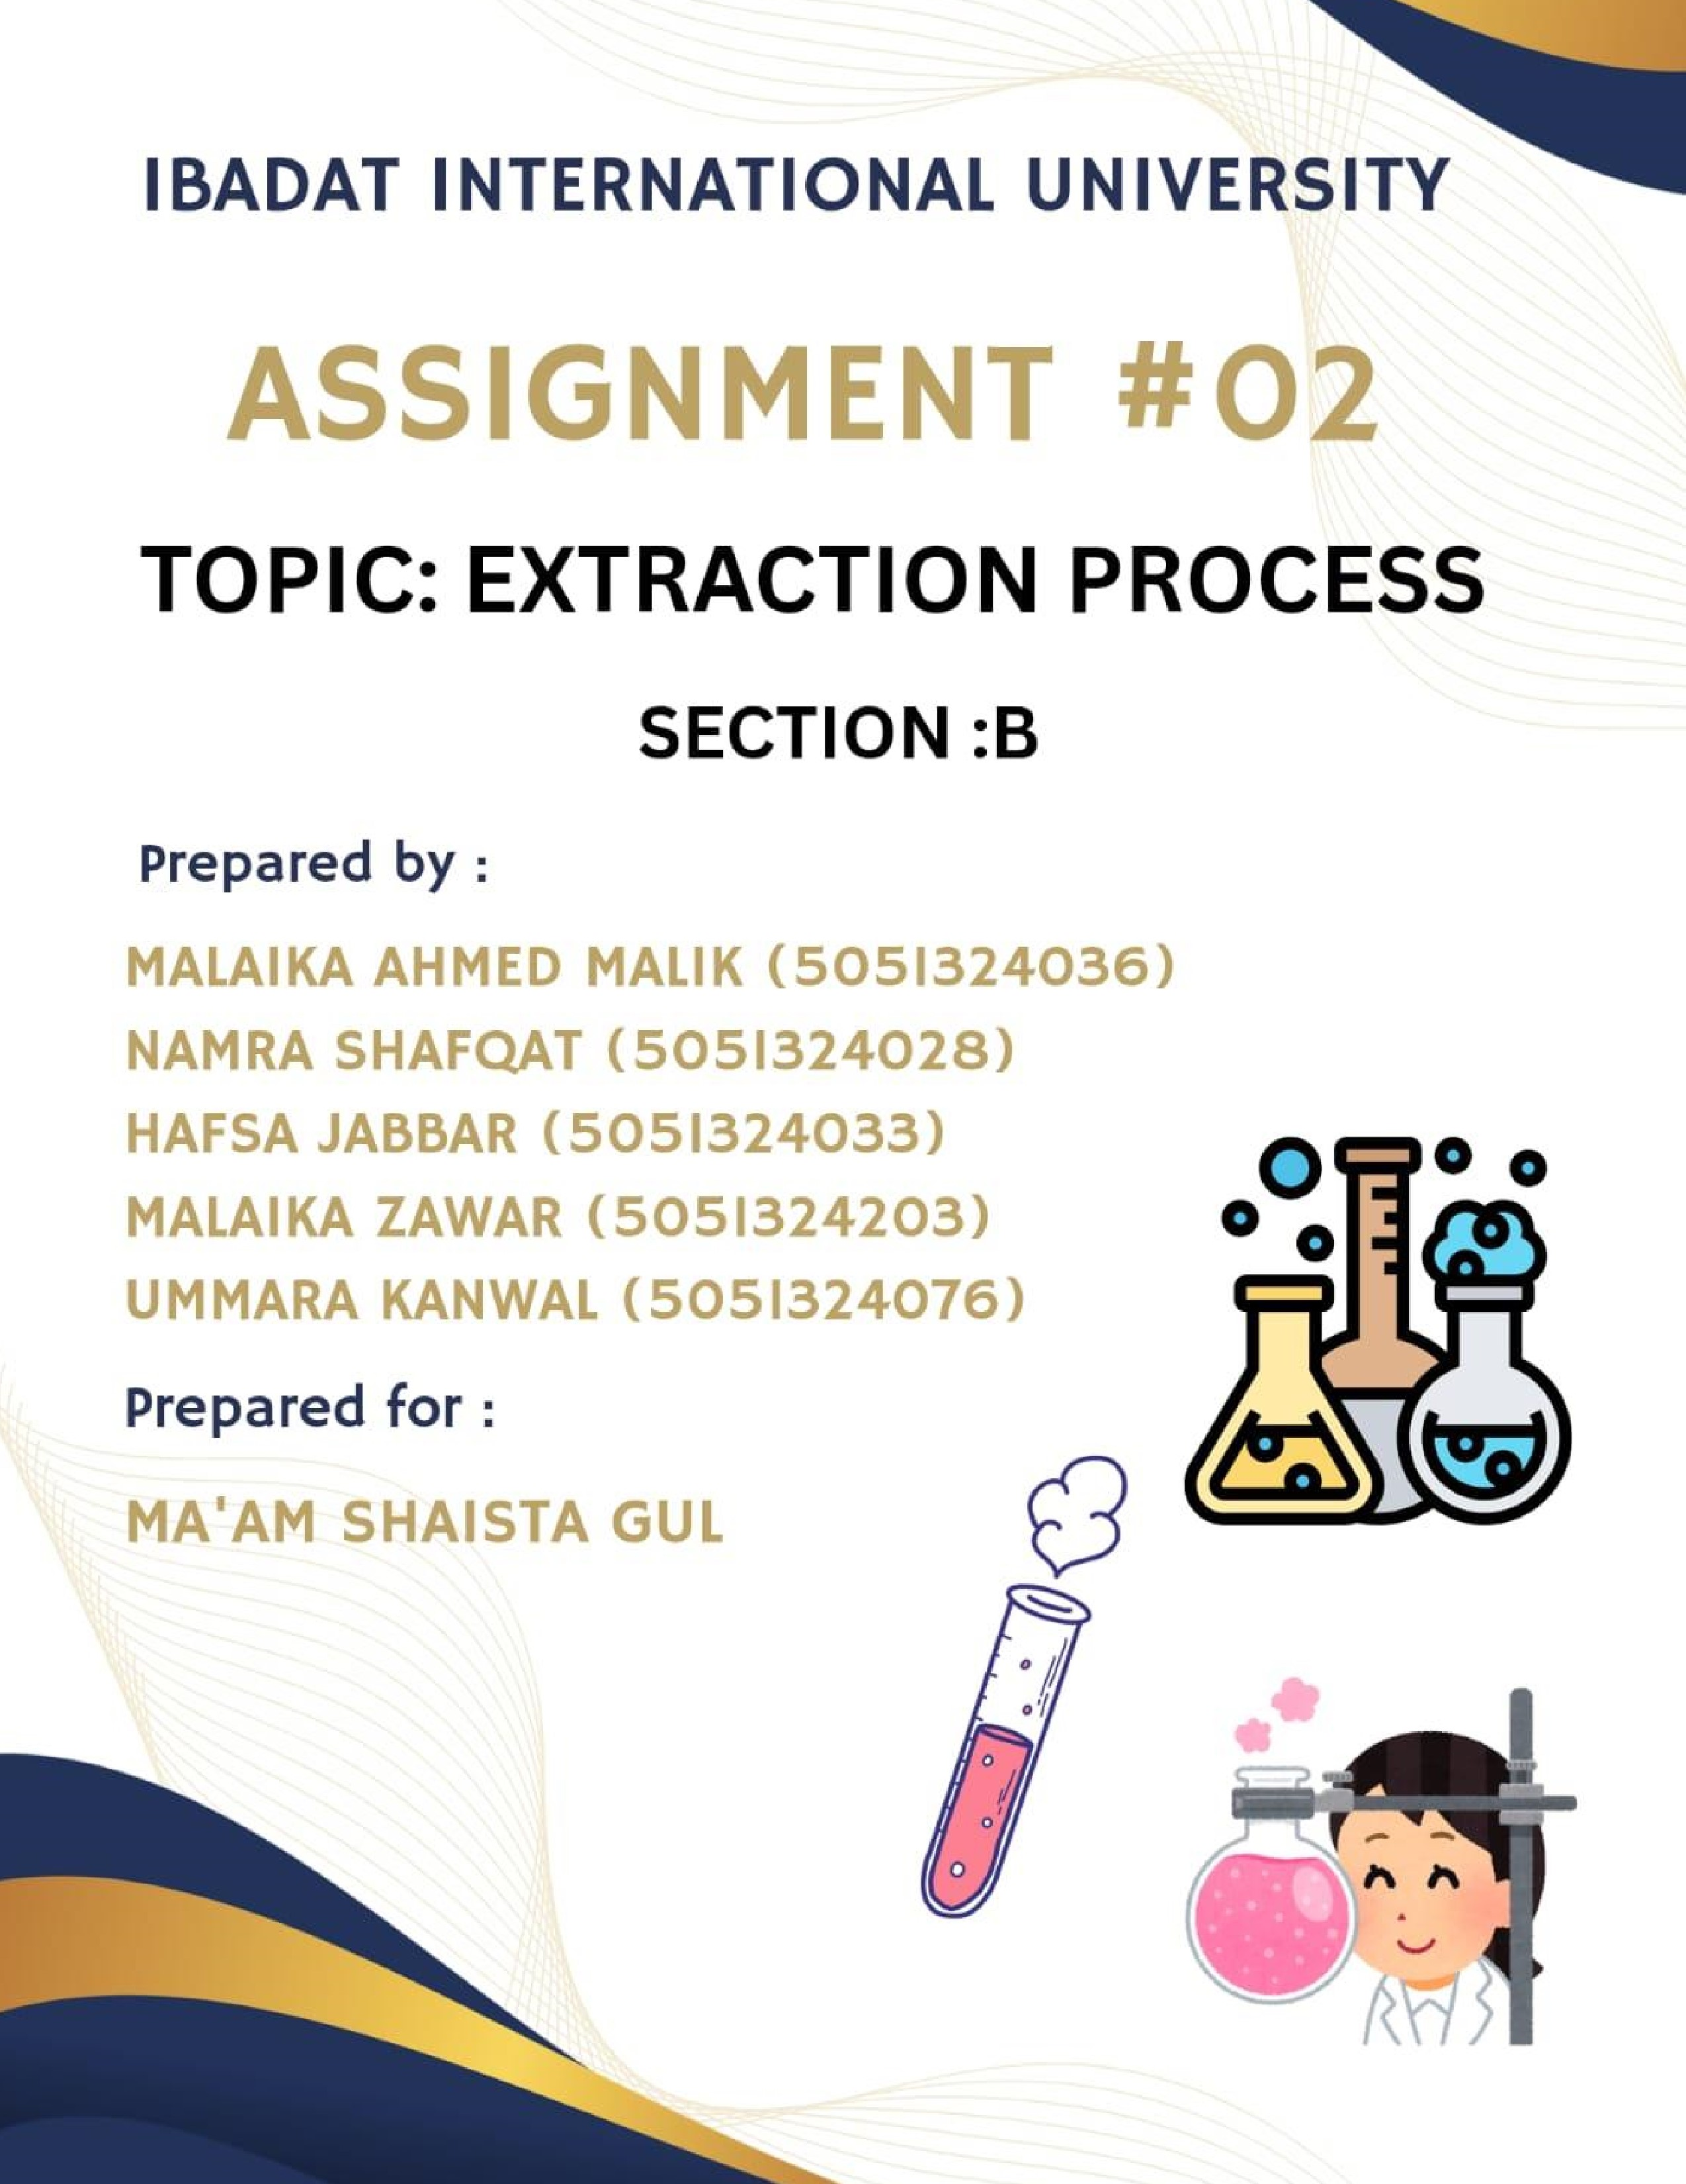


Extraction Process
Introduction: (Malaika Zawar)
Extraction is a pivotal procedure within the pharmaceutical sciences dedicated to isolating bioactive compounds from natural sources, such as plants, animals, and microorganisms. This methodology is essential in procuring active pharmaceutical ingredients (APIs) that underpin many therapeutic agents. The effectiveness and precision of extraction directly influence the ultimate quality, potency, and safety profile of pharmaceutical formulations.

Objectives of the Extraction Process:
The extraction process in pharmacy targets several fundamental goals, including:
- Isolation of Active Constituents:
The separation of pharmacologically beneficial compounds from raw natural materials.
- Enhancement of Purity:
Achieving extracts with minimal impurities to guarantee safety and therapeutic efficacy.
- Maximization of Yield:
Ensuring that the highest possible quantity of the target compound is retrieved.
- Formulation Preparation:
Extracts are compatible with different pharmaceutical dosage forms.
- Standardization:
Consistency in the concentration of active ingredients across batches for reproducible therapeutic outcomes.
Principles of Extraction: (Hafsa Jabbar)
Extraction fundamentally relies on the principle of selective solubility, whereby solvents are chosen to dissolve particular constituents based on their chemical characteristics and affinities.
Critical steps in the extraction process include:
- Solvent Selection: g
Opting for a solvent that preferentially dissolves the desired compound while excluding undesirables.
- Mass Transfer:
The movement of solutes from plant material or other matrices into the solvent phase.
- Equilibrium Establishment:
A dynamic balance is achieved where the concentration of solute in the solid and liquid phases stabilizes.
• Partition Coefficient:
Understanding how a compound distributes itself between two immiscible solvents, a principle vital for liquid-liquid extraction techniques.
Types of Extraction Methods and Their Applications:
- Maceration:
Definition:
“Maceration is a cold extraction technique where plant materials are soaked in a suitable solvent at ambient temperature to dissolve soluble compounds gently without heat application.” Process:
  - Plant materials are cleansed, dried thoroughly, and coarsely powdered.
  - The powdered material is submerged in a selected solvent (menstruum) for a set period, usually between three to seven days.
  - Occasional stirring or agitation is performed to facilitate efficient extraction.
  - Following maceration, the mixture is filtered to separate the liquid extract from the plant residue.
Applications:
  - Well-suited for extracting thermolabile substances prone to degradation via heat.
  - Commonly employed in the preparation of tinctures and herbal extracts within traditional medicinal systems.
Advantages:
  - Simple, economical, and requires minimal technical apparatus.
Disadvantages:

  - Relatively slow extraction process.
  - Lower extraction efficiency when compared with alternative methods.
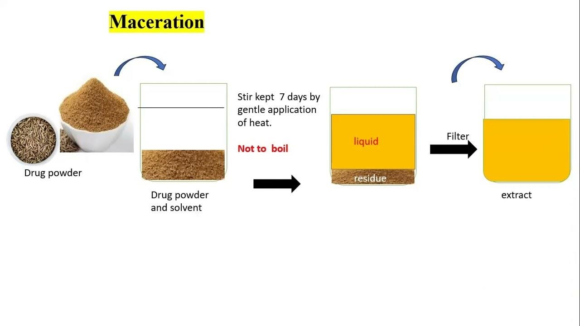

- Percolation:
Definition:
“Percolation is a continuous extraction process wherein solvent percolates through a column of powdered drug material, extracting soluble components as it passes.” Process:
  - The powdered substance is wetted with the solvent and allowed to soak for several hours (imbibition).
  - The moistened powder is then packed firmly into a percolator vessel.
  - A fresh solvent is added on top and permitted to flow slowly through the material.
  - The extract is collected from the base of the percolator in a continuous manner.
Applications:
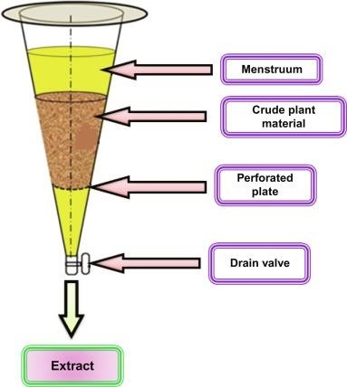
  - Frequently used for producing fluid extracts on a large scale.
  - Favored in industrial processes owing to its continuous extraction advantage.
Advantages:
  - More efficient extraction than maceration.
  - Continuous operation allows enhanced yield.
Disadvantages:
  - Requires specialized equipment and setup.
  - Unsuited for materials that swell or gelatinize upon solvent contact.

- Soxhlet Extraction: (Malaika Ahmed)
Definition:
“Soxhlet extraction is a technique where solvent is cyclically vaporized, condensed, and passed through the sample repeatedly for exhaustive extraction.” Process: ❖ Powdered material is placed inside a thimble within the Soxhlet apparatus.
  - Solvent is heated to generate vapor, which condenses and flows through the sample.
  - This cycling continues, effectively extracting the target compounds into the solvent.
Applications:
  - Especially effective for isolating lipophilic substances such as fats and oils.
  - Widely employed for extracting essential oils and other bioactive plant constituents.
Advantages:
  - Highly efficient and thorough extraction process.
  - Utilizes less solvent compared to traditional maceration.
Disadvantages:
  - Not advisable for heat-sensitive compounds due to extended exposure to heat.
  - Relatively time-intensive.
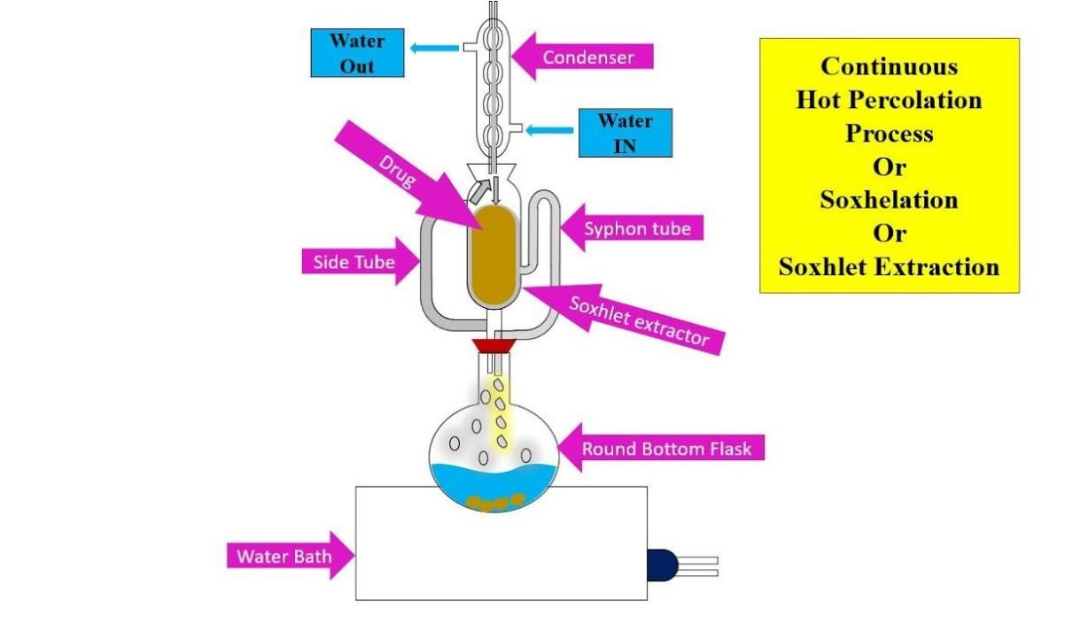

- Liquid-Liquid Extraction:
Definition:
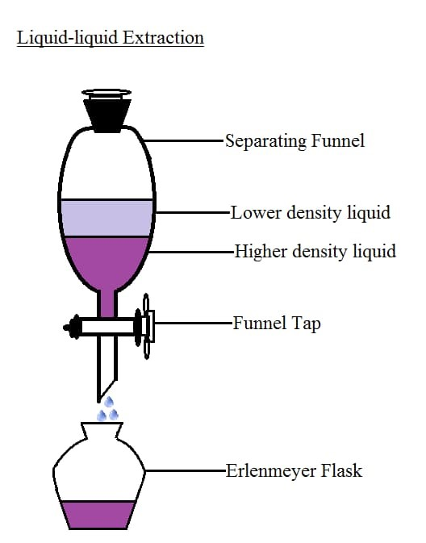
“Liquid-liquid extraction capitalizes on the differential solubility of compounds between two immiscible liquids, usually aqueous and organic phases, to separate components.” Process:
  - The target compound mixture is dissolved in one solvent phase.
  - A second immiscible solvent is added, resulting in two distinct layers.
  - The compound distributes itself between the two solvents based on its affinity or solubility (partitioning).
  - The two layers are separated and the compound extracted from the solvent in which it preferentially dissolves.
Applications:
  - Frequently employed in purification of complex compounds like antibiotics and alkaloids.
  - Critical step in drug development to isolate and purify chemical entities.
Advantages:
  - Effective for compounds with differing polarities. ❖ Scalable to industrial requirements.
Disadvantages: ❖ Formation of emulsions can complicate phase separation.
  - Careful solvent choice is necessary to maximize efficiency and selectivity.

- Supercritical Fluid Extraction (SFE): (Namra Shafqat)
Definition:
Utilizes supercritical fluids, substances above critical temperature and pressure, to extract bioactive compounds with unique solvent properties.
Process: ❖ Supercritical carbon dioxide (CO₂) is most commonly applied.
  - The sample is loaded into the extraction chamber, where supercritical CO₂ passes through it.
  - The fluid dissolves compounds selectively, and depressurization separates the extract from CO₂.
Applications:
  - Used to extract essential oils, flavors, and fragrances.
  - Applied in decaffeinating coffee and tea, preserving delicate flavors.
Advantages:
  - Environmentally benign and non-toxic solvent system.
  - Operates at moderate temperatures, preserving heat-sensitive compounds.
Disadvantages:
  - High initial cost for sophisticated equipment.
  - Requires meticulous control of temperature and pressure parameters.
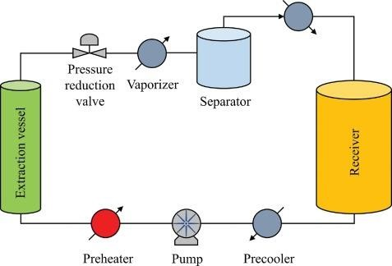

Factors Affecting Extraction:
Several variables impact the efficiency and outcome of the extraction process, including:
  - Polarity of Solvent:
Determines the solubility of target molecules.
  - Temperature:
Elevated temperatures can increase solubility, though they may risk degrading sensitive compounds.
  - Particle Size of Material:
Finer particles increase surface area, aiding faster and more complete extraction.
  - Duration of Extraction:
Longer contact times generally improve yield but may co-extract impurities.
  - Agitation or Stirring:
Enhances solvent penetration, enhancing mass transfer.
  - Ratio of Solvent to Material:
Adequate solvent volume ensures thorough immersion of the material.
Solvents Used in Extraction: (Ummara Kanwal)
Choosing appropriate solvents is critical to successful extraction. Common solvents include:
  - Water:
Universal solvent ideal for polar compounds.
  - Ethanol:
Versatile solvent for diverse compounds, widely used in tinctures.
  - Methanol:
Highly polar, popular for phenolics and flavonoids extraction.
  - Acetone:
Medium polarity solvent, bridging polar and non-polar compound solubility.
  - Chloroform:
The non-polar solvent is used for alkaloid isolation.
  - Hexane:
Non-polar solvents are chiefly for lipid and essential oil extraction.
  - Supercritical CO₂:
Green alternative, non-toxic, ideal for thermally sensitive materials.
Applications in Pharmacy:
Extraction techniques are foundational to many pharmaceutical applications, such as:
  - Drug Discovery:
Isolating novel bioactive compounds from natural sources.
  - Herbal Medicine Production:
Generating standardized herbal extracts for therapeutic formulations.
  - Quality Assurance:
Maintaining consistency and potency throughout production batches.
  - Nutraceuticals:
Extracting vitamins, antioxidants, and health-promoting substances.
  - Cosmeceuticals:
Obtaining natural ingredients for skincare and cosmetic products.
Conclusion:
Extraction remains a cornerstone of pharmaceutical sciences, enabling the precise isolation and purification of vital bioactive substances indispensable for drug manufacturing and therapeutic use. Mastery of extraction principles, methods, and influencing factors is essential to ensuring high-quality, efficacious, and safe pharmaceutical preparations capable of meeting modern healthcare demands.
References:
  - Behera, B., Chowdhury, N., & Das, A. (2020). Principles and Applications of Extraction Techniques in Pharmaceutical Sciences. Pharma Journal International, 15(2), 45–58.
  - Harborne, J. B. (1998). Phytochemical Methods: A Guide to Modern Techniques of Plant Analysis (3rd ed.). Chapman & Hall.
  - Skoog, D. A., Holler, F. J., & Crouch, S. R. (2017). Principles of Instrumental Analysis (7th ed.). Cengage Learning.
  - Esfahani, M. H. N., & Amiri, H. (2019). Supercritical Fluid Extraction in Pharmaceutical
Industry: A Review. Journal of Pharmacy & Bioallied Sciences, 11(Suppl 2), S318–S323.
  - Wilson, K., & Walker, J. (2010). Principles and Techniques of Biochemistry and Molecular Biology (7th ed.). Cambridge University Press.
  - Rao, P. V., & Rao, A. V. (2012). Extraction Techniques and Applications. International Journal of Pharmacy and Pharmaceutical Sciences, 4(1), 9–13.
  - Evans, W. C. (2009). Trease and Evans’ Pharmacognosy (16th ed.). Saunders Elsevier.
  - Anonymous. (2017). Phytochemical Extraction Methods: Fundamentals and Applications. Pharmaceutical Analytical Chemistry, 8(1), 1–12.

